UNIT – III Elementary Combinatorics

Basics of Counting, Combinations and Permutations,Enumeration of Combinations and Permutations, Enumerating Combinations andPermutations with Repetitions, Enumerating Permutations with Constrained Repetitions,

**1.**If there are 10 multiple-choice questions on an exam, each having 3 possible answers, how many different possibilities are there for sequences of correct answers?

**Solution:**

**2.** A brand of women’s jeans can be ordered in seven different sizes, 3 different colors and 3 different styles. How many jeans have to be ordered if the store wants to have one pair of each type.

**Solution:**

**3.** A gardener has 6 rows in his garden available for 6 different vegetables. If each vegetable gets one row, how many different ways are there to position the vegetables in the garden?

**Solution:**

**4.** The Big Triple consists of picking the correct order of finish of the first 3 horses in the 9th race. If there are 12 horses entered in the race, how many outcomes are there?

**Solution:**, so

**5.** The number of ways four aces can be located in a deck of 52 cards..

**Solution:** Apparently, order counts in this case. .

**6.** The Quinella consists of picking the horses that will place first or second regardless of order. If 8 horses are entered in a race, how many winning combinations are there?

**Solution:**, so

7. How many 7 letter words can be spelled with the 7 letters abcdefg without repeating any letter?

**Solution:** 7! = 5040

8. How many 4 letter words can be spelled with the 7 letters abcdefg without repeating any letter?

**Solution:** 7!/3! = 840

9. How many 4 letter words can you spell with 2 A’s and 2 B’s?

**Solution:** 4!/2!2!=6

10. In a class, there are 27 boys and 14 girls. The teacher wants to select 1 boy and 1 girl to represent the class for a function. In how many ways can the teacher make this selection?

**Solution:** Here the teacher is to perform two operations:

(i) Selecting a boy from among the 27 boys and

(ii) Selecting a girl from among 14 girls

The first of these can be done in 27 ways and second can be performed in 14 ways. By the fundamental principle of counting, the required number of ways is 27 × 14 = 378.

11. (i) How many numbers are there between 99 and 1000 having 7 in the units place?

(ii) How many numbers are there between 99 and 1000 having atleast one of their digits 7?

**Solution:**

(i) First note that all these numbers have three digits. 7 is in the unit’s place. The

middle digit can be any one of the 10 digits from 0 to 9. The digit in hundred’s

place can be any one of the 9 digits from 1 to 9. Therefore, by the fundamental

principle of counting, there are 10 × 9 = 90 numbers between 99 and 1000 having 7 in the unit’s place.

(ii) Total number of 3 digit numbers having atleast one of their digits as 7 = (Total numbers of three digit numbers) – (Total number of 3 digit numbers in which 7 does not appear at all).

= (9 × 10 × 10) – (8 × 9 × 9)

= 900 – 648 = 252.

12 In how many ways can 5 children be arranged in a line such that (i) two

particular children of them are always together (ii) two particular children of them are never together.

**Solution:**

(i) We consider the arrangements by taking 2 particular children together as one and hence the remaining 4 can be arranged in 4! = 24 ways. Again two particular children taken together can be arranged in two ways. Therefore, there are 24 × 2 = 48 total ways of arrangement.

(ii) Among the 5! = 120 permutations of 5 children, there are 48 in which two children are together. In the remaining 120 – 48 = 72 permutations, two particular children are never together.

13 In how many ways 3 mathematics books, 4 history books, 3 chemistry books and 2 biology books can be arranged on a shelf so that all books of the same subjects are together.

**Solution:** First we take books of a particular subject as one unit. Thus there are

4 units which can be arranged in 4! = 24 ways. Now in each of arrangements, mathematics books can be arranged in 3! ways, history books in 4! ways, chemistry books in 3! ways and biology books in 2! ways. Thus the total number of ways = 4! × 3! × 4! × 3! × 2! = 41472.

14 Three married couples are to be seated in a row having six seats in a cinema hall. If spouses are to be seated next to each other, in how many ways can they be seated? Find also the number of ways of their seating if all the ladies sit together.

**Solution:** Let us denote married couples by S 1 , S 2 , S 3 , where each couple is considered

to be a single unit as shown in the following figure:

[][] [][] [][]

1 st 2 nd 3 rd

Then the number of ways in which spouces can be seated next to each other is

3! = 6 ways.

Again each couple can be seated in 2! ways. Thus the total number of seating arrangement so that spouces sit next to each other = 3! × 2! × 2! × 2! = 48.

Again, if three ladies sit together, then necessarily three men must sit together. Thus, ladies and men can be arranged altogether among themselves in 2! ways.

Therefore, the total number of ways where ladies sit together is 3! × 3! × 2! = 144.

15. A boy has 3 library tickets and 8 books of his interest in the library. Of these 8, he does not want to borrow Mathematics Part II, unless Mathematics Part I is also borrowed. In how many ways can he choose the three books to be borrowed?

**Solution:** Let us make the following cases:

Case (i) Boy borrows Mathematics Part II, then he borrows Mathematics Part I also.So the number of possible choices is 6 C 1 = 6.

Case (ii) Boy does not borrow Mathematics Part II, then the number of possible choices is 7C 3 = 35.

Hence, the total number of possible choices is 35 + 6 = 41.

**Binomial Coefficients, The Binomial and Multinomial Theorems,**

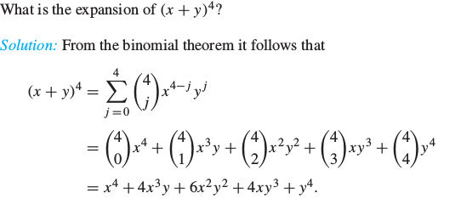



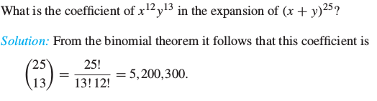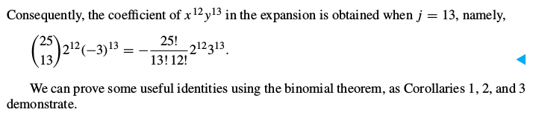

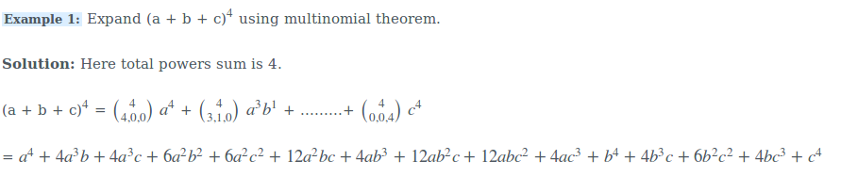

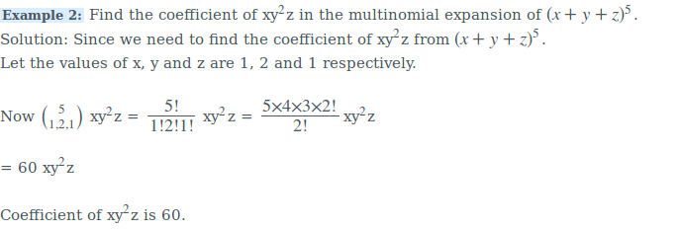

## -----------------------------------------------------------------------------------------------------------------------------------------------------------------

**The Principle of InclusionExclusion.**

1. A total of 35 programmers interviewed for a job; 25 knew FORTRAN, 28 knew PASCAL, and 2 knew neither languages. How many knew both lan-

guages?

**Solution:**

Let A be the group of programmers that knew FORTRAN, B those who knew PASCAL. Then A ∩ B is the group of programmers who knew both languages. By the Inclusion-Exclusion Principle we have

|A ∪ B| = |A| + |B| − |A ∩ B|.

That is, 33 = 25 + 28 − |A ∩ B|.

Solving for |A ∩ B| we find |A ∩ B| = 20.

2. Find the number of mathematics students at a college taking at least one of the languages French, German, and Russian, given the following data:

65 study French,

20 study French and German,

45 study German, 25 study French and Russian,

8 study all three languages.

42 study Russian, 15 study German and Russian,

Find n(F ∪ G ∪ R) where F, G, and R denote the sets of students studying French, German, and Russian, respectively.

**Solution:**

By the Inclusion–Exclusion Principle,

n(F ∪ G ∪ R) = n(F ) + n(G) + n(R) − n(F ∩ G) − n(F ∩ R) − n(G ∩ R) + n(F ∩ G ∩ R)

= 65 + 45 + 42 − 20 − 25 − 15 + 8 = 100

Namely, 100 students study at least one of the three languages.

## -----------------------------------------------------------------------------------------------------------------------------------------------------------------

**Objective Type Questions**

1. There are four bus routes between A and B; and three bus routes between B and C. A man can travel round-trip in number of ways by bus from A to C via B. If he does not want to use a bus route more than once, in how many ways can he make round trip?

(A) 72

(B) 144

(C) 14

(D) 19

**Solution:** (A)

2. In how many ways a committee consisting of 3 men and 2 women, can

be chosen from 7 men and 5 women?

(A) 45

(B) 350

(C) 4200

(D) 230

**Solution:** (B)

3. All the letters of the word ‘EAMCOT’ are arranged in different possible

ways. The number of such arrangements in which no two vowels are adjacent to each

other is

(A) 360

(B) 144

(C) 72

(D) 54

**Solution:** (B)

4. Ten different letters of alphabet are given. Words with five letters are formed from these given letters. Then the number of words which have atleast one letter repeated is

(A) 69760

(B) 30240

(C) 99748

(D) 99784

**Solution:** (A)

5. The number of signals that can be sent by 6 flags of different colours taking one or more at a time is

(A) 63

(B) 1956

(C) 720

(D) 21

**Solution:** (B)

6. In an examination there are three multiple choice questions and each question has 4 choices. Number of ways in which a student can fail to get all answer correct is

(A) 11

(B) 12

(C) 27

(D) 63

**Solution:** (D).