UNIT-IV

Recurrence Relation
Short Answer Questions

1.The generating function for the sequence 1, 1, 1, . . . is the function

 |  | 1 |  |  | ∞
 |  | 1 |  | = 1 + x + x² + · · · = | _{x}j
 | 1 | − | x | = 1 + x + x² + · · · = | _{x}j
 |  | − |  |  | j=0

2.What are the generating functions for the sequences {ak}{ak} with ak=2ak=2 and ak=3kak=3k?
Solution
When ak=2ak=2, generating function, G(x)=∑∞k=02xk=2+2x+2x2+2x3+…G(x)=∑k=0∞2xk=2+2x+2x2+2x3+…
When ak=3k,G(x)=∑∞k=03kxk=0+3x+6x2+9x3+…
3.Define Recurrence relations:

A.Introduction :A recurrence relation is a formula that relates for any integer n ≥ 1, the n-th term of a sequence A = {ar}∞r=0 to one or more of the terms a0,a1,….,an-1. Example. If Sn denotes the sum of the first n positive integers, then

4. Construct a gen fcn for the

sequence of squares: 0, 1, 4, 9, 16, 25, . . ..
n² + n

sol: 1 + 2 + · · · + n =

 |  |  |  |  | 2x |  |  |  |  | generates n² + n
and |  |  |  | (1 − x)³
 |  |  |  |  |  |  | x |  |  |  |  | generates n
 |  |  |  |  |  | (1 − x)²
Thus, |  | 2x |  |  |  | − |  |  |  | x |  |  | = | x² + x
Thus, | (1 | − | x)³ |  |  | − |  | (1 |  | − |  | x)² | = | (1 | − | x)³
2

is a gen fcn for n².
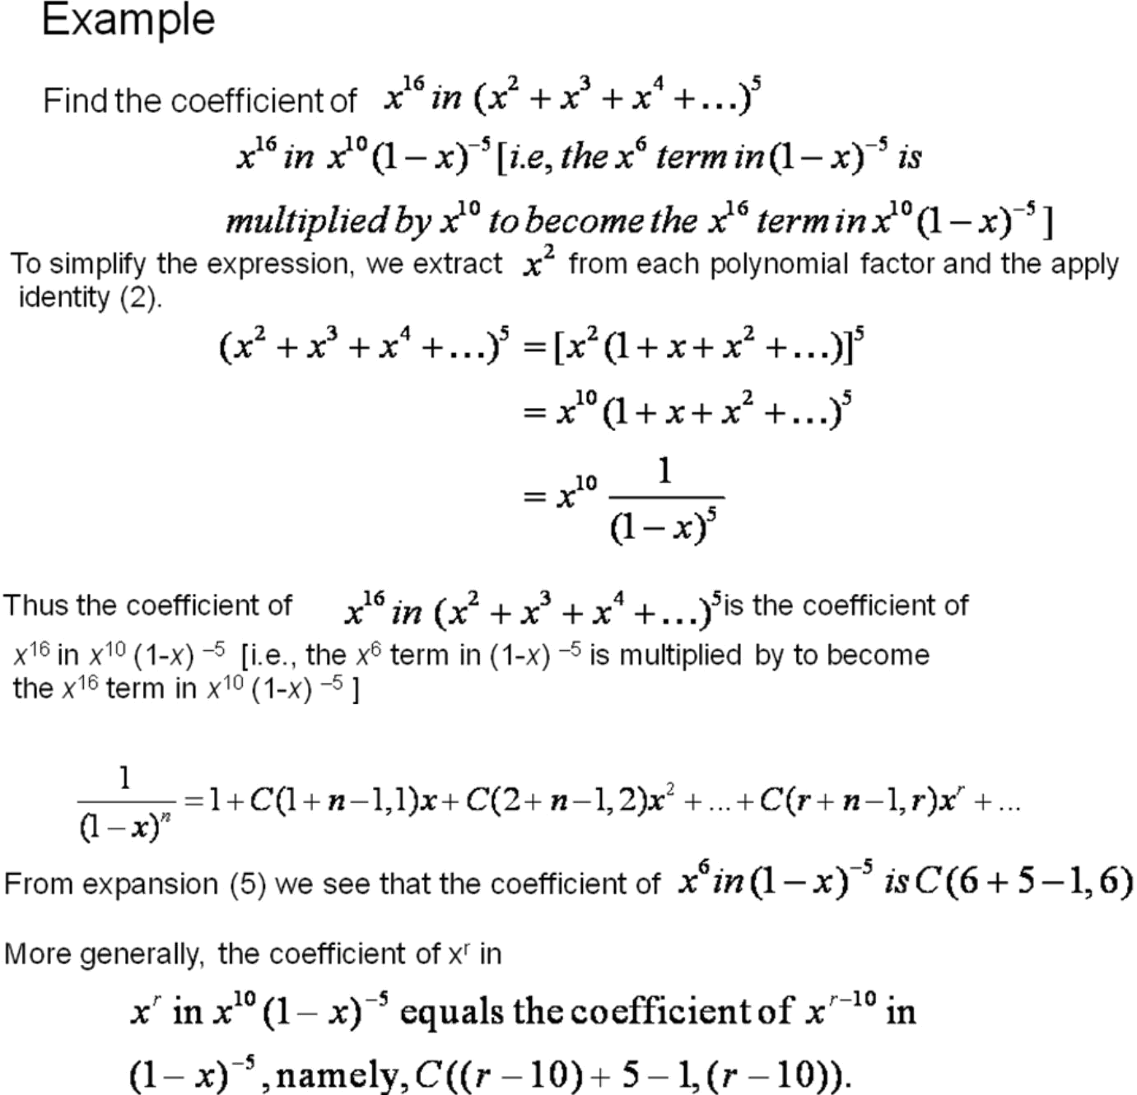
5.
6.Find the particular solution of
a_{n+4}-5a_{n+3}+9a_{n+2}-7a_{n+1} +2a_{n}=3 , n 0
satisfying the initial conditions a₀ = 2, a₁ = -1/2, a₂ = -5, a₃ = -31/2 .
Solution We first find the general solution u_{n} for the homogeneous problem. We then find a particular solution v_{n} for the nonhomogeneous problem without considering the initial conditions. Thena_{n}=u_{n}+v_{n} would be the general solution of the nonhomogeneous problem. We finally make use of the initial conditions to determine the arbitrary constants in the general solution so as to arrive at our required particular solution.
7. Find u_{n}: Since the associated characteristic equation
⁴-5 ³ +9 ² -7 + 2 =0
Sol:has the sum of all the coefficients being zero, i.e. 1-5+9-7+2=0, it must have a root =1. After factorising out ( -1) via ⁴-5 ³+9 ²-7 + 2 = ( -1)( ³-4 ²+5 -2), the rest of the roots will come from ³-4 ²+5 -2 =0. Notice that ³-4 ²+5 -2=0 can again be factorised by a factor ( -1) because 1-4+5-2=0. This way we can derive in the end that the roots are
₁ =1 | with multiplicity | m₁=3 , and
₂=2 | with multiplicity | m₂=1 .
Thus the general solutions for the homogeneous problem is
u_{n} = (A+Bn+Cn²)1^{n}+D2^{n} ,
or simply u_{n}=A+Bn+Cn²+D2^{n} because 1^{n} 1.
8.Solve the recurrence relation Fn=5Fn−1−6Fn−2Fn=5Fn−1−6Fn−2 where F0=1F0=1 and F1=4F1=4
Solution
The characteristic equation of the recurrence relation is −
x2−5x+6=0,x2−5x+6=0,
So, (x−3)(x−2)=0(x−3)(x−2)=0
Hence, the roots are −
x1=3x1=3 and x2=2x2=2
The roots are real and distinct. So, this is in the form of case 1
Hence, the solution is −
Fn=axn1+bxn2Fn=ax1n+bx2n
Here, Fn=a3n+b2n (As x1=3 and x2=2)Fn=a3n+b2n (As x1=3 and x2=2)
Therefore,
1=F0=a30+b20=a+b1=F0=a30+b20=a+b
4=F1=a31+b21=3a+2b4=F1=a31+b21=3a+2b
Solving these two equations, we get a=2a=2 and b=−1b=−1
Hence, the final solution is −
Fn=2.3n+(−1).2n=2.3n−2n

9.Let a non-homogeneous recurrence relation be Fn=AFn–1+BFn−2+f(n)Fn=AFn–1+BFn−2+f(n)with characteristic roots x1=2x1=2 and x2=5x2=5.
Trial solutions for different possible values of f(n)f(n) are as follows −
f(n) | Trial solutions
4 | A
5.2^{n} | An2^{n}
8.5^{n} | An5^{n}
4^{n} | A4^{n}
2n²+3n+1 | An²+Bn+C

10.What is the generating function of the infinite series; 1,1,1,1,…1,1,1,1,…?
Solution
Here, ak=1ak=1, for 0≤k≤∞0≤k≤∞
Hence, G(x)=1+x+x2+x3+…⋯=1(1−x)

Long Answer Questions

1.Solve the recurrence relation an = a n-1 + f(n) for n ³1 by substitution

a1= a0 + f(1)

a2 = a1 + f(2) = a0 + f(1) + f(2))

a3 = a2 + f(3)= a0 + f(1) + f(2) + f(3)

.

.

.

an = a0 + f(1) + f(2) +….+ f(n)

n

- a0 + ∑ f(k)

K = 1

Thus, an is just the sum of the f(k) „s plus a0.

More generally, if c is a constant then we can solve an = c a n-1 + f(n) for n ³1 in the same way:

a1 = c a0 + f(1)

a2 = c a1 + f(2) = c (c a0 + f(1)) + f(2)

= c2 a0 + c f(1) + f(2)

a3= c a2 + f(3) = c(c 2 a0 + c f(1) + f(2)) + f(3)

=c3 a0 + c2 f(1) + c f(2) + f(3)

.

.

.

an = c a n-1 + f(n) = c(c n-1 a0 + c n-2 f(1) +. . . + c n-2 + f(n-1)) + f(n)

=c n a0 + c n-1 f(1) + c n-2 f(2) +. . .+ c f(n-1) + f(n)

Or

an = c n a0 + ∑c n-k f(k)
2.How to Generate Functions.

A.In mathematics, a generating function is a formal power series in one indeterminate, whose coefficients encode information about a sequence of numbers a_{n} that is indexed by the natural numbers. Generating functions were first introduced by Abraham de Moivre in 1730, in order to solve the general linear recurrence problem. One can generalize to formal power series in more than one indeterminate, to encode information about arrays of numbers indexed by several natural numbers.

Generating functions are not functions in the formal sense of a mapping from a domain to a codomain; the name is merely traditional, and they are sometimes more correctly called generating series.

Ordinary generating function

The ordinary generating function of a sequence a_{n} is
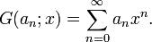

When the term generating function is used without qualification, it is usually taken to mean an ordinary generating function.

If a_{n} is the probability mass function of a discrete random variable, then its ordinary generating function is called a probability-generating function.

The ordinary generating function can be generalized to arrays with multiple indices. For example, the ordinary generating function of a two-dimensional array a_{m, n} (where n and m are natural numbers) is
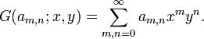

Example:
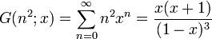

3.Solve the recurrence relation Fn=5Fn−1−6Fn−2Fn=5Fn−1−6Fn−2 where F0=1F0=1 and F1=4F1=4
Solution
The characteristic equation of the recurrence relation is −
x2−5x+6=0,x2−5x+6=0,
So, (x−3)(x−2)=0(x−3)(x−2)=0
Hence, the roots are −
x1=3x1=3 and x2=2x2=2
The roots are real and distinct. So, this is in the form of case 1
Hence, the solution is −
Fn=axn1+bxn2Fn=ax1n+bx2n
Here, Fn=a3n+b2n (As x1=3 and x2=2)Fn=a3n+b2n (As x1=3 and x2=2)
Therefore,
1=F0=a30+b20=a+b1=F0=a30+b20=a+b
4=F1=a31+b21=3a+2b4=F1=a31+b21=3a+2b
Solving these two equations, we get a=2a=2 and b=−1b=−1
Hence, the final solution is −
Fn=2.3n+(−1).2n=2.3n−2nFn=2.3n+(−1).2n=2.3n−2n

4.Solve the recurrence relation − Fn=10Fn−1−25Fn−2Fn=10Fn−1−25Fn−2 where F0=3F0=3 and F1=17F1=17
Solution
The characteristic equation of the recurrence relation is −
x2−10x−25=0x2−10x−25=0
So (x−5)2=0(x−5)2=0
Hence, there is single real root x1=5x1=5
As there is single real valued root, this is in the form of case 2
Hence, the solution is −
Fn=axn1+bnxn1Fn=ax1n+bnx1n
3=F0=a.50+b.0.50=a3=F0=a.50+b.0.50=a
17=F1=a.51+b.1.51=5a+5b17=F1=a.51+b.1.51=5a+5b
Solving these two equations, we get a=3a=3 and b=2/5b=2/5
Hence, the final solution is − Fn=3.5n+(2/5).n.2nFn=3.5n+(2/5).n.2n
5.Solve the recurrence relation Fn=2Fn−1−2Fn−2Fn=2Fn−1−2Fn−2 where F0=1F0=1 and F1=3F1=3
Solution
The characteristic equation of the recurrence relation is −
x2−2x−2=0x2−2x−2=0
Hence, the roots are −
x1=1+ix1=1+i and x2=1−ix2=1−i
In polar form,
x1=r∠θx1=r∠θ and x2=r∠(−θ),x2=r∠(−θ), where r=2–√r=2 and θ=π4θ=π4
The roots are imaginary. So, this is in the form of case 3.
Hence, the solution is −
Fn=(2–√)n(acos(n.⊓/4)+bsin(n.⊓/4))Fn=(2)n(acos(n.⊓/4)+bsin(n.⊓/4))
1=F0=(2–√)0(acos(0.⊓/4)+bsin(0.⊓/4))=a1=F0=(2)0(acos(0.⊓/4)+bsin(0.⊓/4))=a
3=F1=(2–√)1(acos(1.⊓/4)+bsin(1.⊓/4))=2–√(a/2–√+b/2–√)3=F1=(2)1(acos(1.⊓/4)+bsin(1.⊓/4))=2(a/2+b/2)
Solving these two equations we get a=1a=1 and b=2b=2
Hence, the final solution is −
Fn=(2–√)n(cos(n.π/4)+2sin(n.π/4))

6.Solve the recurrence relation Fn=3Fn−1+10Fn−2+7.5nFn=3Fn−1+10Fn−2+7.5n where F0=4F0=4and F1=3F1=3
Solution
This is a linear non-homogeneous relation, where the associated homogeneous equation is Fn=3Fn−1+10Fn−2Fn=3Fn−1+10Fn−2 and f(n)=7.5nf(n)=7.5n
The characteristic equation of its associated homogeneous relation is −
x2−3x−10=0x2−3x−10=0
Or, (x−5)(x+2)=0(x−5)(x+2)=0
Or, x1=5x1=5 and x2=−2x2=−2
Hence ah=a.5n+b.(−2)nah=a.5n+b.(−2)n , where a and b are constants.
Since f(n)=7.5nf(n)=7.5n, i.e. of the form c.xnc.xn, a reasonable trial solution of at will be AnxnAnxn
at=Anxn=An5nat=Anxn=An5n
After putting the solution in the recurrence relation, we get −
An5n=3A(n–1)5n−1+10A(n–2)5n−2+7.5nAn5n=3A(n–1)5n−1+10A(n–2)5n−2+7.5n
Dividing both sides by 5n−25n−2, we get
An52=3A(n−1)5+10A(n−2)50+7.52An52=3A(n−1)5+10A(n−2)50+7.52
Or, 25An=15An−15A+10An−20A+17525An=15An−15A+10An−20A+175
Or, 35A=17535A=175
Or, A=5A=5
So, Fn=An5n=5n5n=n5n+1Fn=An5n=5n5n=n5n+1
The solution of the recurrence relation can be written as −
Fn=ah+atFn=ah+at
=a.5n+b.(−2)n+n5n+1=a.5n+b.(−2)n+n5n+1
Putting values of F0=4F0=4 and F1=3F1=3, in the above equation, we get a=−2a=−2and b=6b=6
Hence, the solution is −
Fn=n5n+1+6.(−2)n−2.5n.

7. Find the general solution of a_{n+1}-a_{n}=n2^{n}+1 for n 0.
Solution
(a)
The general solution for homogeneous problem is u_{n}=A because the only root of the characteristic equation is ₁=1.
(b)
Since n2^{n}+1 = 2^{n} n +1^{n} is of the form ₁^{n}(b₁n+b₀)+ ^{n}₂ c₀ and ₂=1 is a simple root of the characteristic equation, we try the similar form v_{n} = 2^{n}(B+Cn) + Dn for a particular solution. Substiting v_{n} into the recurrence relation, we have
n2^{n}+1 = v_{n+1}-v_{n} | = | 2^{n+1}(B+C(n+1)) + D(n+1) - 2^{n}(B+Cn) - Dn
 | = | 2^{n}(Cn+B+2C) + D ,
i.e.
2^{n} ( (C-1)n + (B+2C) ) + (D-1) = 0 .
In order the above equation be identically 0 for all n 0, we require all its coefficients to be 0, i.e.
C-1=0 , B+2C=0 , D-1=0 .
Hence B=-2, C=1 and D=1 and the particular solution v_{n} =2^{n}(n-2)+n.

(c)
The general solution is u_{n}+v_{n} and thus reads
a_{n} = 2^{n}(n-2)+n+A , n 0 .

8.Solve the recurrence relation Fn=3Fn−1+10Fn−2+7.5nFn=3Fn−1+10Fn−2+7.5n where F0=4F0=4and F1=3F1=3
Solution
This is a linear non-homogeneous relation, where the associated homogeneous equation is Fn=3Fn−1+10Fn−2Fn=3Fn−1+10Fn−2 and f(n)=7.5nf(n)=7.5n
The characteristic equation of its associated homogeneous relation is −
x2−3x−10=0x2−3x−10=0
Or, (x−5)(x+2)=0(x−5)(x+2)=0
Or, x1=5x1=5 and x2=−2x2=−2
Hence ah=a.5n+b.(−2)nah=a.5n+b.(−2)n , where a and b are constants.
Since f(n)=7.5nf(n)=7.5n, i.e. of the form c.xnc.xn, a reasonable trial solution of at will be AnxnAnxn
at=Anxn=An5nat=Anxn=An5n
After putting the solution in the recurrence relation, we get −
An5n=3A(n–1)5n−1+10A(n–2)5n−2+7.5nAn5n=3A(n–1)5n−1+10A(n–2)5n−2+7.5n
Dividing both sides by 5n−25n−2, we get
An52=3A(n−1)5+10A(n−2)50+7.52An52=3A(n−1)5+10A(n−2)50+7.52
Or, 25An=15An−15A+10An−20A+17525An=15An−15A+10An−20A+175
Or, 35A=17535A=175
Or, A=5A=5
So, Fn=An5n=5n5n=n5n+1Fn=An5n=5n5n=n5n+1
The solution of the recurrence relation can be written as −
Fn=ah+atFn=ah+at
=a.5n+b.(−2)n+n5n+1=a.5n+b.(−2)n+n5n+1
Putting values of F0=4F0=4 and F1=3F1=3, in the above equation, we get a=−2a=−2and b=6b=6
Hence, the solution is −
Fn=n5n+1+6.(−2)n−2.5n

