

**UNIT-8**

**ROBOT APPLICATIONS IN MANUFACTURING**

**Introduction:-**

There are many robot applications in which the robot is required to move a workpart or other material from one location to another. The most basic of these applications is where the robot picks the part up

from one position and transfers it to another position. In other applications, the robot is used to load and/or unload a production machine of some type. We divide material-handling applications into two

specific categories:

1. Material transfer applications

2. Machine loading/unloading applications.

➢ **GENERAL CONSIDERATIONS IN ROBOT MATERIAL HANDLING:-**

In planning an application in which the robot will be used to transfer parts, load a machine, or other similar operation, there are several considerations that must be reviewed.

**1. Part positioning and orientation:** In most parts-handling applications the parts must be presented to the robot in a known position and orientation.

**2. Gripper design:** Special end effectors must be designed for the robot to grasp and hold the workpart

during the handling operation

**3. Minimum distances moved:** The material-handling application should be planned so as to minimize the distances that the parts must be moved.

**4. Robot work volume:** The cell layout must be designed with proper consideration given to the robot's

capability to reach the required extreme locations in the cell and still allow room to maneuver the gripper.

**5. Robot weight capacity:** There is an obvious limitation on the material handling operation that the

load capacity of the robot must not be exceeded. A robot with sufficient weight-carrying capacity must be specified for the application.

**6. Accuracy and repeatability:** Some applications require the materials to be handled with very high precision. Other applications are less demanding in this respect.

**7. Robot configuration, degrees of freedom, and control:** Many parts transfer operations are simple enough that they can be accomplished by a robot with two to four joints of motion. Machine-loading applications often require more degrees of freedom. Palletizing operations, and picking parts from a

moving conveyor are examples where the control requirements are more demanding

**8. Machine utilization problems:** It is important for the application to effectively utilize all pieces of

equipment in the cell. In a machine loading/unloading operation, it is common for the robot to be idle while the machine is working, and the machine to be idle while the robot is working.

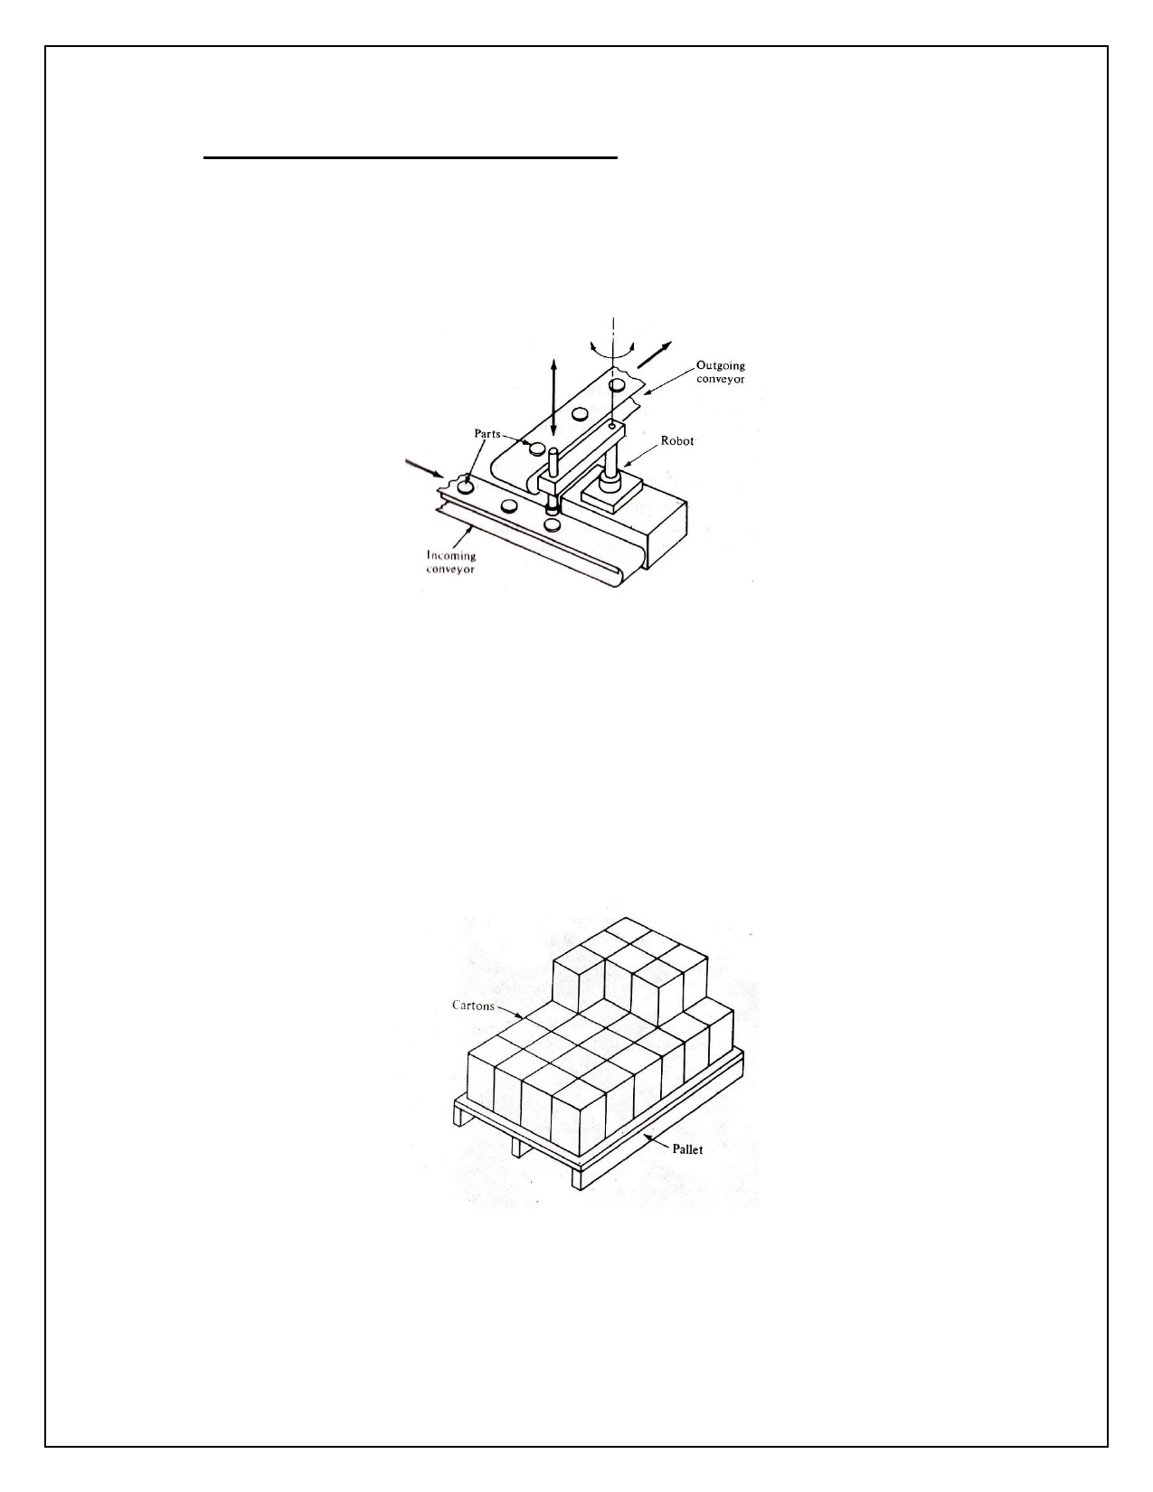

➢ **MATERIAL TRANSFER APPLICATIONS OF ROBOT:**

Material transfer applications are defined as operations in which the primary objective is to move a part

from one location to another location. They are usually considered to be among the most straightforward of robot applications to implement.

**Pick-and-Place Operations:**

In pick and-place operation, the robot pick up the part at one location and moves it to another location. The part is available to the robot by mechanical feeding device or belt conveyor in a known location and orientation. A simple limit switch is used to stop the component to allow the part to grasp by robot pick

up, move with part and position the part at a desired location. The orientation of the part remains

unchanged during the travelling. The basic operation are shown in figure. In this case, 2 DOF is involved, one degree of freedom is required to lift the component from pickup point and put it down at the drop-

off point and second! DOF is needed to move the part between these two positions. In some cases, a reorientation of the component is accomplished during the move period.

**Palletizing and related operations:**

In material transfer application of robot, the use of pallets for material handling and storage is done.

Large number of containers are placed on a pallet for material handling and storage is done. Large

number of containers are placed on a pallet, instead of handling instead of handling individual cartons. The pallets are moved mechanically within the manufacturing plant or warehouse by fork lift trucks or



conveyors. The only handling of the individual cartons arises when the component is placed onto the

pallet or when it is removed from the pallet. The loading of cartons onto pallets is typically heavy work performed manually by unskilled labour. A typical pallet configuration is shown configure below. Each

carton is placed at a different location on the pallet, the variation in carton location is in three dimensions. The pallets are usually stacked on top of each other in layers as shown in figure.

**MACHINE LOADING AND UNLOADING OF ROBOT:-**

These applications are material-handling operations in which the robot is us to service a production

machine by transferring parts to and/or from the machine. There are three cases that tit into this

application category:

**Machine load/unload:** The robot loads a raw workpart into the process and unloads a finished part. A machining operation is an example of this case.

**Machine loading:** The robot must load the raw workpart or materials into if machine but the part is

ejected from the machine by some other means a press working operation the robot may be

programmed to load metal blanks into the press but the finished parts are allowed to drop out of the press by gravity.

**Machine unloading:** The machine produces finished parts from raw material that are loaded directly

into the machine without robot assistance. The robot unloads the part from the machine. Examples in this category include die casting and plastic modeling applications.

Robots have been successfully applied to accomplish the loading and/or unloading function in the

following production operations:

1. Die casting

2. Plastic molding

3. Forging and related operations

4. Machining operations

5. Stamping press operations

**1. Die casting:**

Die casting is a manufacturing process in which molten metal is forced into the cavity of a mold under high pressure. The mold is called a die (hence the name, die casting). The process is used to cast metal

parts with sufficient accuracy so that subsequent finishing operations are usually not required. Common metals used for die-casted parts include alloys of zinc, tin, lead, aluminum, magnesium, and copper.

The die consists of two halves that are opened and closed by a die casting machine. During operation

the die is closed and molten metal is injected into the cavity by a pump. To ensure that the cavity is

filled, enough molten metal is forced into the die that it overflows the cavity and creates "flash" in the

space between the die halves. When the metal has solidified, the die is opened and the cast part is

ejected, usually by pins which push the part away from the mold cavity. When the part is removed from



the machine, it is often quenched (to cool the part) in a water bath. The flash that is created during the

casting process must be removed subsequently by a trimming operation which cuts around the

periphery of the part. Thus, the typical die-casting production cycle consists of casting, removing the part from the machine, quenching, and trimming.

The production rates in the die-casting process range from about 100 up to 700 openings of the die per hour, depending on type of machine, the metal being cast, and the design of the part.

The die-casting process represents a relatively straightforward application for industrial robots.

**2. Plastic Molding:**

Plastic molding is a batch-volume or high-volume manufacturing process used to make plastic parts to

final shape and size. The term plastic molding covers a number of processes, including compression

molding, injection molding, thermoforming, blow molding, and extrusion. Injection molding is the most

important commercially, and is the process in this group for which robots are most often used. The

injection-molding operation is quite similar to die casting except for the differences in materials being

processed. A thermoplastic material is introduced into the process in the form of small pellets or

granules from a storage hopper. It is heated in a heating chamber to 200 to 300 C to transform it into semifluid (plastic) state and injected into the mold cavity under high pressure. The plastic travels from the heating chamber into the part cavity through a sprue-and-runner network that is designed into the

mold. If too much plastic is injected into the mold Hash is created where the two halves of the mold come together. If too little material is injected into the unacceptable. When the plastic material has hardened sufficiently the mold opens and the part(s) are removed from the mold.

**3. Forging and related operations:**

Forging is a metalworking process in which metal is pressed or hammered into the desired shape. It is

one of the oldest processes and derived from the kinds of metalworking operations performed by

blacksmiths in ancient times. It is most commonly performed as a hot working process in which the

metal is heated to a high temperature prior to forging. It can also be done as a' cold working process.

Cold forging adds considerable strength to the metal and is used for high-quality products requiring this property such as hand tools (e.g., hammers and wrenches). Even in #hot forging, the metal flow induced by the hammering process adds strength to the formed part.

**4. Machining operations:**

Machining is a metal working process in which the shape of the part is changed by removing excess

material with a cutting tool. It is considered to be a secondary process in which the final form and

dimensions are given to the part after a process such as casting or forging has provided the basic shape

of the part. There are a number of different categories of machining operations. The principal types include turning, drilling, milling, shaping, planing, and grinding.

The machine tools that perform machining operations have achieved a relatively high level of

automation after many years of development. In particular the use of computer control (e.g., computer

numerical control and direct numerical control) permits this type of equipment to be interfaced with relative ease to similarly controlled equipment such as robots.



Robots have been successfully utilized to perform the loading and unloading functions in machining operations. The robot is typically used to load a law workpart (a casting, forging, or other basic form) into the machine tool and to unload the finished part at the completion of the machining cycle.

The following robot features generally contribute to the success of the machine tool load/unload

application:

**Dual gripper:** The use of a dual gripper permits the robot to handle the raw workpart and the finished part at the same time. This permits the production cycle time to be reduced.

**Up to six joint motions:** A large number of degrees of freedom of the arm and wrist are required to manipulate and position the part in the machine tool.

**Good repeatability:** A relatively high level of precision is required to properly position 'the part into the chuck or other work holding fixture in the machine tool.

**Palletizing and depalletizing capability:** In mid volume production, the raw parts are sometimes most

conveniently presented to the workcell and delivered away from the workcell on pallets. The robot's controller and programming capabilities must be sufficient to accommodate this requirement.

**Programming features:** There are several desirable programming features that facilitate the use of

robots in machining applications. In machine cells used for batch production of different parts, there is

the need to perform some sort of changeover of the setup between batches. Part of this changeover procedure involves replacing the robot program for the previous batch with the program for the next

batch. The robot should be able to accept disk, tape, or other storage medium for ease in changing programs. Another programming feature needed for machining is the capability to handle irregular elements, such, as tool changes or pallet changes, in the program.

**5. Stamping press operations:**

Stamping press operations are used to cut and form sheet metal parts. The process is performed by

means of a die set held in a machine tool called a press (or stamping press). The sheet metal stock used

as the raw material in the process comes in several forms, including coils, sheets, and individual flat

blanks. When coil stock is fed into the press, the process can be made to operate in a highly automated

manner at very high cycle rates. When the starting material consists of large flat sheets or individual blanks, automation becomes more difficult. These operations have traditionally been performed by

human workers, who must expose themselves to considerable jeopardy by placing their hands inside the press in order to load the blanks. During the last decade, the Occupational Safety and Health Act (OSHA)

has required certain alterations in the press in order to make its operation safer. The economics of the

OSHA requirements have persuaded many manufacturers to consider the use of robots for press loading

as alternatives to human operators. Noise is another factor which makes press working an unfriendly environment for humans.

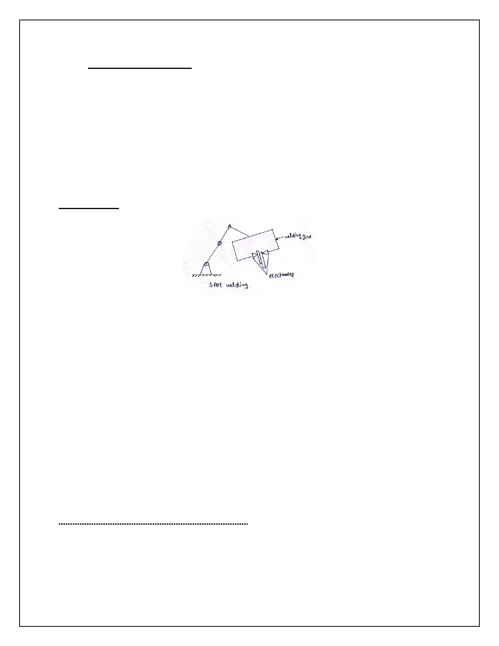

➢ **PROCESSING OPERATIONS:-**

In processing operations, the robots uses a tool as end effector to accomplish some processing

operations on a work part. Manipulates the tooling relative to the working part during the cycle.

In processing operation, the robot performed by the following categories:

1. Spot welding

2. Continuous arc welding

3. Spray coating

4. Other processing operations.

**1. Spot welding:**

As the term suggests, spot welding is a process in which two sheet metal parts are fused together at

localized points by passing a large electric current through the parts where the weld is to be made. The fusion is accomplished at relatively low voltage levels by using two copper (or copper alloy) electrodes to squeeze the parts together at the contact points and apply the current to the weld area. The electric

current results in sufficient heat in the contact area to fuse the two metal parts, hence producing the weld.

Spot welding has traditionally been performed manually by either of two methods. The first method uses a spot-welding machine in which the parts are inserted between the pair of electrodes that are

maintained in a fixed position. This method is normally used for relatively small, parts that can be easily handled.

The second method involves manipulating a portable spot-welding gun into position relative to the

parts. This would be used for larger work such as automobile bodies. The word "portable" is perhaps an

exaggeration. The welding gun consists of the pair of electrodes and a frame to open and close the

electrodes. In addition, large electrical cables are used to deliver the current to the electrodes from a

control panel located near the workstation. The welding gun with cables attached is quite heavy and can easily exceed 100 lb in weight.

**Capabilities and features of robot in spot welding:-**

i. The robot must be relatively large.

ii. It must be sufficient payload capacity.

iii. The work volume must be adequate for the size of the product.

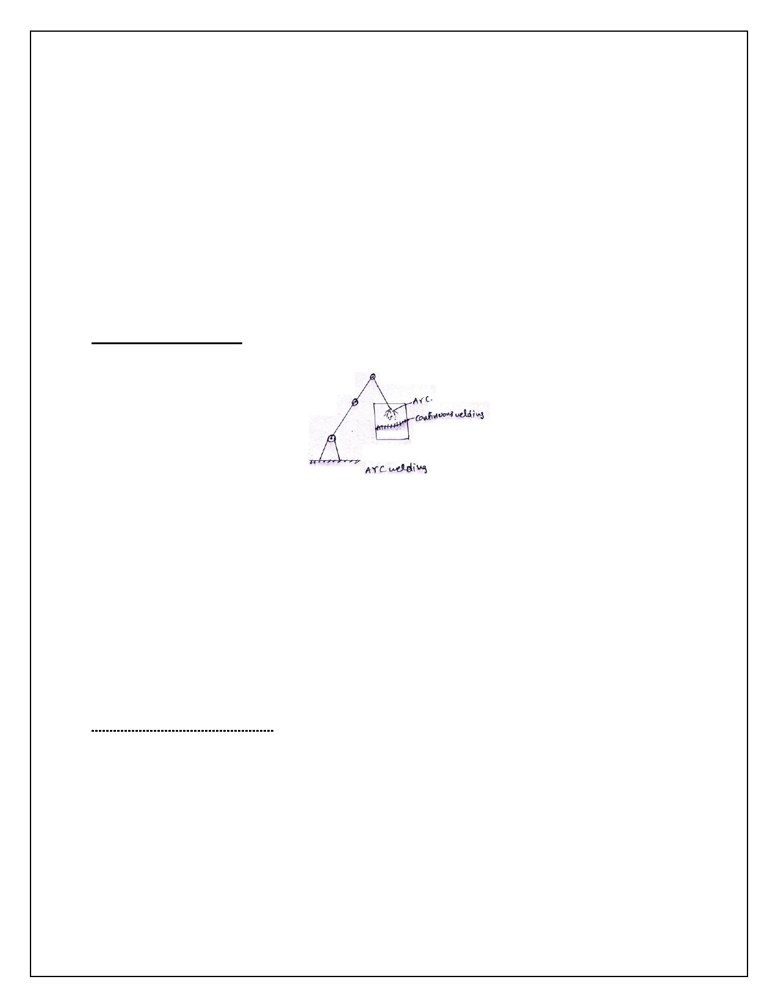

iv. It should have increase number of DOF

v. The controller memory must have enough capacity to accomplish the many positioning steps required for the spot welding.

vi. The robot must be able to switch from one program holding sequence to another as the model change.

**Benefits of robot in spot welding:**

i. Improved production quality

ii. Operator safety

iii. Better control over the production.

**2. Continuous arc welding**

Arc welding is a continuous welding process as opposed to spot welding which might be called a

discontinuous process. Continuous arc welding is used to make long welded joints in which an airtight seal is often required between the two pieces of metal being joined. The process uses an electrode in the form of a rod or wire of metal to supply the high electric current needed for establishing the arc. Currents are typically 100 to 300A at voltages of 10 to 30 V. The arc between the welding rod and the

metal parts to be joined produces temperatures that are sufficiently high to form a pool of molten metal

to fuse the two pieces together. The electrode can also be used to contribute to the molten pool, depending on the type of welding process.

The high temperatures created in arc welding and the resulting molten metals are inherently dangerous. The high electrical current used to create the arc is also unsafe; Sparks and smoke are generated during the process and these are a potential threat to the operator.

**Features of the Welding Robot:**

**i. Work volume and degrees of freedom:** The robot's work volume must be large enough for the sizes of the parts to be welded.

**ii. Motion control system:** Continuous-path control is required for are welding. The robot must be capable of a smooth continuous motion in order to maintain uniformity of the welding seam.

**iii. Precision of motion:** The accuracy and repeatability of the robot determines to a large extent the quality of the welding job.

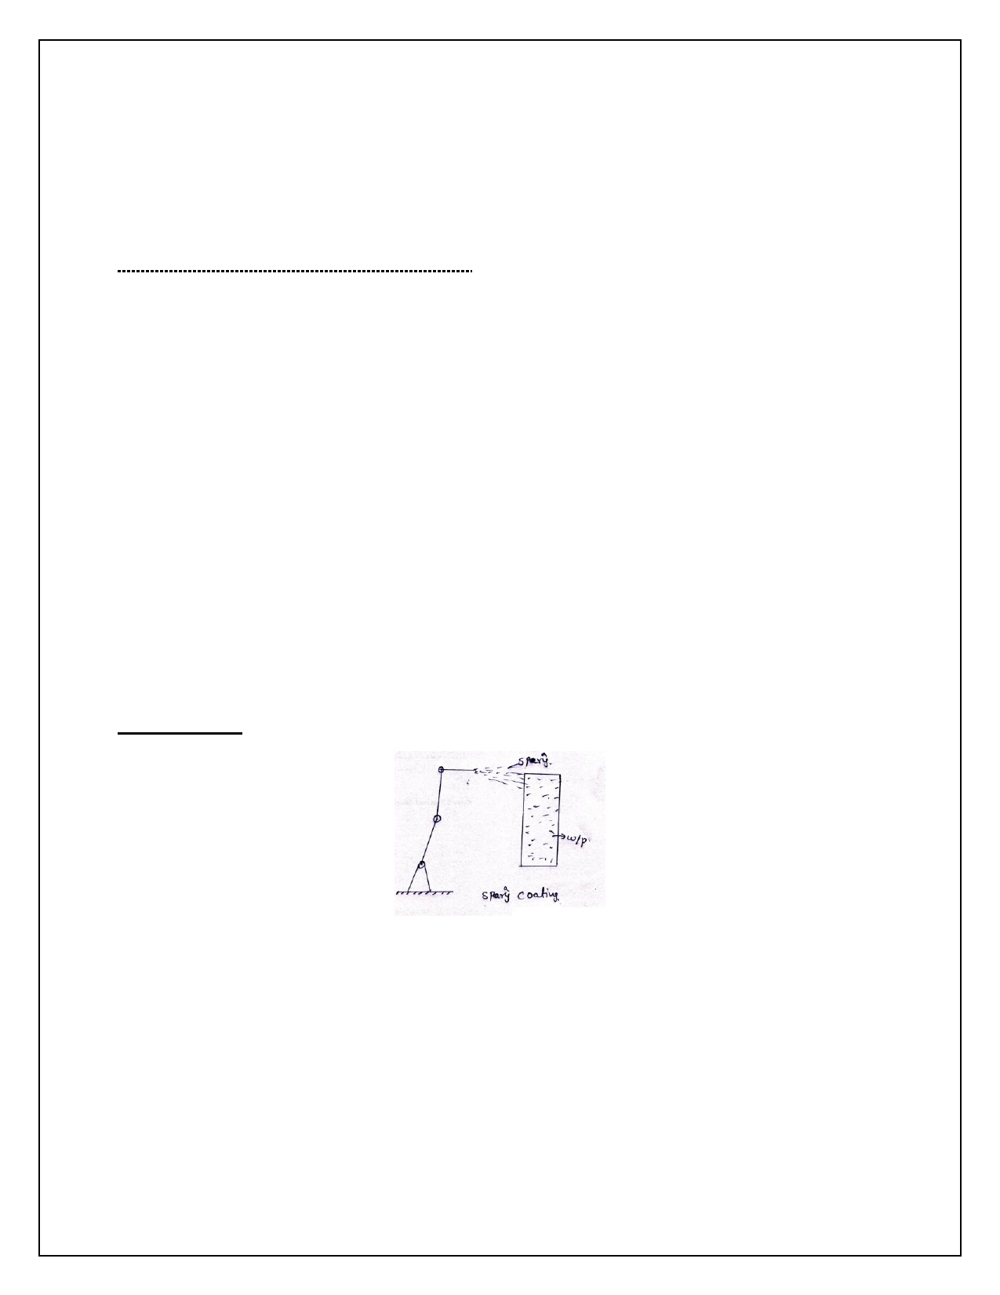

**iv. Interface with other systems:** The robot must be provided with sufficient input/output and control capabilities to work with the other equipment in the cell.

**v. Programming:** Programming the robot for continuous arc welding must be considered carefully.

**Advantages and Benefits of Robot Arc Welding:**

A robot arc-welding cell for batch production has the potential for achieving a number of advantages

over a similar manual operation. These advantages include the following:

1. Higher productivity

2. Improved safety and quality-of-work life

3. Greater quality of product

4. Process rationalization.

**Sensors in Robotic Arc -Welding:**

The robotic arc-welding sensor systems considered here are all designed to track the welding seam and provide information to the robot controller to help guide the welding path. The approaches used for this purpose divide into two basic categories: contact and noncontact sensors. There are two types of sensor

systems,

i) Contact arc-welding sensors

ii) Noncontact arc-welding sensors.

**3. Spray coating:**

Most products manufactured from metallic materials require some form of painted finish before

delivery to the customer. The technology for applying these finishes varies in complexity from simple

manual methods to highly sophisticated automatic techniques. We divide the common industrial coating

methods into two categories:

1. Immersion and How-coating methods

2. Spray-coating methods.

Immersion and flow-coating methods are generally considered to be low-technology methods of

applying paint to the product. Immersion involves simply dipping the part or product into a tank of liquid



paint. When the object is removed, the excess paint drains back into the tank. The tanks used in the

process can range in size from 1 or 2 gallons for small objects to thousands of gallons for large fabricated metal pr0ducts.

The second major category of industrial painting is spray coating. This method involves the use of spray guns to apply the paint or other coating to the object. Spray painting is typically accomplished by human

workers who manually direct the spray at the object so as to cover the desired areas. The paint spray

systems come in various designs, including conventional air spray, airless spray, and electrostatic spray.

In general, the requirements of the robot for spray-coating applications are the following:

1. Continuous-path control

2. Hydraulic drive

3. Manual lead through programming

4. Multiple program storage.

**Benefits oi Robot Spray Coating:**

1. Removals of operators from hazardous environment

2. Lower energy consumption

3. Consistency of finish

4. Reduced coating material usage

5. Greater productivity.

**4. OTHER PROCESSING OPERATIONS USING ROBOTS:**

In addition to spot welding, arc welding, and spray coating, there are a number of other robot

applications which utilize some form of specialized tool as the end effector. Operations which are in this

category include:

Drilling, routing, and other machining operations,

Grinding, polishing, deburring, wire brushing, and similar operations,

Riveting,

Waterjet cutting,

Laser drilling and cutting.

➢ **Assembly operations:**

The term assembly is defined here to mean the fitting together of two or more discrete parts to form a

new subassembly. The assembly operations are,

1. Parts presentation methods

2. Assembly tasks

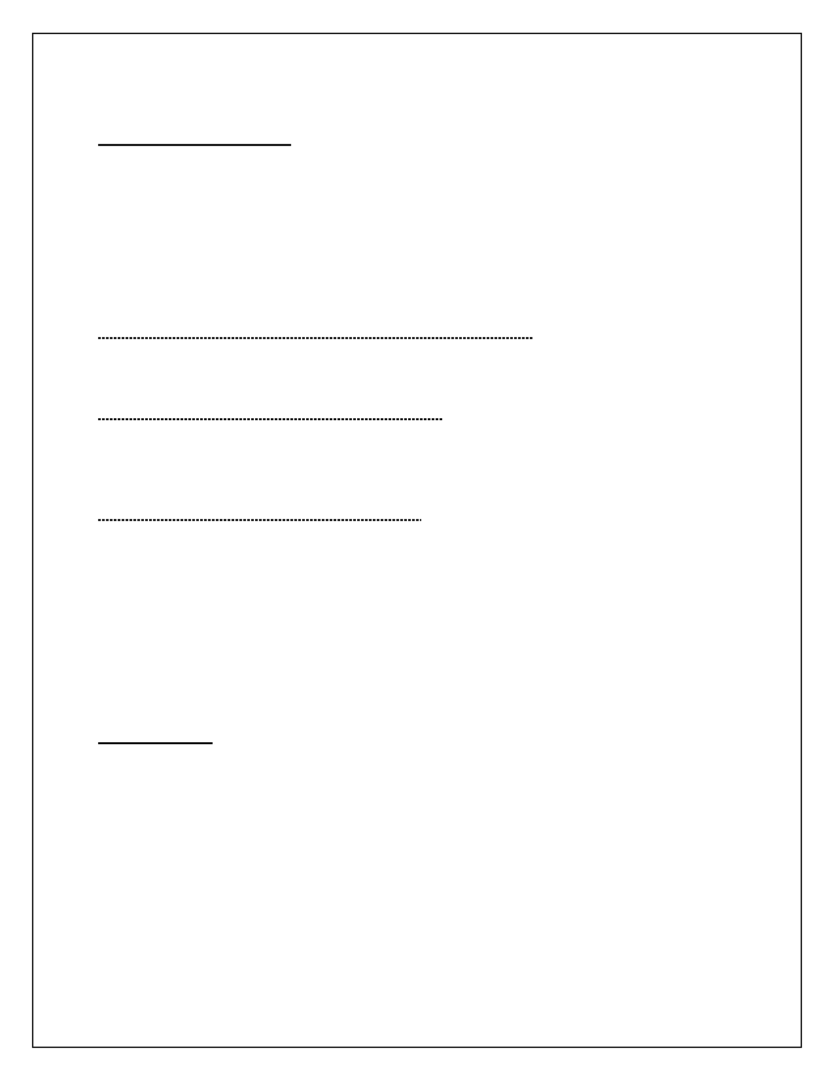

3. Assembly cell designs.

**1. Parts presentation methods:**

In order for a robot to perform an assembly task, the part that is to be assembled must be presented to

the robot. There are several ways to accomplish this presentation function, involving various levels of

structure in the workplace:

i) Parts located within a specific area (parts not positioned or oriented)

ii) Parts located at a known position (parts not oriented)

iii) Parts located in a known position and orientation.

i) Parts located within a specific area (parts not positioned or oriented):

In this case, the robot is required to use some form of sensory input to guide it to the part location and to pick up the part.

ii) Parts located at a known position (parts not oriented):

In the second case, the robot would know where to go to get the part, but would then have to solve the orientation problem. This might require the robot to perform an additional handling operation to orient the part.

iii) Parts located in a known position and orientation:

The third way of presenting the part to the robot (known position and orientation) is the most common method currently used, and is in fact the method used in automatic assembly that precedes the advent of robotics.

There are a number of methods for presenting parts in a known position and orientation, they are

i. Bowl feeders

ii. Magazine feeders

iii. Trays and pallets

**2. Assembly tasks:**

Assembly operations can be divided into two basic categories:

i. parts mating and

ii. parts joining.

**i) parts mating :**

In parts mating, two (or more) parts are brought into contact with each other.

The variety of parts mating operations include the following assembly situations:

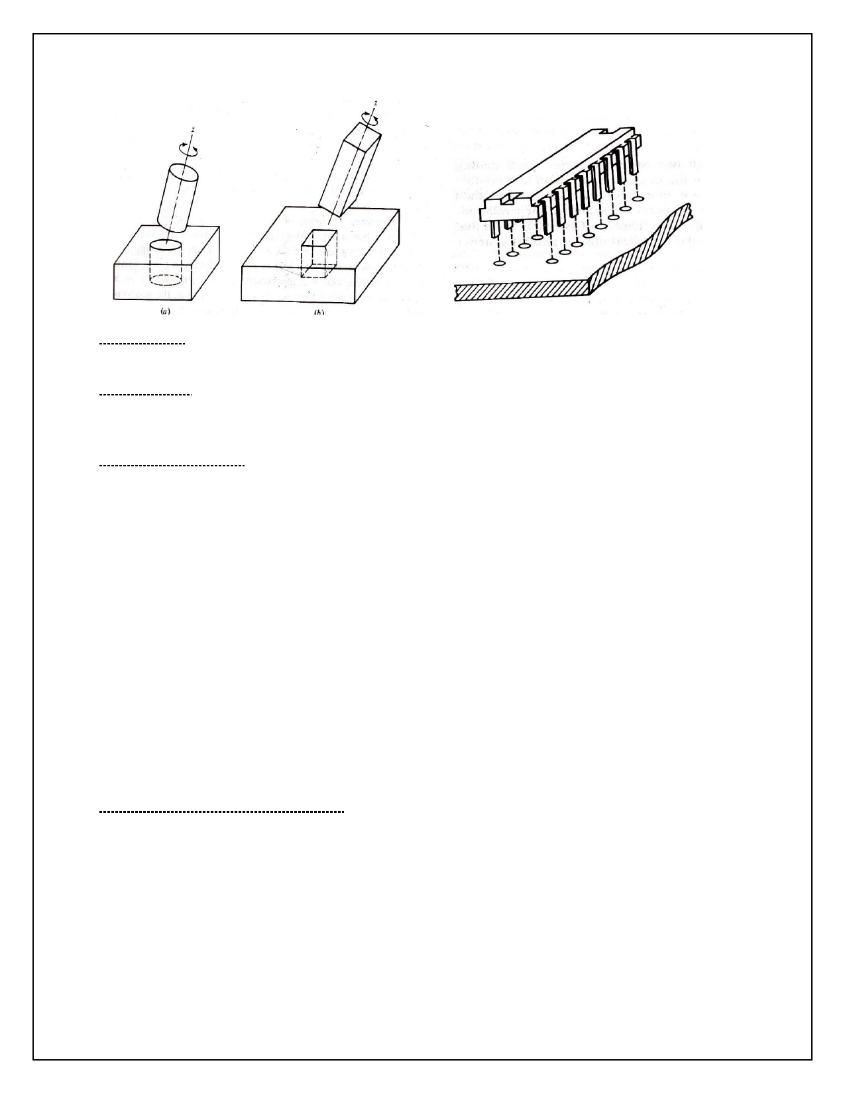

I. Peg-in-hole. This operation involves the insertion of one part (the peg) into another part (the hole). It represents the most common assembly task.

II. Hole-on-peg. This is a variation of the peg-in-hole task. Similar problems exist in defining the degrees

of freedom needed to execute the mating of the two parts. A typical example of the hole-on-peg task would be the placement of a bearing or gear onto a shaft.

III. Multiple peg-in-hole. This is another variation on case 1 except that one.

**ii) parts joining:**

In parts joining, two (or more) parts are mated and then additional steps are taken to ensure that the parts will maintain their relation- ship with each other.

The possible joining operations include the following:

I.

II.

III. IV. V.

VI.

VII.

VIII.

Fastening screws

Retainers Press fits Snap fits

Welding and related joining methods

Adhesives Crimpling Sewing.

**ASSEMBLY SYSTEM CONFIGURATIUNS:**

There are two basic configurations of assembly systems, a single workstation, and a series of workstations (an assembly line). Combinations of these two basic types are also possible.

**Single-Workstation Assembly:**

In this configuration all of the parts which are required to complete the desired assembly are presented

to the operator or robot at a single workstation. All of the parts mating and joining tasks for the

assembly are accomplished at the single workstation. In manual assembly, this configuration is generally used for low-volume products (e.g., custom-engineered machinery). In robotic assembly, the conditions

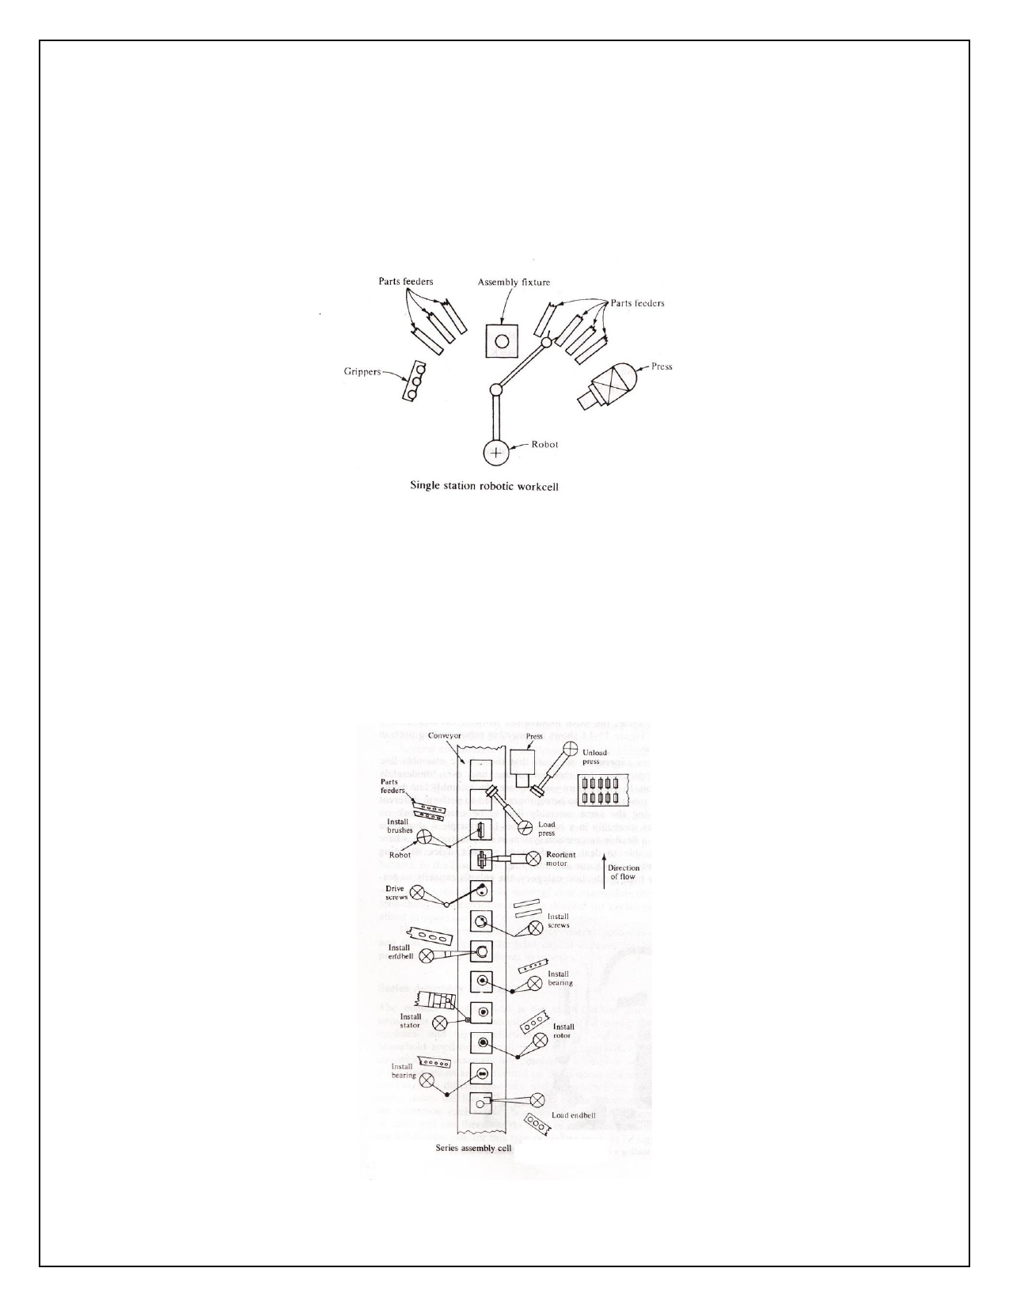

warranting the use of this configuration are different from those for manual assembly. A single-station

robotic assembly system would typically be used for low- and medium-volume work in which there were

a limited number of assembly tasks and parts to be handled. This means that the product is of low to

medium complexity. The features and problems of this configuration are illustrated by means of an example.

**Series Assembly Systems:**

The manual assembly line is the most familiar assembly configuration. It constitutes the series assembly

system. This configuration is used in many medium- and high-production assembly situations, such as

automobiles, household appliances, small power tools, and other products made in large quantities. The

assembly line consists of a series of workstations at which only a few operations are performed on the product at each station. Each station is working on a different product, and the products are gradually built up as they move down the line.

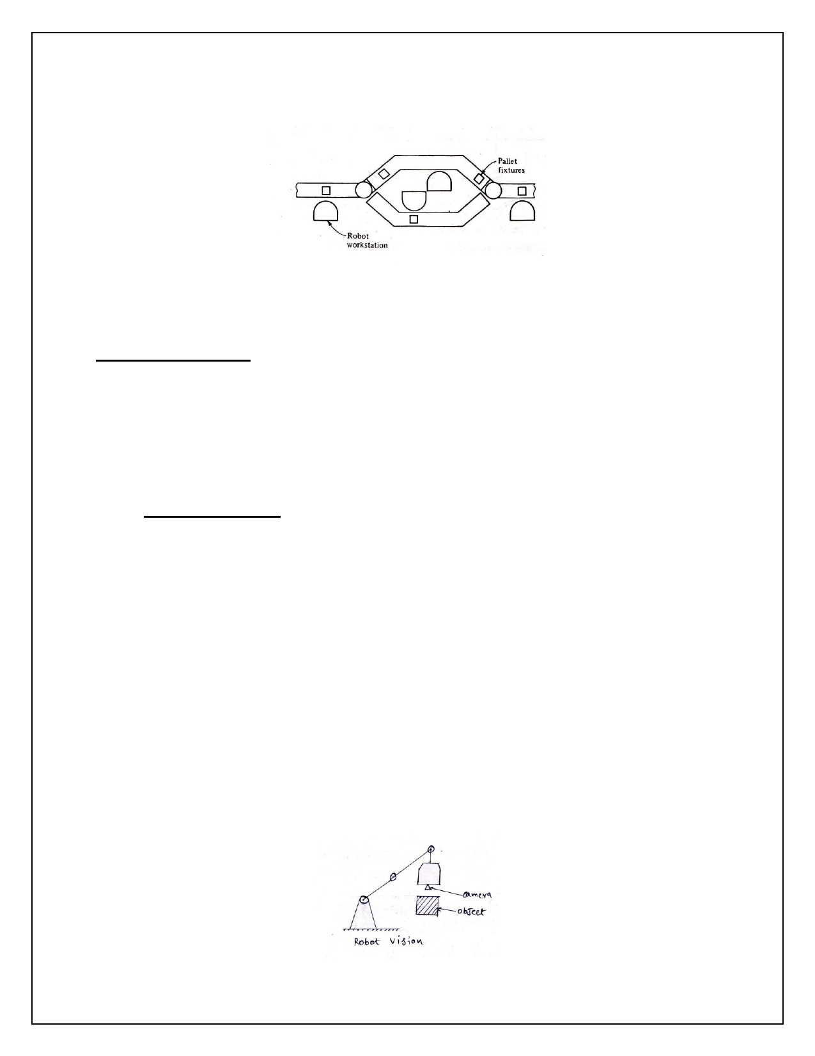

**Parallel Assembly Systems:**

The concept of a parallel arrangement in a robotic workcell is pictured in Fig. In essence the work can take either of two (or more) routes to have the same operations performed. There are two conditions under which parallel workstations would normally be considered.

**3. Assembly cell designs:-**

Certain assembly tasks are more difficult for a robot to perform than others. If possible, this difficulty factor should be considered in the design of the product. As an example, for a robot to accomplish the

screw-fastening operation without the use of an automatic screwdriver is difficult. Even with a powered

device to perform the operation, the process of turning the screw into the part requires time. If the objective of using a threaded fastener is to allow for subsequent disassembly (e.g., for service of the product), then the use of screws may be an appropriate design decision.

➢ **Inspection operations:**

Inspection is a quality control operation that involves the checking of parts, assemblies, or products for

conformance to certain criteria generally specified by the design engineering department. The

inspection function is commonly done for incoming raw materials at various stages of the production

process, and at the completion of manufacturing prior to shipping the product. Testing is another quality

control operation often associated with inspection. The distinction between the two terms is that testing normally involves the functional aspects of the product, such as testing to ensure that the product operates properly, fatigue testing, environmental testing, and similar procedures.

Robotics can be used to accomplish inspection or testing operations for mechanical dimensions and

other physical characteristics, and product function and performance. Generally the robot must work with other pieces of equipment in order to perform the operations. Examples include machine vision

systems, robot manipulated inspection and/or testing equipment, and robot loading and unloading

operation with automatic test equipment. The following subsections will discuss these three categories of robotic inspection systems.

**Vision Inspection Systems:**



Machine vision as a sensor in robotics was discussed in Chap. Some of the robotic applications of vision

systems include part location, parts identification, and bin picking. Machine vision can also be used to

implement a robotic inspection system. Typical robotic vision systems are capable of analyzing two-

dimensional scenes by extracting certain features from the images. Examples of inspection tasks carried out by this procedure include dimensional accuracy, surface finish, and completeness and correctness of an assembly or product.

**Robot-Manipulated Inspection or Test Equipment:**

This method of robotic inspection involves the robot moving an inspection or testing device around the

part or product. An example would be for a robot to manipulate an electronic inspection probe or a

laser probe along the surface of the object to be measured. As long as the accuracy of the measurement is not required to exceed the repeatability of the robot, the approach is feasible.

**Robot-Loaded Test Equipment:**

The third application area in robotic inspection is loading and unloading inspection and testing

equipment. This application is very similar to machine tool loading/unloading. There are various types of

inspection and testing equipment that can be loaded by a robot. These include mechanical, electrical, and pnemnatic gauges, and functional testing devices.