**UNIT-4**

**NUCLEAR POWER PLANT**

**Introduction**

As large amounts of coal and petroleum are being used to produce energy, time may come when their reserves may not be able to meet the energy requirements. Thus there is tendency to seek alternative sources of energy. The discovery that energy can be liberated by the nuclear fission of materials like uranium (U), Plutonium (Pu), has opened up a new source of power of great importance. The heat produced due to fission of U and Pu is used to heat water to generate steam which is used for running turbogenerator.

It has been found that one kilogram of U can produce as much energy as can be produced by burning 4500 tonnes of high grade coal. This shows that nuclear energy can be successfully employed for producing low cost energy in abundance as required by the expanding and industrializing population of future.

Some of the factors which go in favor of nuclear energy are as follows:

1. Hydro electric power is of storage type and is largely dependent of monsoons. The systems getting power from such plants have to shedload during the period of low rainfall.

2. Oil is mainly needed for transport, fertilizers and petrochemicals and thus cannot be used in large quantities for power generation.

3. Coal is available only in some parts of the country and transportation of coals requires big investments.

4. Nuclear power is partially independent of geographical factors, the only requirement being there should be reasonably good supply of water. Fuel transportation networks and larger storage facilities are not needed and nuclear power plant is a clean source of power which does not pollute the air if radioactive hazards are effectively prevented.

5. Large quantity of energy is released with consumption of only a small amount of fuel.

**Nuclear fission**

 The fuel inside the reactor is a metal called uranium. Uranium exists as an isotope in the form of U235

, U 234 and U238 . Out of these isotopes U235 is more unstable. When a neutron is captured by a nucleus of an atom of U 235 , it splits up roughly into two equal fragments and about 2.5 neutrons are released and a large amount of energy (nearly 200 million electron volts(MeV) is produced. This is called fission process. The neutrons so produced are very moving neutrons and can be made to fission other nuclei of U 235 thus enabling a chain reaction to take place. When a large number of fission occurs, enormous amount of heat is produced. The following fig. .shows the chain reaction.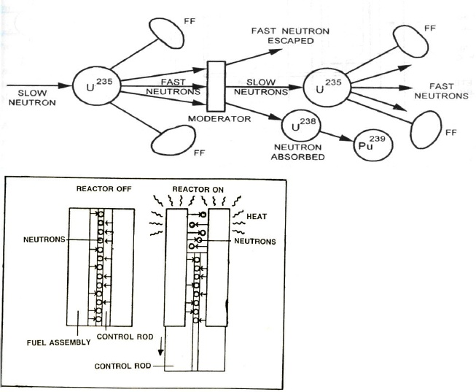

  It may be observed from the fig. that 2.5 neutrons are released in fission of each nucleus of U 235 , out of these one neutron is used to sustain the chain reaction, 0.9 neutrons is absorbed by U 238 and becomes Pu 239 . The remaining 0.6 neutrons escape from the reactor. Moderators are provided to slow down the neutrons from the high velocities but not to absorb them. The moderators which are commonly used are ordinary water and Heavy water.

Control rods limit the number of fuel atoms that can split. They are made up of a material that absorbs neutrons. To turn on the reactor some rods are pulled out. The rods are made of boron or cadmium.

**Main components of a nuclear power plant**

 The main components of a nuclear power plant are

• Nuclear fuel

• Nuclear reactor

• Steam generator

• Moderator

• Control rods

• Reflector

• Turbine

• Condenser

• Shielding

**Nuclear Fuel:**

Fuel of a nuclear reactor should be fissionable material which can be defined as an element or isotope whose nuclei can be caused to undergo nuclear fission by nuclear bombardment and to produce a fission chain reaction. It can be one or all of the following U 235

, U 233 and Pu 239

**Nuclear reactor:**

A nuclear reactor may be regarded as a substitute for the boiler furnace of a steam power plant. Heat is produced in the reactor due to nuclear fission of the fuel. During the fission process, the large amount of heat is liberated. This large amount of heat is absorbed by the coolant and it is circulated through the core. The various types of reactors used in nuclear power plant is1.Boiling water reactor2.Pressurised water reactor3.Fast breeder reactor

**Steam generator(Heat Exchanger)**:

 The heat liberated in the reactor is taken up by the coolant circulating through the core. The purpose of the coolant is to transfer the heat generated in the reactor core and use it for steam generation. Ordinary water or heavy water is a common coolant.

**Moderator**:

It is used to reduce the kinetic energy of fast neutrons into slow neutrons and to increase the probability of chain reaction. Graphite, heavy water and beryllium are generally used as moderator. A moderator should possess the following properties:

1. It should have high thermal conductivity

2. It should be available in large quantities in pure form

3. It should have high melting point in case of solid moderators and low melting point in case of liquid moderators. Solid moderators should also possess good strength and machinability

4. It should provide good resistance to corrosion

5. It should be stable under heat and radiation6.It should be able to slow down neutrons

**Control rods:**

 They regulate the rate of a chain reaction. They are made of boron, cadmium or other elements which absorb neutrons. Control rods should posses the following properties:1.They should have adequate heat transfer properties2.They should be stable under heat and radiation3.They should be corrosion resistant4.They should be sufficient strong and should be able to shut down the reactor almost instantly under all conditions.5.They should have sufficient cross sectional area for the absorption.

**Reflector:**

 The neutrons produced during the fission process will be partly absorbed by the fuel rods, moderator, coolant or structural material etc.Neutrons left unabsorbed will try to leave the reactor core and will be lost. Such loss is minimized by surrounding the reactor core by a material called reflector which will send the neutrons back into the core. The returned neutrons can then cause more fission and improve the neutrons economy of the reactor. Generally the reflector is made up of graphite and beryllium.

**Turbine:**

 The steam produced in the steam generator is passed to the turbine. Work is done by the expansion of stem in the turbine.

**Condenser:**

 The exhaust steam from the turbine flows to the condenser where cooling water is circulated. The exhaust steam is condensed to water in the condenser by cooling. The condensate is pumped again into the steam generator by the feed pump.

**Shielding:**

 The reactor is a source of intense radioactivity. These radiations are very harmful and shielding is provided to absorb the radioactive rays. A thick concrete shielding and a pressure vessel are provided to prevent the radiations escaped to atmosphere.

**Working of a Nuclear Power plant**

 The reactor of a nuclear power plant is similar to the furnace of steam power plant. The heat liberated in the reactor due to the nuclear fission of the fuel is taken up by the coolant circulating through the reactor core. Hot coolant leaves the reactor at top and then flows through the tubes of steam generator (boiler) and passes on its heat to the feed water. The steam produced is passed through the turbine and after work has been done by expansion of steam in the turbine, steam leaves the turbine and flows to condenser. Pumps are provided to maintain the flow of coolant, condensate and feed water.

**TYPES OF NUCKEAR REACTORS:**

**Boiling water reactor (BWR):**

In this reactor, enriched uranium (enriched uranium contains more fissionable isotope U235 than the naturally occurring percentage 0.7% as nuclear fuel and water is used as coolant. Water enters the reactor at the bottom. It takes up the heat generated due to the fission of fuel and gas converted into steam. Steam leaves the reactor at the top and flows into the turbine. Water also serves as moderator. India’s first nuclear power plant at Tarapur has two reactors (each of 200 MW capacity) of boiling water reactor type.

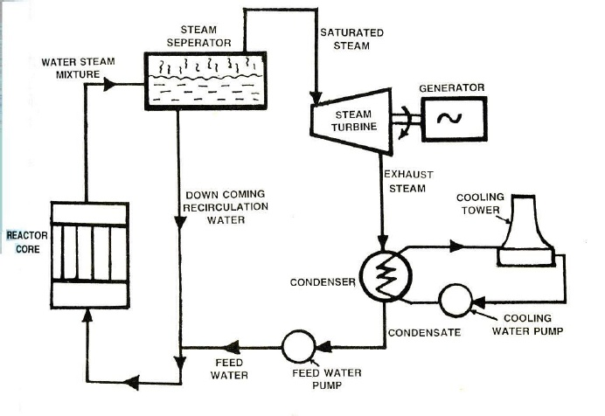

**Fig.BOILING WATER REACTOR**

**Pressurised Water reactor (PWR):**

Pressurised Water Reactor is a pressurised water nuclear plant is shown in fig. It uses enriched uranium as fuel. Water is used as coolant and moderator. Water passes through the reactor core and takes up the heat liberated due to nuclear fission of the fuel. In order that water may not boil (due to its low boiling point 212 0 F at atmospheric conditions) and remain in liquid state, it is kept under a pressure of about 1200 p.s.i.g in the pressuriser. This enables water to take up more heat from the reactor. From the pressuriser, water flows to the steam generator where it passes on its heat to the feed water which in turn gets converted into steam.

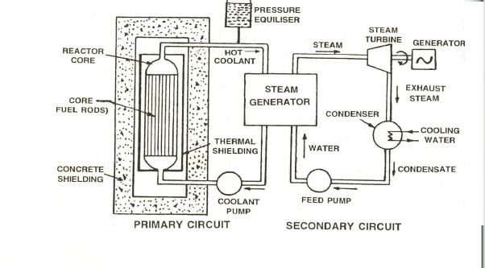

**Fast breeder reactor (FBR):**

In this reactor the core containing U 235 is surrounded by a blanket (layer of fertile material placed outside the core) or fertile material U 238 . In this reactor no moderator is used. The fast moving neutrons liberated due to fission of U 235 are absorbed by U 238which gets converted into fissionable material Pu 239 , Pu 239 is capable of sustaining chain reaction. Thus the reactor is important because it breeds fissionable material from fertile material U 238 available in large quantities. This reactor uses two liquid metal coolant circuits. Liquid sodium is used as primary coolant when circulated through the tubes of intermediate heat exchanger transfer its heat to secondary coolant sodium potassium alloy. The secondary coolant while flowing through the tubes of steam generator, transfer its heat to feed water. Fast breeder reactors are better than conventional reactor both from the point of view of safety and thermal efficiency. For India which already is fast advancing towards self reliance in the field of nuclear power technology the fast breeder reactor becomes inescapable in view of the massive reserves of thorium and the finite limits of its uranium resources.

**Advantages of nuclear power plant**

1. The fuel used in nuclear power plant is uranium; it does not release chemical or solid pollutants into the air during use.

2. Space required is less when compared with other power plants.

3. Fuel consumption is very less.

4. Fuel transportation cost is low and no large storage area for fuel is required.

5. The plant is not affected by weather conditions. The plant can function throughout the year (Hydel power plants depends on monsoon)

6. By using nuclear fuel we can conserve the fossil fuels like coal, oil, gas etc for other purposes. For example coal can be used to power steam engines, oil can be used for running vehicles, and gas be used for cooking.

7. Number of workers required is less.

8. Nuclear power plant is the only source which can meet the increasing demand of electricity.

9.A nuclear power plant uses much less fuel than a fossil fuel plant 1 metric ton of uranium fuel = 3 million metric tons of coal = 12 million barrels of oil

**Disadvantages of nuclear power plant**

1. Nuclear plants cost more to build than thermal or hydro electric power plants of the same capacity.
2. Radioactive wastes must be disposed carefully; otherwise it will adversely affect the health of workers and the environment as awhole.
3. Maintenance cost of the plant is high.
4. Not suitable for varying load conditions
5. Well trained persons are required to operate the plant.

**Nuclear power stations in India**

• Tarapur Nuclear power station (Bombay) – Boiling water reactor –200 MW

• Rana Pratap Sagar Nuclear power station (Kota in Rajasthan) – Two200 MW

• Kalpakkam Nuclear power station – Two 235 MW – Pressurised water reactor

• Narora Nuclear power station (Uttar Pradesh) – Two 235 MW –CANDU reactor 30

  • Kakarpur Nuclear power plant (Gujarat) – 4 235 MW CANDU type reactor 31.