UNIT-III

MARKET AND NEW ECONOMIC ENVIRONMENT

Introduction

Pricing is an important, if not the most important function of all enterprises. Since every enterprise is engaged in the production of some goods or/and service. Incurring some expenditure, it must set a price for the same to sell it in the market.

Price

Price denotes the exchange value of a unit of good expressed in terms of money. Thus the current price of a maruti car around Rs. 2,00,000, the price of a hair cut is Rs. 25 the price of a economics book is Rs. 150 and so on. Nevertheless, if one gives a little, if one gives a little thought to this subject, one would realize that there is nothing like a unique price for any good. Instead, there are multiple prices.

Price concepts

Price of a well-defined product varies over the types of the buyers, place it is received, credit sale or cash sale, time taken between final production and sale, etc.

The multiple prices is more serious in the case of items like cars refrigerators, coal, furniture and bricks and is of little significance for items like shaving blade, soaps, tooth pastes, creams and stationeries. Differences in various prices of any good are due to differences in transport cost, storage cost accessories, interest cost, intermediaries’ profits etc.

Price determinants – Demand and supply (Equilibrium Price)

The price at which demand and supply of a commodity is equal known as equilibrium price. The demand and supply schedules of a good are shown in the table below.

Demand supply schedule
Price | Demand | Supply
50 | 100 | 200
40 | 120 | 180
30 | 150 | 150
20 | 200 | 110
10 | 300 | 50

Of the five possible prices in the above example, price Rs.30 would be the market-clearing price. No other price could prevail in the market. If price is Rs. 50 supply would exceed demand and consequently the producers of this good would not find enough customers for their demand, thereby they would accumulate unwanted inventories of output. Similarly if price were Rs.10, there would be excess demand, which would give rise to competition among the buyers of good, forcing price to Rs.30. At price Rs.30, demand equals supply and thus both producers and consumers are satisfied. The economist calls such a price as equilibrium price.

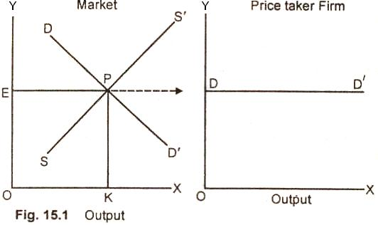

It was seen in unit 1 that the demand for a good depends on, a number of factors and thus, every factor, which influences either demand or supply is in fact a determinant of price. Accordingly, a change in demand or/and supply causes price change.

BASIC FACTORS IN PRICING

Factors considered while pricing:

Price of raw materials: Price of any item primarily depends upon the raw material availability and the cost spent on purchasing the raw martial. If prices of raw materials are high, price of the finished product will also be high and vice versa. If availability of raw materials is less, the price will get increased else it will be minimum.

Production costs: Next factor deterring the price of the product is the production costs. Higher the production costs, higher will be the price of finished goods. It includes cost of machinery, hiring people, transportation costs, and distribution costs etc.

Profit expectation: Profit expectation influences the price a lot. If the organization has higher profit expectations, the price of the product becomes high and vice versa.

Price of the complementary goods: The organization needs to have an eye on the Complementary goods price. If the complimentary goods price is high, the organization has to reduce its price otherwise both the products will lose the demand. But the firm can price the item high if the price of complimentary good is less.

Number of substitutes: If the number of substitutes for the product is high, the organization should be very careful while pricing the item. Because of perfect competition, there is a chance of losing the customer base. If the number of substitutes is less, the organization can price the item according to their wish.

Intervention of government: One of the most important factors in the necessary products is the government intervention. In the some product category, Government will fix some price ceiling and the organization has to price their items according to that only.

Demand for the product: The most common factor that has to be considered while pricing is demand. Higher the demand, higher the price can be charged.

MARKET

Market is a place where buyer and seller meet, goods and services are offered for the sale and transfer of ownership occurs. A market may be also defined as the demand made by a certain group of potential buyers for a good or service. The former one is a narrow concept and later one, a broader concept.

Narrow concept Economists describe a market as a collection of buyers and sellers who transact over a particular product or product class (the housing market, the clothing market, the grain market etc.). For business purpose we define a market as people or organizations with wants (needs) to satisfy, money to spend, and the willingness to spend it.

Broadly, market represents the structure and nature of buyers and sellers for a commodity/service and the process by which the price of the commodity or service is established. In this sense, we are referring to the structure of competition and the process of price determination for a commodity or service

Different Market Structures

Market:

A Market is a place where sellers sell and buyers buy a commodity. According to Robert Dorfman, a market is a group of people and firm who are in contact with one another for the purpose of buying and selling some commodity. It is not necessary that every member of the market be in contact with every other one; the contacts may be indirect.

Market structure describes the competitive environment in the market for any good or service. A market consists of all firms and individuals who are willing and able to buy or sell a particular product. This includes firms and individuals currently engaged in buying and selling a particular product, as well as potential entrants.
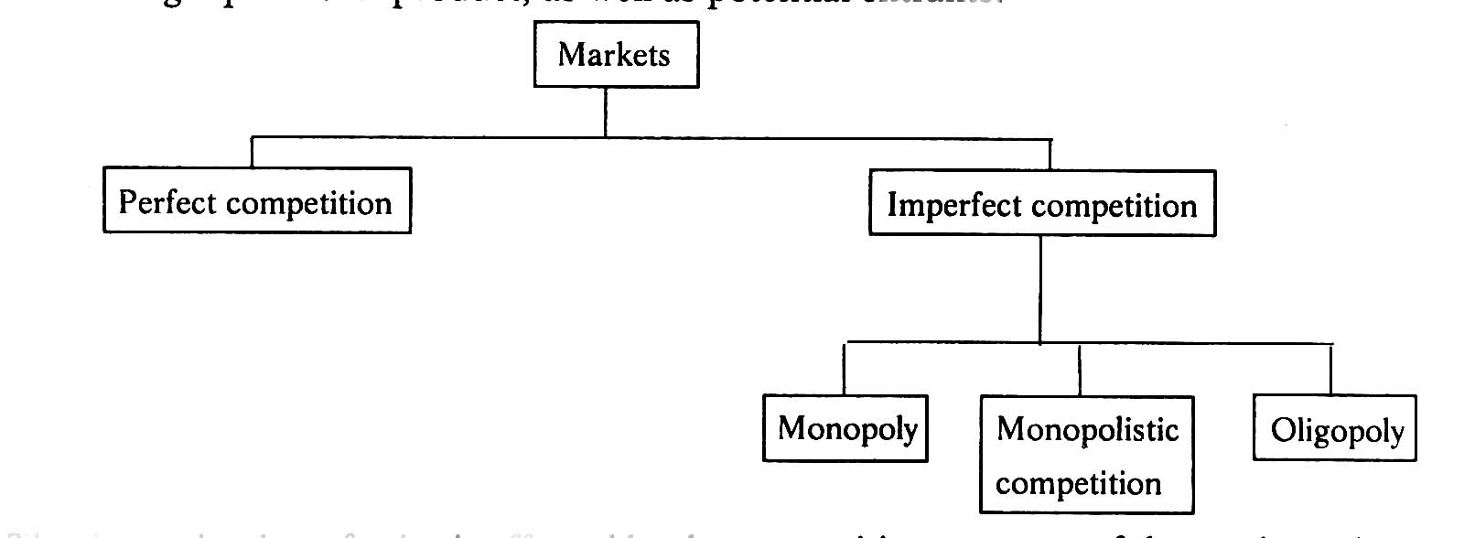

Perfect competitionIt refers to a market structure where competition among the sellers and buyers prevails in its most perfect form. In a perfectly competitive market, a single market price prevails for the commodity, which is determined by the forces of total demand and total supply in the market.

Monopoly:- If there is only one seller, monopoly market is said to exist. An extreme version of imperfect market is monopoly. Here a single seller completely controls the entire industry. It is only firm producing the given product in its industry. In case of monopoly, there is very little difference between the firm and industry. The firm is called monopolist or monopoly firm. Maruti-Suzuki enjoyed all the government protection for a long time when it enjoyed monopoly in respect of small cars.

Monopolistic Competition:- When large number of sellers produces differentiated products, monopolistic competition is said to exist. A product is said to be differentiated when its important features vary. It may be differentiated based on real or perceived differences. For cameras, the important features include Zoom lenses, focal length, memory, size of camera, aperture and exposure controls, flash, safety, digital day and date display, and the overall picture quality and so on.

Duopoly:- If there are two sellers, duopoly is said to exist. If Pepsi and coke are the two companies in soft drinks, this market is called duopoly. Basic facilities for satellite communication are presently provided by Mahan agar Telephone Nigam Limited (MNTL) and videsh sanchar Nigam Limited (VSNL). This market for satellite Communication can be referred to as duopoly.

Oligopoly:- Another variety of imperfect competition is oligopoly. If there is competition among a few sellers, oligopoly is said to exist. The examples are the car manufacturing companies (such as Maruti suzuki, Hindustan Motors, Daewoo, Toyota and so on), newspapers (such as The Hindu, Indian Express, times of india, Economic Times, Eenadu and so on). In oligopoly, each individual seller or firm can affect the market price

Comparison of various market forms
Characteristic |  | Perfect competition | Imperfect competition
 |  |  | Monopolistic competition | oligopoly | Monopoly
 | Number of firms | Many | Many | few | one
 | Ability to affect price | None | Limited | Some | considerable
 | Entry barriers | None (Free entry) | None (Free entry) | Some (limited entry) | Complete (No entry)
 | Product type | Homogeneous | Differentiated | Homogeneous | Brand
 | Marketing methods | Commodity exchanges or actions | Advertising quality and design differences | Advertising quality  Revelry administered prices | Promotional and public relations advertising
 | Example | Fruit stalls | Grocer | Cars | Post office

Characteristics of Perfect Competition

The following features characterize a perfectly competitive market:

A large number of buyers and sellers: The number of buyers and sellers is large and the share of each one of them in the market is so small that none has any influence on the market price.

Homogeneous product: The product of each seller is totally undifferentiated from those of the others. Under perfect competition, the product offered for sale by all the seller must be identical in every respect. The goods offered for sale are perfect substitutes of one another. Buyers have no special preference for the product of a particular seller. No seller can raise the price above the prevailing price or lower the price below the prevailing price.

Free entry and exit: Any buyer and seller is free to enter or leave the market of the commodity. Under perfect competition, there will be no restriction on the entry and exit of both buyers and sellers. If the existing sellers start making abnormal profits, new sellers should be able to enter the market freely. This will bring down the abnormal profits to the normal level. Similarly, when losses will occur existing sellers may leave the market. However, such free entry or free exit is possible only in the long run, but not in the short-run.

Perfect knowledge: All buyers and sellers have perfect knowledge about the market for the commodity. Perfect competition implies perfect knowledge on the part of buyers and sellers regarding the market conditions. As a results, no buyer will be prepared to pay a price higher than the prevailing price. Sellers will not charge a price higher or lower than the prevailing price. In this market, advertisement has no scope.

Indifference (No attachment):: No buyer has a preference to buy from a particular seller and no seller to sell to a particular buyer.There is no attachment between the buyers and sellers under perfect competition. Since products of all sellers are identical and their prices are the same a buyer is free to buy the commodity from any seller he likes. He has no special inclination for the product of any seller as in case of monopolistic competition or oligopoly. Theoretically, perfect competition is irrelevant. In reality, it does not exist.

Non-existence of transport costs: Perfectly competitive market also assumes the non-existence of transport costs.

Perfect mobility of factors of production: Factors of production must be in a position to move freely into or out of industry and from one firm to the other.The second perfection mobility of factors of production from one use to another use. This feature ensures that all sellers or firms get equal advantages so far as services of factors of production are concerned. This is essential to enable the firms and industry to achieve equilibrium.
Under such a market no single buyer or seller plays a significant role in price determination. One the other hand all of them jointly determine the price. The price is determined in the industry, which is composed of all the buyers and seller for the commodity. The demand curve facing the industry is the sum of all consumers’ demands at various prices. The industry supply curve is the sum of all sellers’ supplies at various prices.
Pure competition and perfect competition
The term perfect competition is used in a wider sense. Pure competition has only limited assumptions. When the assumptions, that large number of buyers and sellers, homogeneous products, free entry and exit are satisfied, there exists pure competition. Competition becomes perfect only when all the assumptions (features) are satisfied. Generally pure competition can be seen in agricultural products.

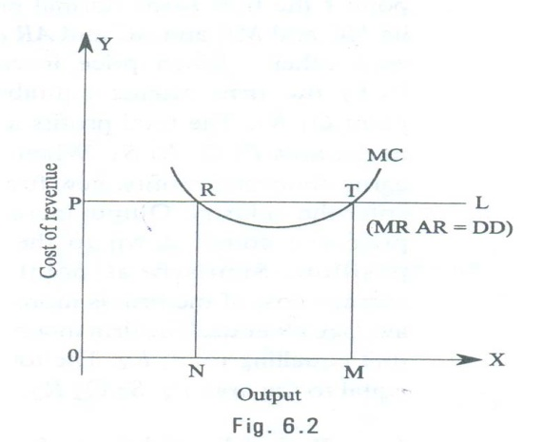
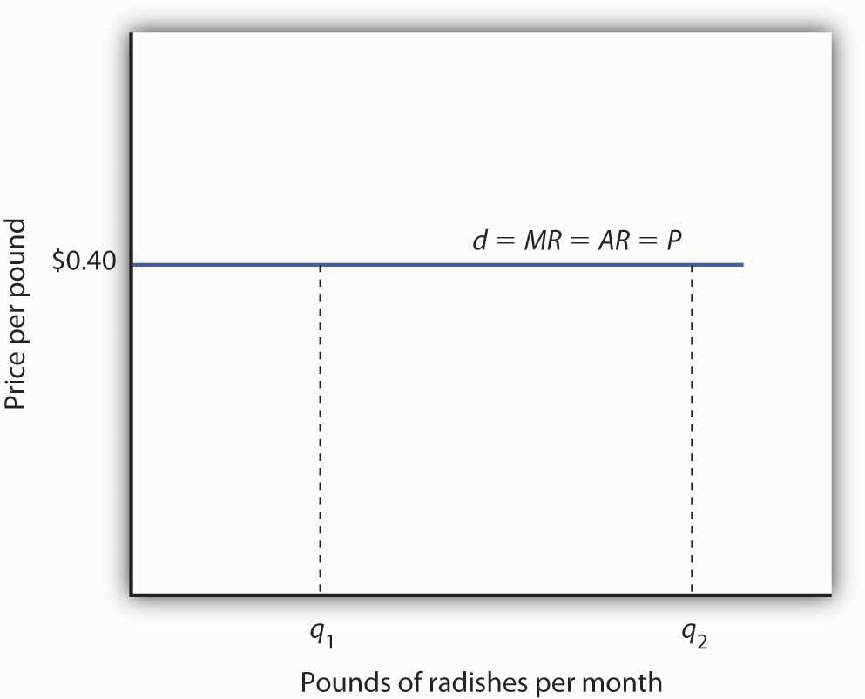

The equilibrium of a perfectly competitive firm may be explained with the help of the fig. 6.2.

In the given fig. PL and MC represent the Price line and Marginal cost curve. PL also represents Marginal revenue, Average revenue and demand. As Marginal revenue, Average revenue and demand are the same in perfect competition, all are equal to the price line. Marginal cost curve is U- shaped curve cutting MR curve at R and T. At point R marginal cost becomes equal to marginal revenue. But MC curve cuts the MR curve from above. So this is not the equilibrium position. The downward sloping marginal cost curve indicates that the firm can reduce its cost of production by increasing output.

PRICE-OUTPUT DETERMINATION IN CASE OF PERFECT COMPETITION

The price or value of a commodity under perfect competition is determined by the demand for and the supply of that commodity.

Under perfect competition there is large number of sellers trading in a homogeneous product. Each firm supplies only very small portion of the market demand. No single buyer or seller is powerful enough to influence the price. The demand of all consumers and the supply of all firms together determine the price.

The individual seller is only a price taker and not a price maker. An individual firm has no price policy of its own. Thus, the main problem of a firm in a perfectly competitive market is not to determine the price of its product but to adjust its output to the given price, So that the profit is maximum.

Marshall however gives great importance to the time element for the determination of price. He divided the time periods on the basis of supply and ignored the forces of demand. It is two types 1. Time based 2. Profit based

TIME BASED

Very short period or Market period

Short period

Long period

Very short period:

It is the period in which the supply is more or less fixed because the time available to the firm to adjust the supply of the commodity to its changed demand is extremely short; say a single day or a few days. The price determined in this period is known as Market Price.

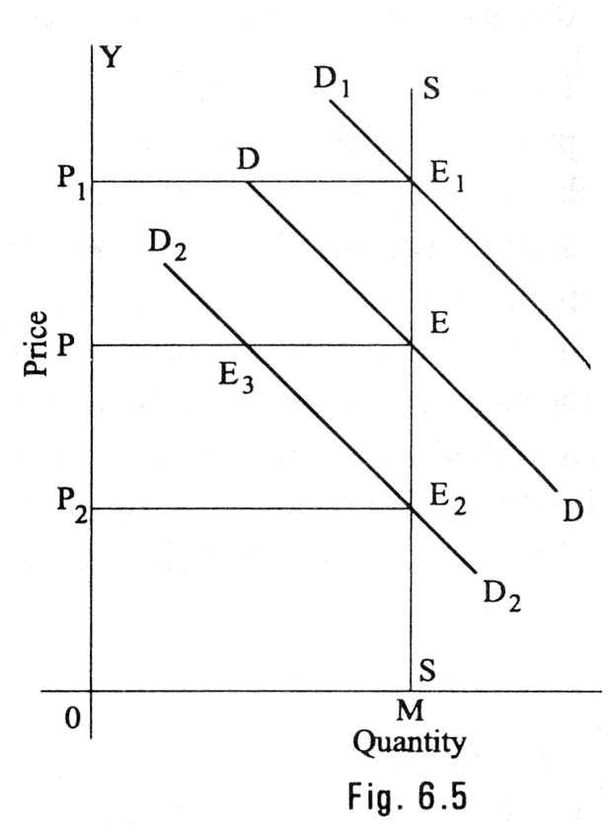

In this figure quantity is represented along X-axis and price is represented along Y-axis. MS is the very short period supply curve of perishable goods. DD is demand curve. It intersects supply curve at E. The price is OP. The quantity exchanged is OM. D1 D1 represents increased demand. This curve cuts the supply curve at E1. Even at the new equilibrium, supply is OM only. But price increases to OP1. So, when demand increases, the price will increase but not the supply. If demand decreases new demand curve will be D2 D2. This curve cuts the supply curve at E2. Even at this new equilibrium, the supply is OM only. But price falls to OP2. Hence in very short period, given the supply, it is the change in demand that influences price. The price determined in a very short period is called Market Price.

Short Period:

In this period, the time available to firms to adjust the supply of the commodity to its changed demand is, of course, greater than that in the market period. In this period altering the variable factors like raw materials, labour, etc can change supply. During this period new firms cannot enter into the industry.

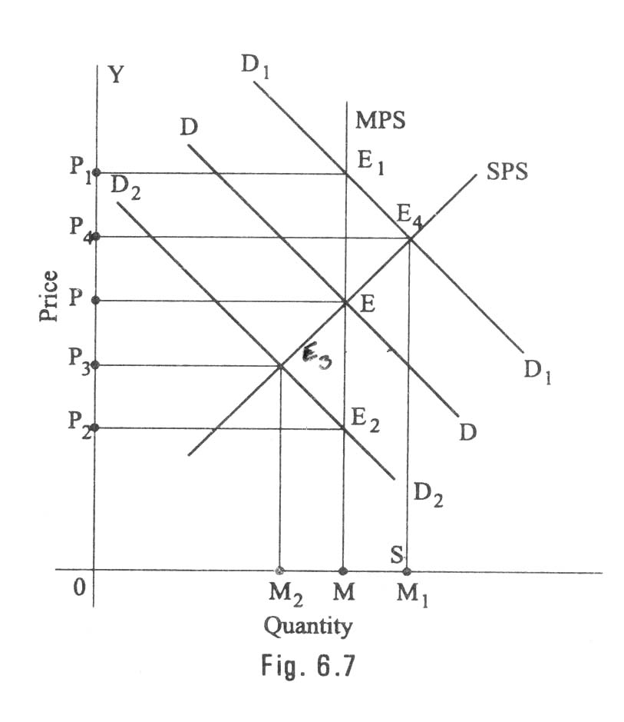

In the given diagram MPS is the market period supply curve. DD is the initial demand curve. It intersects MPS curve at E. The price is OP and out put OM. Suppose demand increases, the demand curve shifts upwards and becomes D1D1. In the very short period, supply remains fixed on OM. The new demand curve D1D1 intersects MPS at E1. The price will rise to OP1. This is what happen in the very short-period.

As the price rises from OP to OP1, firms expand output. As firms can vary some factors but not all, the law of variable proportions operates. This results in new short-run supply curve SPS. It interests D1 D1 curve at E4. The price will fall from OP1 to OP4.

It the demand decreases, DD curve shifts downward and becomes D2D2. It interests MPS curve at E2. The price will fall to OP2. This is what happens in market period. In the short period, the supply curve is SPS. D2D2 curve interests SPS curve at E3. The short period price is higher than the market period price.

Long period:

In this period, a sufficiently long time is available to the firms to adjust the supply of the commodity fully to the changed demand. In this period not only variable factors of production but also fixed factors of production can be changed. In this period new firms can also enter the industry. The price determined in this period is known as long run normal price.

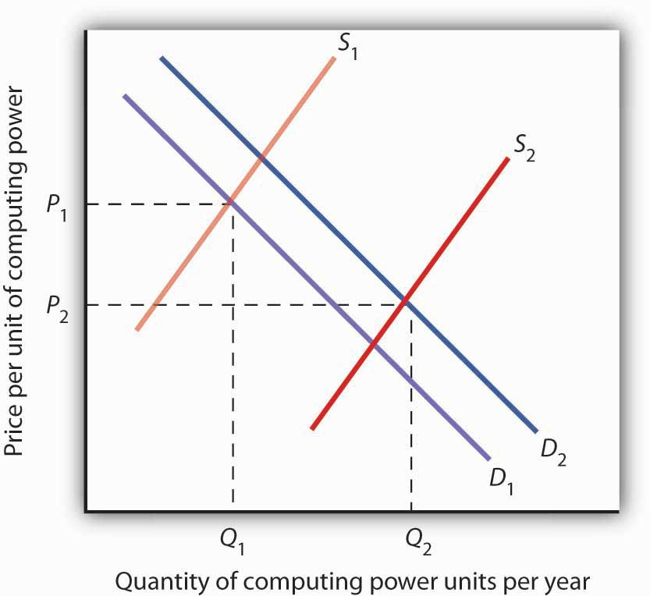

PRICE FIXATION AND PROFIT

Super normal profit :

Normal profit :

Subnormal profit

Super normal profit :

The price and output of the firm are determined, under perfect competition, based on the industry price and its own cost. The industry price has greater say in this process because the firm’s own sales are very small and significant. The process of price output determination in case of perfect competition is illustrated.

The firm’s demand curve is horizontal at the price determined in the industry (MR=AR=price). This demand curve is also known as average revenue curve. This is because if all the units are sold at the same price, on an average, the revenue to the firm equals its price.

When the average revenue is constant (neither falling nor rising), it will coincide with the marginal revenue curve. Thus, CC is the demand curve representing the price, average revenue curve, and also the marginal revenue curve (Price = AR = MR). Average cost (AC) and marginal cost (MC) are the firm average and marginal cost curves.

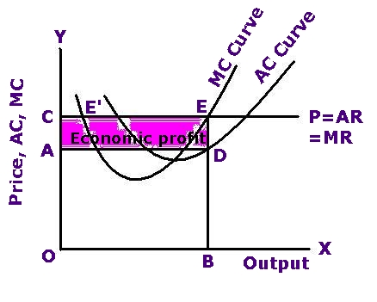

In fig. 8.3, the firm satisfies both conditions: (a) MR = MC; and (b) MC curve must cut the MR curve from below. The firm attains equilibrium at point D where MR = MC. The MC curve passes through the minimum point of AC curve.

Equilibrium Output Determination of a Firm under Perfect Competition in the Short run:

The firm gets higher profits as long as the price (in this case MR or AR) it receives for each unit exceeds the average cost (AC) of production.

Average, DE is the average profit and the area CDEF is the total profit which constitutes the ‘supernormal’ or ‘abnormal’ profits.

Based on its cost function and marker condition, the firm may make profits. Losses or just break even in the short-run

Normal profit :

Having been attracted by supernormal profits, more and more firms enter the industry. With the result, there will be a scramble for scare inputs among the competing firms pushing the input prices. Hence, the average cost increases. The entry of more and more firms will expand the supply pulling down the marker price. As a result, the super normal profits hitherto enjoyed by the firms get eroded. The entry of the firms into the industry continues till the supernormal profits but not supernormal profits. Normal profits are the profits that are just sufficient for the firms to stay in the business. It is to be noted that normal profits are included in the average cost curve.

All those firms that are not able to earn at least normal will leave the industry.

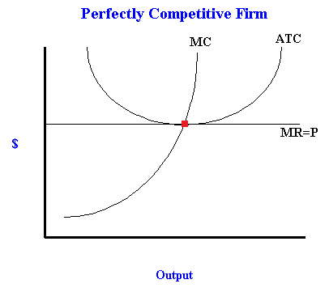

Subnormal profit

In the short-run, if the marker price is below the average cost, the firm may still supply goods provided the market price is above the average variable cost. If the market price is below the average variable cost, the firm refuses to sell the goods even in the short-run for the simple reason that, by not selling the goods, the firm suffers a loss equal to average fixed cost only. If it sells the goods, the loss will be more than the average fixed costs. Thus, the firm’s short-run supply curve will be that portion of the marginal cost curve which is above the average variable cost curve

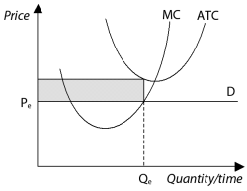
Long-run marginal cost (LMC) curve passes through the minimum point of the long-run average cost curve (LAC) at E, while passing through the marginal revenue curve. E is the equilibrium point and the firm produces OQ units of output. It can be noted that normal profits are not visible to the naked eye since normal profits are included in the average cost. Long-run average cost includes the opportunity cost of staying in business

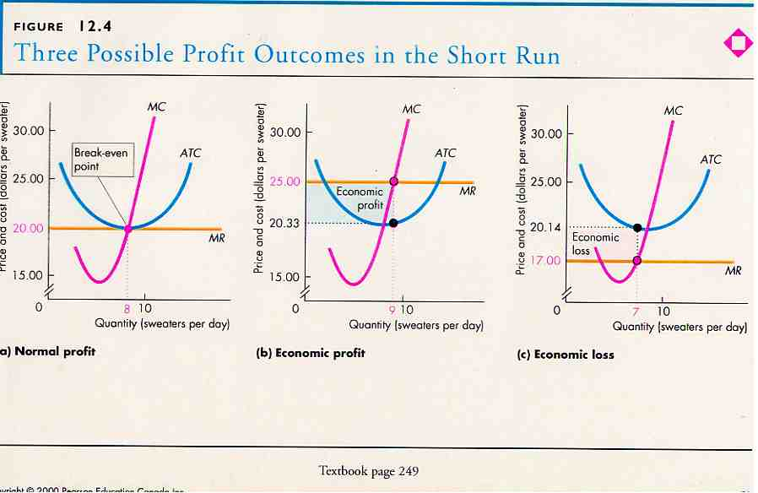

.

Monopoly

The word monopoly is made up of two syllables, Mono and poly. Mono means single while poly implies selling. Thus monopoly is a form of market organization in which there is only one seller of the commodity. There are no close substitutes for the commodity sold by the seller. Pure monopoly is a market situation in which a single firm sells a product for which there is no good substitute.

Features of monopoly

The following are the features of monopoly.

Single person or a firm: A single person or a firm controls the total supply of the commodity. There will be no competition for monopoly firm. The monopolist firm is the only firm in the whole industry.

No close substitute: The goods sold by the monopolist shall not have closely competition substitutes.Even if price of monopoly product increase people will not go in far substitute. For example: If the price of electric bulb increase slightly, consumer will not go in for kerosene lamp.

Large number of Buyers: Under monopoly, there may be a large number of buyers in the market who compete among themselves.

Price Maker: Since the monopolist controls the whole supply of a commodity, he is a price-maker, and then he can alter the price.

Supply and Price: The monopolist can fix either the supply or the price. He cannot fix both. If he charges a very high price, he can sell a small amount. If he wants to sell more, he has to charge a low price. He cannot sell as much as he wishes for any price he pleases.

Downward Sloping Demand Curve: The demand curve (average revenue curve) of monopolist slopes downward from left to right. It means that he can sell more only by lowering price.

Types of Monopoly

Monopoly may be classified into various types. The different types of monopolies are explained below:

Legal Monopoly: If monopoly arises on account of legal support or as a matter of legal privilege, it is called Legal Monopoly. Ex. Patent rights, special brands, trade means, copyright etc.

Government Monopoly: Sometimes the government will take the responsibility of supplying a commodity and avoid private interference. Ex. Water, electricity. These monopolies, created to satisfy social wants, are formed on social considerations. These are also called Social Monopolies.

Private Monopoly: If the total supply of a good is produced by a single private person or firm, it is called private monopoly. Hindustan Lever Ltd. Is having the monopoly power to produce Lux Soap.

Pricing under Monopoly

Monopoly refers to a market situation where there is only one seller. He has complete control over the supply of a commodity. He is therefore in a position to fix any price. Under monopoly there is no distinction between a firm and an industry. This is because the entire industry consists of a single firm.

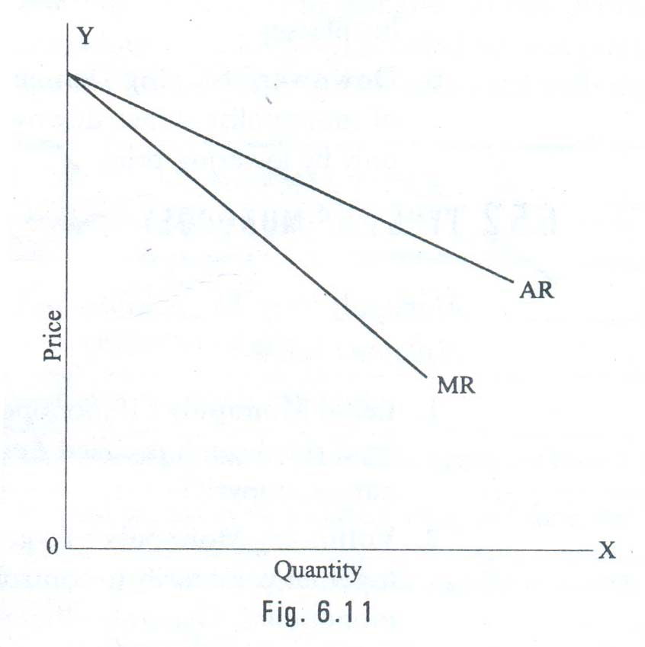

The market demand curve of the monopolist (the average revenue curve) is downward sloping. Its corresponding marginal revenue curve is also downward sloping. But the marginal revenue curve lies below the average revenue curve as shown in the figure. The monopolist faces the down-sloping demand curve because to sell more output, he must reduce the price of his product. The firm’s demand curve and industry’s demand curve are one and the same. The average cost and marginal cost curve are U shaped curve. Marginal cost falls and rises steeply when compared to average cost.

Price output determination (Equilibrium Point)

The monopolistic firm attains equilibrium when its marginal cost becomes equal to the marginal revenue. The monopolist always desires to make maximum profits. He makes maximum profits when MC=MR. He does not increasing his output if his revenue exceeds his costs. But when the costs exceed the revenue, the monopolist firm incur loses. Hence the monopolist curtails his production. He produces up to that point where additional cost is equal to the additional revenue (MR=MC). Thus point is called equilibrium point. The price output determination under monopoly may be explained with the help of a diagram.

In the diagram 6.12 the quantity supplied or demanded is shown along X-axis. The cost or revenue is shown along Y-axis. AC and MC are the average cost and marginal cost curves respectively. AR and MR curves slope downwards from left to right. AC and MC and U shaped curves. The monopolistic firm attains equilibrium when its marginal cost is equal to marginal revenue (MC=MR). Under monopoly, the MC curve may cut the MR curve from below or from a side. In the diagram, the above condition is satisfied at point E. At point E, MC=MR. The firm is in equilibrium. The equilibrium output is OM.

The above diagram (Average revenue) = MQ or OP

Average cost = MR

Profit per unit = Average Revenue-Average cost=MQ-MR=QR

Total Profit = QRXSR=PQRS

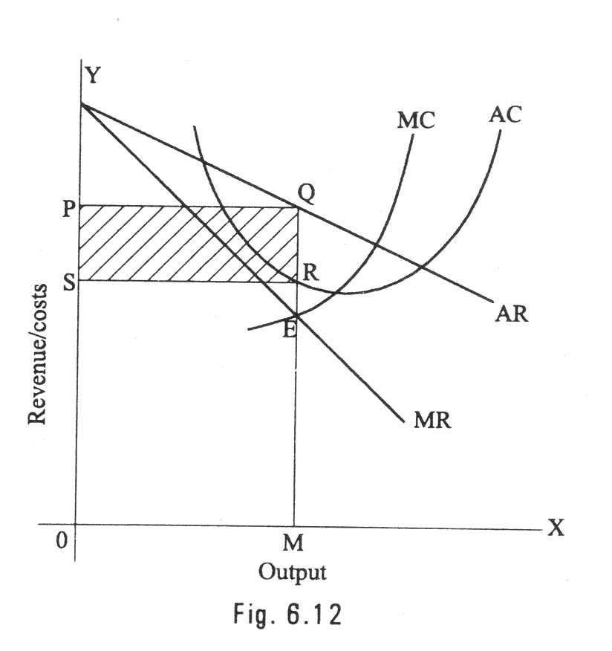

The area PQRS resents the maximum profit earned by the monopoly firm.

But it is not always possible for a monopolist to earn super-normal profits. If the demand and cost situations are not favorable, the monopolist may realize short run losses.

Through the monopolist is a price marker, due to weak demand and high costs; he suffers a loss equal to PABC.

If AR > AC -> Abnormal or super normal profits.

If AR = AC -> Normal Profit

If AR < AC -> Loss

In the long run the firm has time to adjust his plant size or to use existing plant so as to maximize profits.

Monopolistic competition

Perfect competition and pure monopoly are rate phenomena in the real world. Instead, almost every market seems to exhibit characteristics of both perfect competition and monopoly. Hence in the real world it is the state of imperfect competition lying between these two extreme limits that work. Edward. H. Chamberlain developed the theory of monopolistic competition, which presents a more realistic picture of the actual market structure and the nature of competition.

Characteristics of Monopolistic CompetitionThe important characteristics of monopolistic competition are:

Existence of Many firms: Industry consists of a large number of sellers, each one of whom does not feel dependent upon others. Every firm acts independently without bothering about the reactions of its rivals. The size is so large that an individual firm has only a relatively small part in the total market, so that each firm has very limited control over the price of the product. As the number is relatively large it is difficult for these firms to determine its price- output policies without considering the possible reactions of the rival forms. A monopolistically competitive firm follows an independent price policy.

Product Differentiation: Product differentiation means that products are different in some ways, but not altogether so. The products are not identical but the same time they will not be entirely different from each other. IT really means that there are various monopolist firms competing with each other. An example of monopolistic competition and product differentiation is the toothpaste produced by various firms. The product of each firm is different from that of its rivals in one or more respects. Different toothpastes like Colgate, Close-up, Forehans, Cibaca, etc., provide an example of monopolistic competition. These products are relatively close substitute for each other but not perfect substitutes. Consumers have definite preferences for the particular verities or brands of products offered for sale by various sellers. Advertisement, packing, trademarks, brand names etc. help differentiation of products even if they are physically identical.

Large Number of Buyers: There are large number buyers in the market. But the buyers have their own brand preferences. So the sellers are able to exercise a certain degree of monopoly over them. Each seller has to plan various incentive schemes to retain the customers who patronize his products.

Free Entry and Exist of Firms: As in the perfect competition, in the monopolistic competition too, there is freedom of entry and exit. That is, there is no barrier as found under monopoly.

Selling costs: Since the products are close substitute much effort is needed to retain the existing consumers and to create new demand. So each firm has to spend a lot on selling cost, which includes cost on advertising and other sale promotion activities.

Imperfect Knowledge: Imperfect knowledge about the product leads to monopolistic competition. If the buyers are fully aware of the quality of the product they cannot be influenced much by advertisement or other sales promotion techniques. But in the business world we can see that thought the quality of certain products is the same, effective advertisement and sales promotion techniques make certain brands monopolistic. For examples, effective dealer service backed by advertisement-helped popularization of some brands through the quality of almost all the cement available in the market remains the same.

Pricing Methods

Pricing is not an exact science. Pricing decisions, more often, are done by trial and error. Most often we see discounts and concessions offered at the time of purchase. Sometimes, certain shames are introduced wherein if you by a packet of Tea powder, a dining still table spoon if free! Why are all these provided? While the main objective of such shames is to increase sales, one of the other objectives is also to correct the pricing strategy, if at all it has gone wrong earlier.

Pricing is an important exercise. Under-pricing will result in losses and over-pricing will make the customers run away. To determine pricing in a scientific manner, it is necessary to understand the pricing objectives, pricing methods, pricing policies, and pricing procedures.

PRICING OBJECTIVES

Pricing objectives refer to the general and specific objectives, which a firm sets for itself in establishing the price of its products and/or services and these are not much different from the marketing objectives or firm's overall business objectives.

Generally, the following are the objectives of pricing.

(a) To maximize profits,

(b) To increase sales

(c) To increase the market share,

(d) To satisfy customers, and

(e) To meet the competition.

PRCING POLICY

The firm has to formulate its pricing policies, particularly when it deals in multiple products. The pricing policies are intended to bring consistency in the pricing pattern. For instance, to maintain price differentials between the deluxe models and basic models and so on. Pricing policy defines how to handle complex issues such as price discrimination and so forth.

PRICING METHODS

1. COST-BASED PRICING METHODS

(a) COST PULS PRICING;- This is also called 'full cost or mark up' pricing. Here the average cost at normal capacity of output is ascertained and then a conventional margin of profit is added to the cost to arrive at the price. In other words, find out the product unit's total cost and add a percentage of profit to arrive at the selling price.

(b) MARGINAL COST PRICING;- In marginal cost pricing, selling price is fixed in such a way that it covers fully the variable or marginal cost and contributes towards recovery of fixed costs fully or partly, depending upon the market situations. In times of stiff competition, marginal cost offers a guide-line as to how far the selling price can be lowered.

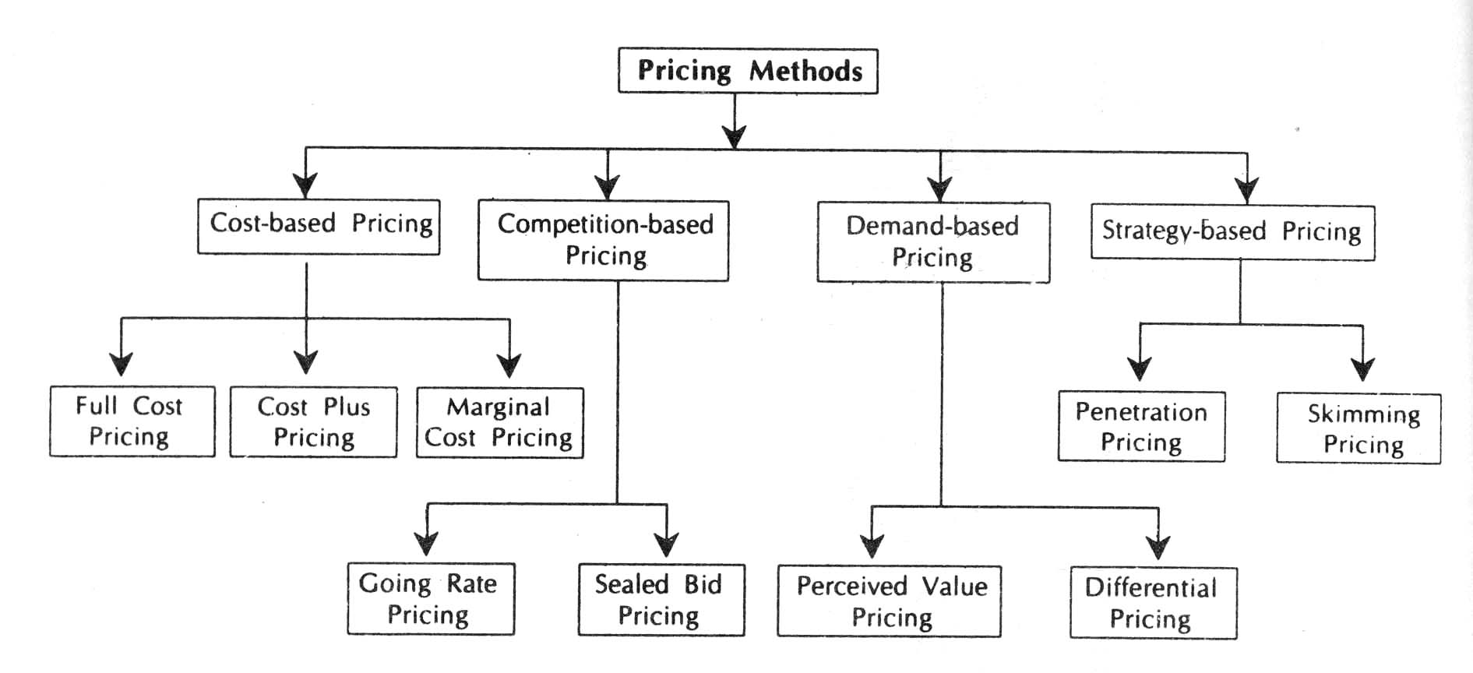

COMPETITION-ORIENTED PRICING

Here the pricing is a very complex task. Here the price of a product is set based on what the competitor charges for similar products. In other words, a reduction in the price of products by the competitor will force us also to follow suit. In such a case, how far we can go on reducing the price? Here the marginal cost concept comes handy. As long as the price covers the marginal cost, continue to sell. If not, better stop selling. It is because, every unit sold at less than marginal cost results in loss.

SEALED BID PRICING;- This method popular in tenders and contracts. Each contracting firm quotes its price in a sealed cover called 'tender'. All the tenders are opened on a scheduled date and the person, who quotes the lowest price, other things remaining the same, is awarded the contract. The objective of the bidding firm is to bag the contract and hence it will quote lower than others. Marginal cost concept continues to be the guiding principle here also. Any price quoted less than the marginal price results in loss. Any price quoted ambitiously, no doubt, results in profit but suffers from the danger of losing the contract.

GOING RATE PRICING;-Here the price charged by the firm is in tune with price charged in the industry as a whole. In other words, the prevailing market price at a given point of time is the guiding factor. When one wants to buy determine the price. Normally the market leaders keep announcing the prevailing prices at a given point of time based on demand and supply positions.

DEMAND-ORIENTED PRICING

The higher the demand, the higher can be the price. Cost is not the consideration here. The key to pricing here is the value as perceived by the consumer. This is a relatively modern marketing concept. Today most of the organizations consider favorably such proposals where there is possibility to charge higher prices on their products and services, even though they call for higher investments and latest technology. Demand-oriented pricing can take two forms: (a) Differential pricing also called price discrimination, (b) perceived value pricing.

PRICE DISCRIMINATION;-

Price discrimination refers to the practice of charging different prices to customers for the same good. The firm uses its desecration to charge differently the different customers. It is also called differential pricing. customers of different profiles can be separated in various ways, such as by different consumer requirements (for example bulk and low gas supply to industrial and household consumers), by nature of product itself (for example original and replacement components of pressure cookers), by geographical areas (domestic and international markets), by income group (in a government hospital the patients are charged a fee based on their income groups) and so on.

The objects of price discrimination are to

* develop a new market including for export,

* utilize the maximum capacity,

* share consumer's surplus along with consumer, not leaving it totally to him,

* meet competition,

* increase market share.

PERCEIVED VALUE PRICING;- Perceived value pricing refers to where the price is fixed on the basis of the perception of the buyer of the value of the products.

STRATEGY-BASED PRICING

MARKET SKIMMING;-

When the product is introduced for the first time in the market, the company follows this method. Under this method, the company fixes a very high price for the product. The main idea is to charge the customer maximum possible. This strategy is mostly found in case of technology products. When Sony introduces a particular TV model, it fixes a very high price. When new series of Pentium is released into market, it is priced very high. Initially, all cannot afford except a very few. As the time passes by, the price comes down and more people can afford to buy except a very few. This method can be followed only when (i) the demand for the product is inelastic,(ii) there is no threat from competitors,(iii) a high price is coupled with high technology or quality.

MARKET PENETRATION;-

This is exactly opposite to the market skimming method. Here the price of the product is fixed so low that the company can increase its market share. The company attains profits with increasing volumes and increase in the market share. More often, the companies believe that it is necessary to dominate the market in the long-run than making profits in the short-run. This method is more suitable where market is highly price-sensitive. In such a case, a low price stimulates more rapid growth. It will be more appropriate in cases where the costs are likely to fall with increase in output. A low price may not attract significant degree of competition also.

TWO-PART PRICING;-

The firms with market power can enhance profits by the strategy of two-part pricing. Under this strategy, a firm charges a fixed fee for the right to purchase its goods, plus a per unit charges for each unit purchased. Entertainment house such as country clubs. Golf courses and health clubs usually adopt this strategy. Then charge a fixed initiation fee plus a charge per month or per visit, to use the facilities. There are also organizations that charge membership fee (equivalent to the consumer surplus) and offer their products and services cost-to-cost basis.

BLOCK PRICING;-

Block pricing is another way a firm with market power can enhance its profits. We see block pricing in our day-to-day life very frequently. Six Lux soaps in a single packed or five Magi noodles in a single pack illustrate this pricing method. By selling certain number of units of a product as one package, the firm earns more than by selling unit wise. The block pricing is a profit maximization price on each package. It is generally the total value the consumer receives for the package, including consumer surplus.

COMMODITY BUNDLING;-

Commodity bundling refers to the practice of bundling two or more different products together and selling them at a single 'bundle price'. The package includes the airfare, hotel, meals, sightseeing and so on at a bundled price instead of pricing each of these services separately. Computer firms offer PCs, assembling as per the customer specifications and offer them at a bundled price. The car companies provide cars with air-conditioning, Power steering, automatic transmission, auto gear and so forth, and sell them at a special price.

PEAK LOAD PRICING;-

During seasonal period when demand is likely to be higher, a firm may enhance profits by peak load pricing. The firm's philosophy is to charge a higher price during peak times than is charged during off-peak times. The pricing is done in such a way that the business is not lost to the competitors. The firm following such a strategy covers the likely losses during the off-peak times form the likely profits from the peak times.

CROSS SUBSIDISATION;-

In cases where demand for two products produced by a firm is interrelated through demand or costs, the firm may enhance the profitability of its operations through cross subsidization. Using the profits generated by established products, a firm may expand its activates by financing new product development and diversification into new product markets.

TRANSFER PRICING;- Transfer pricing is an internal pricing technique. It refers to a price at which inputs of one department are transferred to another, in order to maximize the overall profits of the company.

BUSINESS AND NEW ECONOMIC ENVIRONMENT
Business is a continuous process. It is group of people working together to maximum Profits. Business involves various functions such as procuring materials Distribution selling.
Definition
Business is a human activity whose objective is to create wealth through purchase and sale of goods and services
---L.H.Hanney---
The following are the alternatives you have on hand:
- You can set up a small/medium/large industry to manufacture
- You can develop software
- You can design hardware
- You can be a consultant
If you choose any one or more of the above, you have chosen the line of activity. The next step for you is to decide whether.
- You want to be only owner (It means you what to be sole trader)
- You want to take some more professionals as co-owners along with you (If partners)
- You want to bring all like-minded people to share the benefits of the common enterprise (You want to promote a joint stock company)
- You want to involve government in the IT business (here you want to suggest government to promote a public enterprise!)
To decide this, it is necessary to know how to evaluate each of these alternatives.

CHARACTERISTICS OF BUSINESS:
1. Entrepreneur: An entrepreneur is a person who can indent the of market for a product or service. Who start the business that person is called entrepreneur
2. Economic activities: It involves various activities like purchasing, sales. ECT
3. Profit motive; Profit motive is the primary motive of the business. The activities which do not lead to profit marking are not business.
4. Financing: It is support is necessary for setting up infrastructure and running
5. Consumersatisfaction:All business must satisfy consumer’s demand.

FACTORS AFFECTING THE CHOICE OF FORM OF BUSINESS ORGANIZATION:
Before we choose a particular form of business organization, let us study what factors affect such a choice?
The following are the factors affecting the choice of a business organization:
- Easy to start and easy to close: The form of business organization should be such that it should be easy to close. There should not be hassles or long procedures in the process of setting up business or closing the same.
- Division of labour: There should be possibility to divide the work among the available owners.
- Large amount of resources: Large volume of business requires large volume of resources. Some forms of business organization do not permit to raise larger resources. Select the one which permits to mobilize the large resources.
- Liability:The liability of the owners should be limited to the extent of money invested in business. It is better if their personal properties are not brought into business to make up the losses of the business.
- Secrecy:The form of business organization you select should be such that it should permit to take care of the business secrets. We know that century old business units are still surviving only because they could successfully guard their business secrets.
- Transfer of ownership:There should be simple procedures to transfer the ownership to the next legal heir.
- Ownership, Management and control:If ownership, management and control are in the hands of one or a small group of persons, communication will be effective and coordination will be easier. Where ownership, management and control are widely distributed, it calls for a high degree of professional’s skills to monitor the performance of the business.
- Continuity: The business should continue forever and ever irrespective of the uncertainties in future.
- Quick decision-making:Select such a form of business organization, which permits you to take decisions quickly and promptly. Delay in decisions may invalidate the relevance of the decisions.
- Personal contact with customer:Most of the times, customers give us clues to improve business. So choose such a form, which keeps you close to the customers.
- Flexibility: In times of rough weather, there should be enough flexibility to shift from one business to the other. Thelesser the funds committed in a particular business, the better it is.
- Taxation: More profit means more tax. Choose such a form, which permits to pay low tax.
Public enterprises
- sole trader
- partners Departmental undertaking
- joint stock company Public corporation
Government Company

SOLE TRADER

The sole trader is the simplest, oldest and natural form of business organization. It is also called sole proprietorship. ‘Sole’ means one. ‘Sole trader’ implies that there is only one trader who is the owner of the business.
It is a one-man form of organization wherein the trader assumes all the risk of ownership carrying out the business with his own capital, skill and intelligence. He is the boss for himself. He has total operational freedom. He is the owner, Manager and controller. He has total freedom and flexibility. Full control lies with him. He can take his own decisions. He can choose or drop a particular product or business based on its merits. He need not discuss this with anybody. He is responsible for himself. Restaurants, Supermarkets, pan shops, medical shops, hosiery shops etc.

Features of sole trader
- It is easy to start a business under this form and also easy to close.
- He introduces his own capital. Sometimes, he may borrow, if necessary
- He enjoys all the profits and in case of loss, he lone suffers.
- He has a high degree of flexibility to shift from one business to the other.
- Business secretes can be guarded well
- There is no continuity. The business comes to a close with the death, illness or insanity of the sole trader He has total operational freedom. He is the owner, manager and controller.
- He can be directly in touch with the customers.
- He can take decisions very fast and implement them promptly.
- Rates of tax, for example, income tax and so on are comparatively very low.

Advantages of sole trader:
The following are the advantages of the sole trader from of business organization:
- Easy to start and easy to close: Formation of a sole trader form of organization is relatively easy even closing the business is easy.
- Personal contact with customers directly: Based on the tastes and preferences of the customers the stocks can be maintained.
- Prompt decision-making: To improve the quality of services to the customers, he can take any decision and implement the same promptly. He is the boss and he is responsible for his business Decisions relating to growth or expansion can be made promptly.
- High degree of flexibility: Based on the profitability, the trader can decide to continue or change the business, if need be.
- Secrecy: Business secrets can well be maintained because there is only one trader.
- Low rate of taxation: The rate of income tax for sole traders is relatively very low.
- Direct motivation: If there are profits, all the profits belong to the trader himself. In other words. If he works more hard, he will get more profits. This is the direct motivating factor. At the same time, if he does not take active interest, he may stand to lose badly also.
- Total Control: The ownership, management and control are in the hands of the sole trader and hence it is easy to maintain the hold on business.
- Minimum interference from government: Except in matters relating to public interest, government does not interfere in the business matters of the sole trader. The sole trader is free to fix price for his products/services if he enjoys monopoly market.
- Transferability: The legal heirs of the sole trader may take the possession of the business.

Disadvantages of sole trader:
The following are the disadvantages of sole trader form:
- Unlimited liability: The liability of the sole trader is unlimited. It means that the sole trader has to bring his personal property to clear off the loans of his business. From the legal point of view, he is not different from his business.
- Limited amounts of capital: The resources a sole trader can mobilize cannot be very large and hence this naturally sets a limit for the scale of operations.
- No division of labour: All the work related to different functions such as marketing, production, finance, labour and so on has to be taken care of by the sole trader himself. There is nobody else to take his burden. Family members and relatives cannot show as much interest as the trader takes.
- Uncertainty: There is no continuity in the duration of the business. On the death, insanity of insolvency the business may be come to an end.
- Inadequate for growth and expansion: This from is suitable for only small size, one-man-show type of organizations. This may not really work out for growing and expanding organizations.
- Lack of specialization: The services of specialists such as accountants, market researchers, consultants and so on, are not within the reach of most of the sole traders.
- More competition: Because it is easy to set up a small business, there is a high degree of competition among the small businessmen and a few who are good in taking care of customer requirements along can service.
- Low bargaining power: The sole trader is the in the receiving end in terms of loans or supply of raw materials. He may have to compromise many times regarding the terms and conditions of purchase of materials or borrowing loans from the finance houses or banks

Partnership

Partnership is an improved from of sole trader in certain respects. Where there are like-minded persons with resources, they can come together to do the business and share the profits/losses of the business in an agreed ratio. Persons who have entered into such an agreement are individually called ‘partners’ and collectively called ‘firm’. The relationship among partners is called a partnership.
Indian Partnership Act, 1932 defines partnership as the relationship between two or more persons who agree to share the profits of the business carried on by all or any one of them acting for all.

Features of partnership
- Relationship: Partnership is a relationship among persons. It is relationship resulting out of an agreement.
- Two or more persons: There should be two or more number of persons.
- There should be a business: Business should be conducted.
- Agreement: Persons should agree to share the profits/losses of the business
- Carried on by all or any one of them acting for all: The business can be carried on by all or any one of the persons acting for all. This means that the business can be carried on by one person who is the agent for all other persons. Every partner is both an agent and a principal. Agent for other partners and principal for himself. All the partners are agents and the ‘partnership’ is their principal.
The following are the other features:
- Unlimited liability: The liability of the partners is unlimited. The partnership and partners, in the eye of law, and not different but one and the same. Hence, the partners have to bring their personal assets to clear the losses of the firm, if any.
- Number of partners: According to the Indian Partnership Act, the minimum number of partners should be two and the maximum number if restricted, as given below:
- 10 partners is case of banking business
- 20 in case of non-banking business
- Division of labour: Because there are more than two persons, the work can be divided among the partners based on their aptitude.
- Personal contact with customers: The partners can continuously be in touch with the customers to monitor their requirements.
- Flexibility: All the partners are likeminded persons and hence they can take any decision relating to business.
PARTNERSHIP DEED
The written agreement among the partners is called ‘the partnership deed’. It contains the terms and conditions governing the working of partnership. The following are contents of the partnership deed.
- Names and addresses of the firm and partners
- Nature of the business proposed
- Duration
- Amount of capital of the partnership and the ratio for contribution by each of the partners.
- Their profit sharing ration (this is used for sharing losses also)
- Rate of interest charged on capital contributed, loans taken from the partnership and the amounts drawn, if any, by the partners from their respective capital balances.
- The amount of salary or commission payable to any partner
- Procedure to value good will of the firm at the time of admission of a new partner, retirement of death of a partner
- Allocation of responsibilities of the partners in the firm
- Procedure for dissolution of the firm
- Name of the arbitrator to whom the disputes, if any, can be referred to for settlement.
- Special rights, obligations and liabilities of partners(s), if any.

Kind of partners
The following are the different kinds of partners:
- Active Partner: Active partner takes active part in the affairs of the partnership. He is also called working partner.
- Sleeping Partner: Sleeping partner contributes to capital but does not take part in the affairs of the partnership.
- Nominal Partner: Nominal partner is partner just for namesake. He neither contributes to capital nor takes part in the affairs of business. Normally, the nominal partners are those who have good business connections, and are well places in the society.
- Partner by Estoppels: Estoppels means behavior or conduct. Partner by estoppels gives an impression to outsiders that he is the partner in the firm. In fact is neither contributes to capital, nor takes any role in the affairs of the partnership.
- Partner by holding out: If partners declare a particular person (having social status) as partner and this person does not contradict even after he comes to know such declaration, he is called a partner by holding out and he is liable for the claims of third parties. However, the third parties should prove they entered into contract with the firm in the belief that he is the partner of the firm. Such a person is called partner by holding out.
- Minor Partner: Minor has a special status in the partnership. A minor can be admitted for the benefits of the firm. A minor is entitled to his share of profits of the firm. The liability of a minor partner is limited to the extent of his contribution of the capital of the firm.

Right of partners
Every partner has right
- To take part in the management of business
- To express his opinion
- Of access to and inspect and copy and book of accounts of the firm
- To share equally the profits of the firm in the absence of any specific agreement to the contrary
- To receive interest on capital at an agreed rate of interest from the profits of the firm
- To receive interest on loans, if any, extended to the firm.
- To be indemnified for any loss incurred by him in the conduct of the business
- To receive any money spent by him in the ordinary and proper conduct of the business of the firm.

Advantages of partnership
The following are the advantages of the partnership from:
- Easy to form: Once there is a group of like-minded persons and good business proposal, it is easy to start and register a partnership.
- Availability of larger amount of capital: More amount of capital can be raised from more number of partners.
- Division of labour: The different partners come with varied backgrounds and skills. This facilities division of labour.
- Flexibility: The partners are free to change their decisions, add or drop a particular product or start a new business or close the present one and so on.
- Personal contact with customers: There is scope to keep close monitoring with customers requirements by keeping one of the partners in charge of sales and marketing. Necessary changes can be initiated based on the merits of the proposals from the customers.
- Quick decisions and prompt action: If there is consensus among partners, it is enough to implement any decision and initiate prompt action. Sometimes, it may more time for the partners on strategic issues to reach consensus.
- The positive impact of unlimited liability: Every partner is always alert about his impending danger of unlimited liability. Hence he tries to do his best to bring profits for the partnership firm by making good use of all his contacts.

Disadvantagesof partnership:
The following are the disadvantages of partnership:
- Formation of partnership is difficult: Only like-minded persons can start a partnership. It is sarcastically said,’ it is easy to find a life partner, but not a business partner’.
- Liability: The partners have joint and several liabilities beside unlimited liability. Joint and several liability puts additional burden on the partners, which means that even the personal properties of the partner or partners can be attached. Even when all but one partner become insolvent, the solvent partner has to bear the entire burden of business loss.
- Lack of harmony or cohesiveness: It is likely that partners may not, most often work as a group with cohesiveness. This result in mutual conflicts, an attitude of suspicion and crisis of confidence. Lack of harmony results in delay in decisions and paralyses the entire operations
- Limited growth: The resources when compared to sole trader, a partnership may raise little more. But when compare to the other forms such as a company, resources raised in this form of organization are limited. Added to this, there is a restriction on the maximum number of partners.

- Instability: The partnership form is known for its instability. The firm may be dissolved on death, insolvency or insanity of any of the partners.
- Lack of Public confidence: Public and even the financial institutions look at the unregistered firm with a suspicious eye. Though registration of the firm under the Indian Partnership Act is a solution of such problem, this cannot revive public confidence into this form of organization overnight. The partnership can create confidence in other only with their performance.

Joint stock company

The joint stock company emerges from the limitations of partnership such as joint and several liability, unlimited liability, limited resources and uncertain duration and so on. Normally, to take part in a business, it may need large money and we cannot foretell the fate of business. It is not literally possible to get into business with little money. Against this background, it is interesting to study the functioning of a joint stock company.
The main principle of the joint stock company from is to provide opportunity to take part in business with a low investment as possible say Rs.1000. Joint Stock Company has been a boon for investors with moderate funds to invest.
The word ‘ company’ has a Latin origin, com means ‘ come together’, pany means ‘ bread’, joint stock company means, people come together to earn their livelihood by investing in the stock of company jointly.

Company Defined
Lord Justice Lindley explained the concept of the joint stock company from of organization as ‘an association of many persons who contribute money or money’s worth to a common stock and employ it for a common purpose.

Features of Joint Stock Company
- Artificial person: The Company has no form or shape. It is an artificial person created by law. It is intangible, invisible and existing only, in the eyes of law.
- Separate legal existence: it has an independence existence, it separate from its members. It can acquire the assets. It can borrow for the company. It can sue other if they are in default in payment of dues, breach of contract with it, if any. Similarly, outsiders for any claim can sue it. A shareholder is not liable for the acts of the company. Similarly, the shareholders cannot bind the company by their acts.
- Voluntary association of persons: The Company is an association of voluntary association of persons who want to carry on business for profit. To carry on business, they need capital. So they invest in the share capital of the company.
- Limited Liability: The shareholders have limited liability i.e., liability limited to the face value of the shares held by him. In other words, the liability of a shareholder is restricted to the extent of his contribution to the share capital of the company. The shareholder need not pay anything, even in times of loss for the company, other than his contribution to the share capital.
- Capital is divided into shares: The total capital is divided into a certain number of units. Each unit is called a share. The price of each share is priced so low that every investor would like to invest in the company. The companies promoted by promoters of good standing (i.e., known for their reputation in terms of reliability character and dynamism) are likely to attract huge resources.
- Transferability of shares: In the company form of organization, the shares can be transferred from one person to the other. A shareholder of a public company can cell sell his holding of shares at his will. However, the shares of a private company cannot be transferred. A private company restricts the transferability of the shares.
- Common Seal: As the company is an artificial person created by law has no physical form, it cannot sign its name on a paper; so, it has a common seal on which its name is engraved. The common seal should affix every document or contract; otherwise the company is not bound by such a document or contract.
- Perpetual succession: ‘Members may comes and members may go, but the company continues for ever and ever’ A. company has uninterrupted existence because of the right given to the shareholders to transfer the shares.
- Ownership and Management separated: The shareholders are spread over the length and breadth of the country, and sometimes, they are from different parts of the world. To facilitate administration, the shareholders elect some among themselves or the promoters of the company as directors to a Board, which looks after the management of the business. The Board recruits the managers and employees at different levels in the management. Thus the management is separated from the owners.
- Winding up: Winding up refers to the putting an end to the company. Because law creates it, only law can put an end to it in special circumstances such as representation from creditors of financial institutions, or shareholders against the company that their interests are not safeguarded. The company is not affected by the death or insolvency of any of its members.
- The name of the company ends with ‘limited’: it is necessary that the name of the company ends with limited (Ltd.) to give an indication to the outsiders that they are dealing with the company with limited liability and they should be careful about the liability aspect of their transactions with the company.

FORMATION OF JOINT STOCK COMPANY
There are two stages in the formation of a joint stock company. They are:
- To obtain Certificates of Incorporation
- To obtain certificate of commencement of Business
Certificate of Incorporation: The certificate of Incorporation is just like a ‘date of birth’ certificate. It certifies that a company with such and such a name is born on a particular day.
Certificate of commencement of Business: A private company need not obtain the certificate of commencement of business. It can start its commercial operations immediately after obtaining the certificate of Incorporation.
The persons who conceive the idea of starting a company and who organize the necessary initial resources are called promoters. The vision of the promoters forms the backbone for the company in the future to reckon with.
The promoters have to file the following documents, along with necessary fee, with a registrar of joint stock companies to obtain certificate of incorporation:
- Memorandum of Association: The Memorandum of Association is also called the charter of the company. It outlines the relations of the company with the outsiders. If furnishes all its details in six clause such as (ii) Name clause (II) situation clause (iii) objects clause (iv) Capital clause and (vi) subscription clause duly executed by its subscribers.
- Articles of association: Articles of Association furnishes the byelaws or internal rules government the internal conduct of the company.
- The list of names and address of the proposed directors and their willingness, in writing to act as such, in case of registration of a public company.
- A statutory declaration that all the legal requirements have been fulfilled. The declaration has to be duly signed by any one of the following: Company secretary in whole practice, the proposed director, legal solicitor, chartered accountant in whole time practice or advocate of High court.
The registrar of joint stock companies peruses and verifies whether all these documents are in order or not. If he is satisfied with the information furnished, he will register the documents and then issue a certificate of incorporation, if it is private company, it can start its business operation immediately after obtaining certificate of incorporation.

Advantages of Joint Stock Company
- Mobilization of larger resources: A joint stock company provides opportunity for the investors to invest, even small sums, in the capital of large companies. The facilities rising of larger resources.
- Separate legal entity: The Company has separate legal entity. It is registered under Indian Companies Act, 1956.
- Limited liability: The shareholder has limited liability in respect of the shares held by him. In no case, does his liability exceed more than the face value of the shares allotted to him.
- Transferability of shares: The shares can be transferred to others. However, the private company shares cannot be transferred.
- Liquidity of investments: By providing the transferability of shares, shares can be converted into cash.
- Inculcates the habit of savings and investments: Because the share face value is very low, this promotes the habit of saving among the common man and mobilizes the same towards investments in the company.
- Democracy in management: the shareholders elect the directors in a democratic way in the general body meetings. The shareholders are free to make any proposals, question the practice of the management, suggest the possible remedial measures, as they perceive, the directors respond to the issue raised by the shareholders and have to justify their actions.
- Economics of large scale production: Since the production is in the scale with large funds at
- Continued existence: The Company has perpetual succession. It has no natural end. It continues forever and ever unless law put an end to it.
- Institutional confidence: Financial Institutions prefer to deal with companies in view of their professionalism and financial strengths.
- Professional management: With the larger funds at its disposal, the Board of Directors recruits competent and professional managers to handle the affairs of the company in a professional manner.
- Growth and Expansion: With large resources and professional management, the company can earn good returns on its operations, build good amount of reserves and further consider the proposals for growth and expansion.
All that shines is not gold. The company from of organization is not without any disadvantages. The following are the disadvantages of joint stock companies.

Disadvantages of Joint Stock Company
- Formation of company is a long drawn procedure: Promoting a joint stock company involves a long drawn procedure. It is expensive and involves large number of legal formalities.
- High degree of government interference: The government brings out a number of rules and regulations governing the internal conduct of the operations of a company such as meetings, voting, audit and so on, and any violation of these rules results into statutory lapses, punishable under the companies act.
- Inordinate delays in decision-making: As the size of the organization grows, the number of levels in organization also increases in the name of specialization. The more the number of levels, the more is the delay in decision-making. Sometimes, so-called professionals do not respond to the urgencies as required. It promotes delay in administration, which is referred to ‘red tape and bureaucracy’.
- Lack or initiative: In most of the cases, the employees of the company at different levels show slack in their personal initiative with the result, the opportunities once missed do not recur and the company loses the revenue.
- Lack of responsibility and commitment: In some cases, the managers at different levels are afraid to take risk and more worried about their jobs rather than the huge funds invested in the capital of the company lose the revenue.
- Lack of responsibility and commitment: In some cases, the managers at different levels are afraid to take risk and more worried about their jobs rather than the huge funds invested in the capital of the company. Where managers do not show up willingness to take responsibility, they cannot be considered as committed. They will not be able to handle the business risks.

Public enterprises

Public enterprises occupy an important position in the Indian economy. Today, public enterprises provide the substance and heart of the economy. Its investment of over Rs.10, 000 crore is in heavy and basic industry, and infrastructure like power, transport and communications. The concept of public enterprise in Indian dates back to the era of pre-independence.

Genesis (aim) of Public Enterprises
In consequence to declaration of its goal as socialistic pattern of society in 1954, the Government of India realized that it is through progressive extension of public enterprises only, the following aims of our five years plans can be fulfilled.
- Higher production
- Greater employment
- Economic equality, and
- Dispersal of economic power

The government found it necessary to revise its industrial policy in 1956 to give it a socialistic bent.

Need for Public Enterprises
The Industrial Policy Resolution 1956 states the need for promoting public enterprises as follows:
- To accelerate the rate of economic growth by planned development
- To speed up industrialization, particularly development of heavy industries and to expand public sector and to build up a large and growing cooperative sector.
- To increase infrastructure facilities
- To disperse the industries over different geographical areas for balanced regional development
- To increase the opportunities of gainful employment
- To help in raising the standards of living

Achievements of public Enterprises
The achievements of public enterprise are vast and varied. They are:
- Setting up a number of public enterprises in basic and key industries
- Generating considerably large employment opportunities in skilled, unskilled, supervisory and managerial cadres.
- Creating internal resources and contributing towards national exchequer for funds for development and welfare.
- Bringing about development activities in backward regions, through locations in different areas of the country.
- Creating viable infrastructure and bringing about rapid industrialization (ancillary industries developed around the public sector as its nucleus).
- Restricting the growth of private monopolies
- Taking over sick industrial units and putting them, in most of the vases, in order,
- Creating financial systems, through a powerful networking of financial institutions, development and promotional institutions, which has resulted in social control and social orientation of investment, credit and capital management systems.
- Benefiting the rural areas, priority sectors, and small business in the fields of industry, finance, credit, services, trade, transport, and consultancy and so on.

Let us see the different forms of public enterprise and their features now.

FORMS OF PUBLIC ENTERPRISES
Public enterprises can be classified into three forms:
- Departmental undertaking
- Public corporation
- Government company

(A)DEPARTMENTAL UNDERTAKING
This is the earliest from of public enterprise. Under this form, the affairs of the public enterprise are carried out under the overall control of one of the departments of the government. The government department appoints a managing director (normally a civil servant) for the departmental undertaking. He will be given the executive authority to take necessary decisions. The departmental undertaking does not have a budget of its own. As and when it wants, it draws money from the government exchequer and when it has surplus money, it deposits it in the government exchequer. However, it is subject to budget, accounting and audit controls.
Examples for departmental undertakings are Railways, Department of Posts, All India Radio, and Doordarshan, Defence undertakings like DRDL, DLRL, ordinance factories, and such.

Features of Departmental Undertaking
- Under the control of a government department: The departmental undertaking is not an independent organization. It has no separate existence. It is designed to work under close control of a government department. It is subject to direct ministerial control.
- More financial freedom: The departmental undertaking can draw funds from government account as per the needs and deposit back when convenient.
- Like any other government department: The departmental undertaking is almost similar to any other government department
- Budget, accounting and audit controls: The departmental undertaking has to follow guidelines (as applicable to the other government departments) underlying the budget preparation, maintenance of accounts, and getting the accounts audited internally and by external auditors.
- More a government organization, less a business organization. The set up of a departmental undertaking is more rigid, less flexible, and slow in responding to market needs.

Advantages of Departmental Undertaking
- Effective control: Control is likely to be effective because it is directly under the Ministry.
- Responsible Executives: Normally the administration is entrusted to a senior civil servant. The administration will be organized and effective.
- Less scope for mystification of funds: Departmental undertaking does not draw any money more than is needed, that too subject to ministerial sanction and other controls. So chances for mis-utilisation are low.
- Adds to Government revenue: The revenue of the government is on the rise when the revenue of the departmental undertaking is deposited in the government account.

Disadvantages
- Decisions delayed: Control is centralized. This results in lower degree of flexibility. Officials in the lower levels cannot take initiative. Decisions cannot be fast and actions cannot be prompt.
- No incentive to maximize earnings: The departmental undertaking does not retain any surplus with it. So there is no inventive for maximizing the efficiency or earnings.
- Slow response to market conditions: Since there is no competition, there is no profit motive; there is no incentive to move swiftly to market needs.
- Redtapism and bureaucracy: The departmental undertakings are in the control of a civil servant and under the immediate supervision of a government department. Administration gets delayed substantially.
- Incidence of more taxes: At times, in case of losses, these are made up by the government funds only. To make up these, there may be a need for fresh taxes, which is undesirable.

Any business organization to be more successful needs to be more dynamic, flexible, and responsive to market conditions, fast in decision making and prompt in actions. None of these qualities figure in the features of a departmental undertaking. It is true that departmental undertaking operates as an extension to the government. With the result, the government may miss certain business opportunities. So as not to miss business opportunities, the government has thought of another form of public enterprise, that is, Public corporation.

B)Public corporation
Having released that the routing government administration would not be able to cope up with the demand of its business enterprises, the Government of India, in 1948, decided to organize some of its enterprises as statutory corporations. In pursuance of this, Industrial Finance Corporation, Employees’ State Insurance Corporation was set up in 1948.
Public corporation is a ‘right mix of public ownership, public accountability and business management for public ends’. The public corporation provides machinery, which is flexible, while at the same time retaining public control.

Definition
A public corporation is defined as a ‘body corporate create by an Act of Parliament or Legislature and notified by the name in the official gazette of the central or state government. It is a corporate entity having perpetual succession, and common seal with power to acquire, hold, dispose off property, sue and is sued by its name”.
Examples of a public corporation are Life Insurance Corporation of India, Unit Trust of India, Industrial Finance Corporation of India, Damodar Valley Corporation and others.

Features
- A body corporate: It has a separate legal existence. It is a separate company by itself. If can raise resources, buy and sell properties, by name sue and be sued.
- More freedom and day-to-day affairs: It is relatively free from any type of political interference. It enjoys administrative autonomy.
- Freedom regarding personnel: The employees of public corporation are not government civil servants. The corporation has absolute freedom to formulate its own personnel policies and procedures, and these are applicable to all the employees including directors.
- Perpetual succession: A statute in parliament or state legislature creates it. It continues forever and till a statue is passed to wind it up.
- Financial autonomy: Through the public corporation is fully owned government organization and the initial finance are provided by the Government, it enjoys total financial autonomy, its income and expenditure are not shown in the annual budget of the government, and it enjoys total financial autonomy. Its income and expenditure are not shown in the annual budget of the government. However, for its freedom it is restricted regarding capital expenditure beyond the laid down limits, and raising the capital through capital market.
- Commercial audit: Except in the case of banks and other financial institutions where chartered accountants are auditors, in all corporations, the audit is entrusted to the comptroller and auditor general of India.
- Run on commercial principles: As far as the discharge of functions, the corporation shall act as far as possible on sound business principles.

Advantages
- Independence, initiative and flexibility: The Corporation has an autonomous set up. So it is independent, take necessary initiative to realize its goals, and it can be flexible in its decisions as required.
- Scope for Redtapism and bureaucracy minimized: The Corporation has its own policies and procedures. If necessary they can be simplified to eliminate redtapism and bureaucracy, if any.
- Public interest protected: The Corporation can protect the public interest by making its policies more public friendly; Public interests are protected because every policy of the corporation is subject to ministerial directives and board parliamentary control.
- Employee friendly work environment: Corporation can design its own work culture and train its employees accordingly. It can provide better amenities and better terms of service to the employees and thereby secure greater productivity.
- Competitive prices: the corporation is a government organization and hence can afford with minimum margins of profit, it can offer its products and services at competitive prices.
- Economics of scale: By increasing the size of its operations, it can achieve economics of large-scale production.
- Public accountability: It is accountable to the Parliament or legislature; it has to submit its annual report on its working results.

Disadvantages
- Continued political interference: the autonomy is on paper only and in reality, the continued.
- Misuse of Power: In some cases, the greater autonomy leads to misuse of power. It takes time to unearth the impact of such misuse on the resources of the corporation. Cases of misuse of power defeat the very purpose of the public corporation.
- Burden for the government: Where the public corporation ignores the commercial principles and suffers losses, it is burdensome for the government to provide subsidies to make up the losses.

(c)GOVERNMENT COMPANY
Section 617 of the Indian Companies Act defines a government company as “any company in which not less than 51 percent of the paid up share capital” is held by the Central Government or by any State Government or Governments or partly by Central Government and partly by one or more of the state Governments and includes and company which is subsidiary of government company as thus defined”.
A government company is the right combination of operating flexibility of privately organized companies with the advantages of state regulation and control in public interest.
Government companies differ in the degree of control and their motive also.
Some government companies are promoted as
- A company to take over the existing sick companies under private management (E.g. Hindustan Shipyard)
- A company established as a totally state enterprise to safeguard national interests such as Hindustan Aeronautics Ltd. And so on.
- Mixed ownership company in collaboration with a private consult to obtain technical know how and guidance for the management of its enterprises, e.g. Hindustan Cables)

Features
The following are the features of a government company:
- Like any other registered company: It is incorporated as a registered company under the Indian companies Act. 1956. Like any other company, the government company has separate legal existence. Common seal, perpetual succession, limited liability, and so on...
- Shareholding: The majority of the share are held by the Government, Central or State, partly by the Central and State Government(s), in the name of the President of India, It is also common that the collaborators and allotted some shares for providing the transfer of technology.
- Directors are nominated: As the government is the owner of the entire or majority of the share capital of the company, it has freedom to nominate the directors to the Board. Government may consider the requirements of the company in terms of necessary specialization and appoints the directors accordingly.
- Administrative autonomy and financial freedom: A government company functions independently with full discretion and in the normal administration of affairs of the undertaking.
- Subject to ministerial control: Concerned minister may act as the immediate boss. It is because it is the government that nominates the directors, the minister issue directions for a company and he can call for information related to the progress and affairs of the company any time.

Advantages
- Formation is easy: There is no need for an Act in legislature or parliament to promote a government company. A Government company can be promoted as per the provisions of the companies Act. Which is relatively easier?
- Separate legal entity: It retains the advantages of public corporation such as autonomy, legal entity.
- Ability to compete: It is free from the rigid rules and regulations. It can smoothly function with all the necessary initiative and drive necessary to complete with any other private organization. It retains its independence in respect of large financial resources, recruitment of personnel, management of its affairs, and so on.
- Flexibility: A Government company is more flexible than a departmental undertaking or public corporation. Necessary changes can be initiated, which the framework of the company law. Government can, if necessary, change the provisions of the Companies Act. If found restricting the freedom of the government company. The form of Government Company is so flexible that it can be used for taking over sick units promoting strategic industries in the context of national security and interest.
- Quick decision and prompt actions: In view of the autonomy, the government company take decision quickly and ensure that the actions and initiated promptly.
- Private participation facilitated: Government company is the only from providing scope for private participation in the ownership. The facilities to take the best, necessary to conduct the affairs of business, from the private sector and also from the public sector.

Disadvantages
- Continued political and government interference: Government seldom leaves the government company to function on its own. Government is the major shareholder and it dictates its decisions to the Board. The Board of Directors gets these approved in the general body. There were a number of cases where the operational polices were influenced by the whims and fancies of the civil servants and the ministers.
- Higher degree of government control: The degree of government control is so high that the government company is reduced to mere adjuncts to the ministry and is, in majority of the cases, not treated better than the subordinate organization or offices of the government.
- Evades constitutional responsibility: A government company is creating by executive action of the government without the specific approval of the parliament or Legislature.
- Poor sense of attachment or commitment: The members of the Board of Management of government companies and from the ministerial departments in their ex-officio capacity. The lack the sense of attachment and do not reflect any degree of commitment to lead the company in a competitive environment.
- Divided loyalties: The employees are mostly drawn from the regular government departments for a defined period. After this period, they go back to their government departments and hence their divided loyalty dilutes their interest towards their job in the government company.

Comparison of Private and Public Sector

 | Private sector | Public sector
1. | Profit is the main motive. It benefits only owners. | Service to the country is the main motive. It benefits all.
2. | It is owned and managed by an individual or a group of individuals. | It is owned and managed by the government
3. | It has to face tough competition in the market. | Generally it is a monopoly concern hence less competition.
4. | Large amount of capital may not be available. | Large amount of capital can be available
5. | It leads to economic inequality and concentration of wealth in the hands of a few | It leads to economic equality. The profits earned are utilized for public welfare.
6. | Large scale business is generally not possible because of limited resources. | Large scale is always possible as the government has huge resources.
7. | Private sector dominates in the production of consumer goods. | The public sector dominates in the production of producer goods.

Comparison of Partnership Business and Joint Stock Company
 | Partnership Business | Joint Stock Company
1. | Registration:  Not a matter of compulsion but a matter of voluntary decision. | Registration is a matter of compulsion for every company, as per the companies’ Act, 1956, provisions.
2. | Basic document:  A partnership deed or agreement is the base which helps partners to conduct business. | Memorandum articles of association prospectus are the documents which create some base for working of a company.
3. | Continuous survival:  In case of firm with only two partners, natural death, retirement of any one partner may dissolve the business. | This being artificial personality liquidation or dissolution is not an easy process. They enjoy longer life than any other form of business.
4. | Capital resources:  Partnership forms are not allowed to issue shares or debentures to the public. They have to rely on the partner’s ability to invest and borrow from banks. | Public as well as private companies are allowed to tackle many sources of finance i.e.  Shares, debentures, public deposits, etc so, they enjoy sound financial position.
5. | No. of presentation:  Minimum 2 persons and maximum 20 persons can be admitted an s partners. | Minimum 2 and maximum 50 persons for private company, No limit of maximum members in public companies.
6. | Competition capacity:  In case of partnership organization, capacity is more than sole trader but less than joint stock company. | More capital and use of expert persons increase the capacity to compete with any other forms of business organization.
7. | Legal restriction:  These are very limited for partnership firms. No required to give any publicity to its accounts. | More legal and other restrictions. Publishing annual reports, according statements is a matter of compulsion.
8. | Scope for expansion:  In case of firms they have to rely on local markets. Scope of expansion is very limited. Cannot take expert’s advice. | More capacity to face competition. Joint stock companies can easily. Undertake expansion activities. They can even export goods to other countries.

Comparison of Individual Proprietorship and Partnership
 | Proprietorship | Partnership
1. | Single owner of the firm. | Minimum two or maximum twenty partners.
2. | Easy to form the organization. | Some legal documents are to be prepared.
3. | Success depends on skills of single owner. | Success depends on co-operation, understanding and skills of different partners.
4. | Proprietor enjoys more freedom and profit. | Partner has less freedom and share of profit.
5. | Single proprietor can raise limited capital. | Partners together can collect large capital as compared to proprietor.
6. | Business risk is totally with single proprietor. | Risk of business is equally divided among partners.
7. | Individual proprietor can take decisions fast. | Partnership decisions are critical and take time.
8. | Individual proprietor business is less efficient with less expertise. | Partnership business is more efficient and more expertise can be available from partners.
9. | After the death of proprietor the business may discontinue. | Partners may carry out the business.
10. | The business secret can be maintained or kept confidential. | Business secrecy cannot be maintained.

Comparison of Joint Stock Company and Public Enterprises
 | Joint Stock Company | Public Enterprises
1. | Main motive is profit making. | Service to the country is main motive.
2. | Management of company is looked after by the board of directions. | It is owned and managed by the government.
3. | It has to face competition in market. | Generally it is a monopoly concern.
4. | Easy to form a company | Legal formalities are to be completed.

Comparison of Co-operative and Joint Stock Company
 | Co-operative Enterprise | Joint Stock Company
1. | Minimum ten and maximum no limit for members. | There is no maximum limit on membership
2. | Suitable for medium or small business. | Suitable for medium or large business.
3. | Liability of members is limited. | Liability is limited to the contribution made by the share holders.
4. | Management by managing committee. | Management of the company is looked after by the board of directions.

Comparison of MOA and AOA
 | Memorandum of association (MOA) | Articles of Association (AOA)
1. | MOA defines the object and scope of the business. | AOA defines the rules, regulation and bye laws of the business.
2. | MOA is a mandatory document. | AOA is an optional document.
3. | Any modification in MOA requires consent of government or court. | Modification in AOA requires resolution of share holders.
4. | MOA is regulated by companies act. | AOA is regulated by shareholders.

