**UNIT - II**

**PRODUCTION AND COST ANALYSIS**

**Introduction:**

The production function expresses a functional relationship between physical inputs and physical outputs of a firm at any particular time period. The output is thus a function of inputs

**Definition:**

Samuelson defines the production function as "the technical relationship which reveals the maximum amount of output capable of being produced by each set of inputs". It is defined for a given state of technical knowledge.

**Input-OutputRelationship or Production Function**

The inputs for any product or service are land, labour, capital, organization and technology. In other words, the production here is the function here of these five variable inputs. Mathematically, this is expressed as

Q=F (L1, L2, C, O, T)

L1 =land

L2 =labour

C = capital

O = organization

T = technology

Where Q is the quantity of production, f explains the function, that is, the type of relation between inputs and outputs these inputs have been taken in conventional terms. In reality, materials also can be included in a set of inputs.

In a specific situation, some factors of production may be important and the relative importance of the factors depends upon the final product to be manufactured. For example, in the case of the software industry, land is not an input factor as significant as that in case of an agricultural product.

In the case of an agricultural product, increasing the other factors of production can increase the production; but beyond a point, increased output can be had only with increased use of agricultural land. Investment in land forms a significant portion of the total cost of production for output. With change in industry and the requirements, the production function also needs to be modified to suit to the situation.

***Assumptions:***

Production function has the following assumptions.

1. The production function is related to a particular period of time.
2. There is no change in technology.
3. The producer is using the best techniques available.
4. The factors of production are divisible.
5. Production function can be fitted to a short run or to long run.

**ProductionFunction with One Variable Inputs and Laws Of Returns**

Assume that a firms production function consists of fixed quantities of all inputs (land, equipment, etc.) except labour which is a variable input when the firm expands output by employing more and more labour it alters the proportion between fixed and the variable inputs. The law can be stated as follows:

“When total output or production of a commodity is increased by adding units of a variable input while the quantities of other inputs are held constant, the increase in total production becomes after some point, smaller and smaller”.

**Three stages of law:**

The behaviors of the Output when the varying quantity of one factor is combines with a fixed quantity of the other can be divided in to three district stages. The three stages can be better understood by following the table.

|  |  |  |  |  |  |
| --- | --- | --- | --- | --- | --- |
| Fixed factor | Variable factor (Labour) | Total product | Average Product | Marginal Product | |
| 1 | 1 | 100 | 100 | - | Stage I |
| 1 | 2 | 220 | 120 | 120 |
| 1 | 3 | 270 | 90 | 50 |
| 1 | 4 | 300 | 75 | 30 | Stage II |
| 1 | 5 | 320 | 64 | 20 |
| 1 | 6 | 330 | 55 | 10 |
| 1 | 7 | 330 | 47 | 0 | Stage III |
| 1 | 8 | 320 | 40 | -10 |

Above table reveals that both average product and marginal product increase in the beginning and then decline of the two marginal products drops of faster than average product.

Total product is maximum when the farmer employs 6th worker, nothing is produced by the 7th worker and its marginal productivity is zero, whereas marginal product of 8th worker is ‘-10’, by just creating credits 8th worker not only fails to make a positive contribution but leads to a fall in the total output.

Production function with one variable input and the remaining fixed inputs is illustrated as below

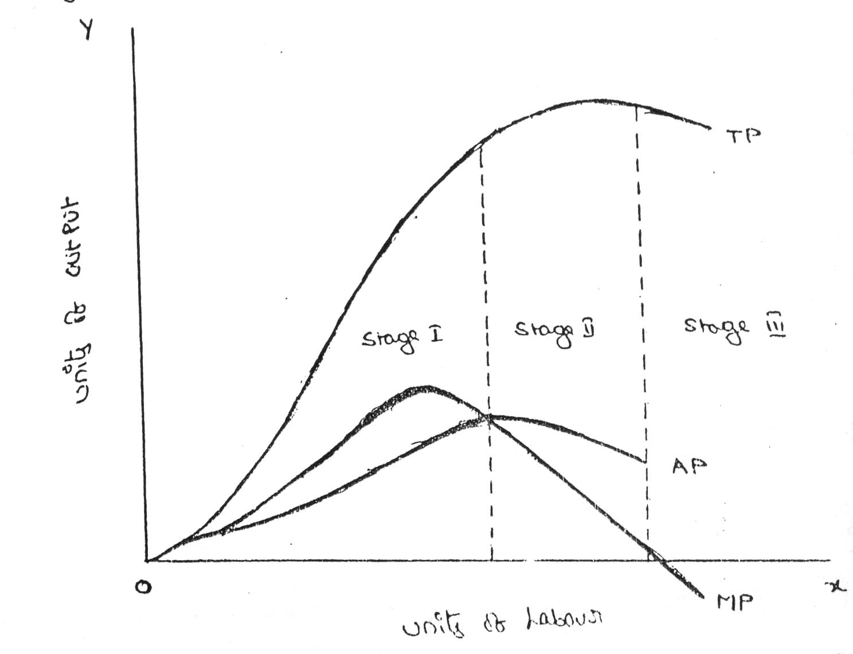

From the above graph the law of variable proportions operates in three stages. In the first stage, total product increases at an increasing rate. The marginal product in this stage increases at an increasing rate resulting in a greater increase in total product. The average product also increases. This stage continues up to the point where average product is equal to marginal product. The law of increasing returns is in operation at this stage.

The law of diminishing returns starts operating from the second stage awards. At the second stage total product increases only at a diminishing rate. The average product also declines. The second stage comes to an end where total product becomes maximum and marginal product becomes zero. The marginal product becomes negative in the third stage. So the total product also declines. The average product continues to decline

|  |  |  |  |
| --- | --- | --- | --- |
| STAGES | TP | MP | AP |
| 1 | Increase at an increasing rate | Increase reach  the maximum | Increase and reach  the maximum |
| 2 | Increase atDiminishing rate Till it reaches Maximum | Diminish equal to zero | Starts Diminish |
| 3 | Start declining | Because negative | Continues to decline |

**ProductionFunction with Two Variable Inputs and Laws of Returns**

Let us consider a production process that requires two inputs, capital(c) and labour (L) to produce a given output (Q). There could be more than two inputs in a real life situation, but for a simple analysis, we restrict the number of inputs to two only. In other words, the production function based on two inputs can be expressed as:

Q=f(C,L)

Normally, both capital and labour are required to produce a product. To some extent, these two inputs can be substituted for each other. Hence the product may choose any combination of labour and capital that gives him the required number of units of output. For any given level of output, a producer may hire both capital and labour, but he is free to choose any one combination of labour and capital out of several such combinations. The alternative combinations of labour and capital yielding a given level of output are such that if the use of one factor input is increased, that of another will decrease and vice versa.

**ISOQUANTS:**

The term Isoquants is derived from the words ‘iso’ and ‘quant’ – ‘Iso’ means equal and ‘quent’ implies quantity. Isoquant therefore, means equal quantity. A family of iso-product curves or isoquants or production difference curves can represent a production function with two variable inputs, which are substitutable for one another within limits.

Isoquants are the curves, which represent the different combinations of inputs producing a particular quantity of output. Any combination on the isoquant represents the some level of output.

Q= f (L, K)

Where ‘Q’, the units of output is a function of the quantity of two inputs ‘L’ and ‘K’.

Thus an isoquant shows all possible combinations of two inputs, which are capable of producing equal or a given level of output. Since each combination yields same output, the producer becomes indifferent towards these combinations.

|  |  |  |  |
| --- | --- | --- | --- |
| Combinations | Labour (units) | Capital (Units) | Output (quintals) |
| A | 1 | 10 | 50 |
| B | 2 | 7 | 50 |
| C | 3 | 4 | 50 |
| D | 4 | 4 | 50 |
| E | 5 | 1 | 50 |

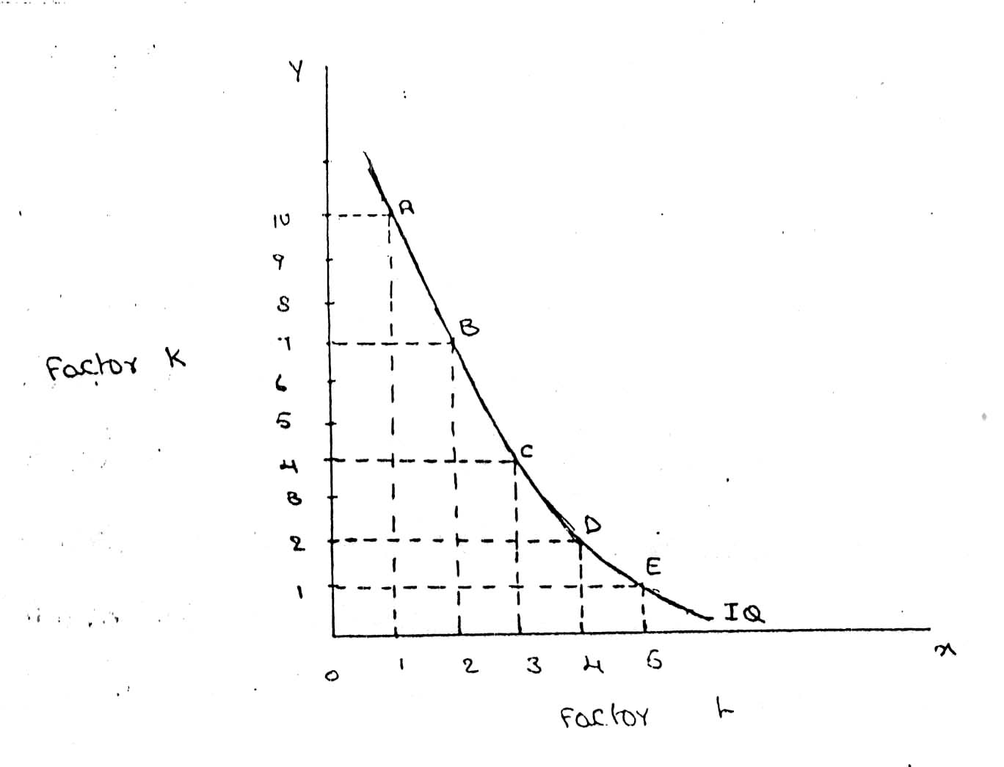

**FEATURES OF AN ISOQUANT**

(1).**DOWNWARD SLOPING:-**Isoquants are downward sloping curves because, if one input increases, the other one reduces. There is no question of increase in both the inputs to yield a given output.

A degree of substitution is assumed between the factors of production. In other words, an isoquant cannot be increasing, as increase in both the inputs does not yield same level of output. If it is constant, it means that the output remains constant though the use of one of the factors is increasing, which is not true, isoquants slope from left to right.

(2).**CONVEX TO ORIGIN:-**Isoquants are convex to the origin. It is because the input factors are not perfect substitutes. One input factors were perfect substituted by other input factor in a 'diminishing marginal rate'. If the input factors were perfect substitutes, the isoquant would be a falling straight line. When the inputs are used in fixed proportion, and substitution of one input for the other cannot take place, the isoquant will be L shaped.

(3).**DO NOT INTERSECT:-**Two isoproducts do not intersect with each other. It is because, each of these denote a particular level of output. If the manufacturer wants to operate at a higher level of output, he has to switch over to another isoquant with a higher level of output and vice versa.

(4).**DO NOT TOUCH AXES:-**The isoquant touches neither x-axis nor y-axis, as both inputs are required to produce a given product.

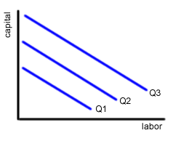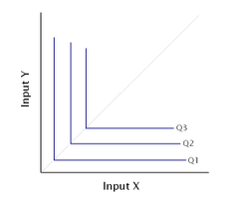

isoquant perfect substitute isoquant not perfect substitute

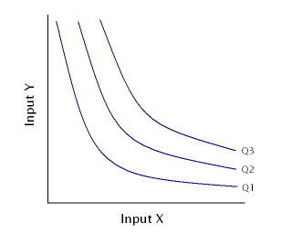

It showing different volume of output

**ISO COST**

## Definition:

A firm can produce a given level of output using efficiently different combinations of two inputs. For choosing efficient combination of the inputs, the producer selects that combination of factors which has the lower cost of production. The information about the cost can be obtained from the***isocost lines.***

**Explanation:**

An isocost line is also called ***outlay line or price line or factor cost line.*** An isocost line shows all the combinations of labor and capital that are available for a given total cost to-the producer..

In economics, the isocost is the set of combinations of goods that have the same total cost; this can be represented by a curve on a graph.   
In economics an `isocost` line shows all combinations of inputs which cost the same total amount

### 

### Isoquant and Isocost

**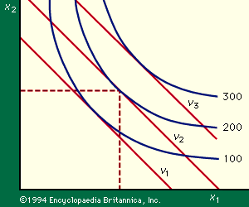**

# Marginal rate of technical substitution

In [economic](http://en.wikipedia.org/wiki/Economic) theory, the **Marginal Rate of Technical Substitution** (**MRTS**) - or **Technical Rate of Substitution** (**TRS**) - is the amount by which the quantity of one input has to be reduced ( − Δ*x*2) when one extra unit of another input is used (Δ*x*1 = 1), so that output remains constant (y = \bar{y}).

MRTS(x_1,x_2) =-\frac{\Delta x_1}{\Delta x_2} = \frac{MP_2}{MP_1}

where *MP*1 and *MP*2 are the [marginal products](http://en.wikipedia.org/wiki/Marginal_product) of input 1 and input 2, respectively, and *MRTS*(*x*1,*x*2) is **Marginal Rate of Technical Substitution** of the input *x*1 for *x*2.Along an isoquant, the MRTS shows the rate at which one input (e.g. capital or labor) may be substituted for another, while maintaining the same level of output. The MRTS can also be seen as the slope of an [isoquant](http://en.wikipedia.org/wiki/Isoquant) at the point in question.

|  |  |  |  |  |
| --- | --- | --- | --- | --- |
| Combinations | Labour (units) | Capital (Units) | Output (quintals) | MRTS |
| A | 20 | 1 | 50 |  |
| B | 15 | 2 | 50 | 5:1 |
| C | 11 | 3 | 50 | 4:1 |
| D | 8 | 4 | 50 | 3:1 |
| E | 6 | 5 | 50 | 2:1 |
| F | 5 | 6 | 50 | 1:1 |

**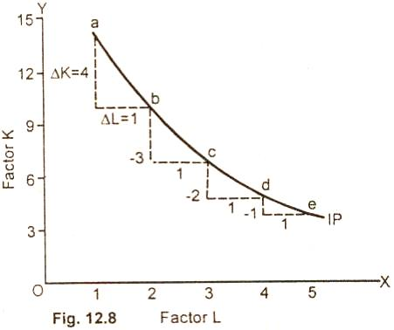**

**Least cost combination of inputs**

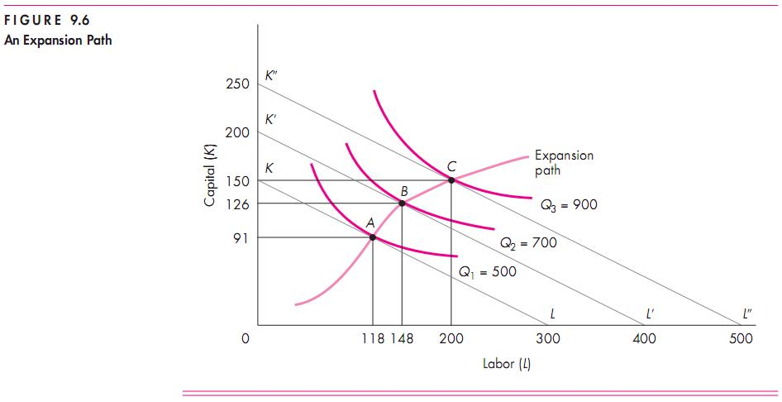

**Cobb-Douglas production function:**

Production function of the linear homogenous type is invested by and first tested by C. W. Cobb and P. H. Dougles in 1899 to1922. This famous statistical production function is known as Cobb-Douglas production function. Originally the function is applied on the empirical study of the American manufacturing industry. Cabb – Douglas production function takes the following mathematical form.

Y= (bKX L1-x)

Where Y=output k=Capital L=Labour

*The production function shows that one percent change in labour, capital reaming the same is associated with a 0.75 %change in output. One percent change in capital, labour reaming the same, is associated with a 0.25 %change in output.*

***Assumptions:***

It has the following assumptions

1. The function assumes that output is the function of two factors viz. capital and labour.
2. It is a linear homogenous production function of the first degree
3. The function assumes that the logarithm of the total output of the economy is a linear function of the logarithms of the labour force and capital stock.
4. There are constant returns to scale
5. All inputs are homogenous(same)

**RETURNS TO SCALE**

Another important attribute of production function is how output responds in the long run to changes in the scale of the firm i.e. when all inputs are increased in the same proportion (by say 10%), how does output change.

Clearly, there are 3 possibilities. If output increases by more than an increase in inputs (i.e.by more than 10%), then the situation is one of **increasing returns to scale (IRS).**

If output increases by less than the increase in inputs, then it is a case of **decreasing returns to scale (DRS).**

Lastly, output may increase by exactly the same proportion as inputs. For example a doubling of inputs may

Lead to a doubling of output. This is a case of **constant returns to scale (CRS).**

|  |  |  |  |  |  |
| --- | --- | --- | --- | --- | --- |
| Capital (Units) | Labour (units) | % increase in both inputs | Output (quintals) | % increase in both output | Law applications |
| 1 | 3 |  | 50 |  |  |
| A2 | 6 | 100 | 120 | 140 | increase |
| 4 | 12 | 100 | 240 | 100 | constant |
| 8 | 24 | 100 | 360 | 50 | decrease |

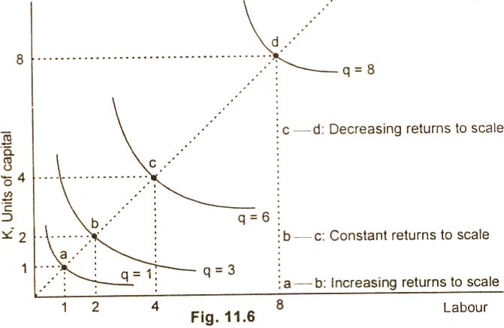

**ECONOMIES OF SCALE**

The economics of scale result because of increase in the scale of production. Marshal divides the economies of scale into two groups:

Internal economies

External; economies

**Internal economies:**

It refers to the economies in production cost which accrue to the firm alone whenit expands it output. the internal economies occur as results of increase in the scale of production.

The internal economies divide into following type:

1. **Managerial economies :**

As the firm expands the firm need qualified managerial personnel to handle each of its functions such as marketing, finace, ect functional specilisational ensure minimum wastage and lower the cost of productions in the long run.

1. **Commercial economies**

The transactions of buying and selling raw material and other operating supplies such as spares and so on. There could be cheaper saving in the procurement, transportation and storage costs. This will leads to lower cost and increase profits.

1. **Financial economies**

There could be cheaper credit facility from the financial institution to meet the capital expenditure or working capital requirement .a large firm to give security to financial institution

1. **Technical economies**

Increase in the scale of production follows when there is sophisticated technology available and the firm is in a position to hire qualified technology manpower to make use of it.

1. **Marketing economies**

As the firm grow lager and lager it can afford to maintain a full fledged marketing departmentindependently to handle the issues related to design of customer ,promotion ,marketing staff.

1. **Risk bearing economies**

As there is growth in size of firm there is increase in the risk also. Sharing in the risk with the insurance companies is the first priority for any firm. The firm insureit machinery and other assets against the fire theft ect.the lager firm can spread their risk so that they do not keep all their eggs in one basket.

1. **Economies of research and development**

Large organizations such as dr.reddy labs,HCL, ect bring out several innovative products.

**External economies**

It refers to the entire firm in the industry, because of growth of the on industry as a whole or because of growth of industry.

1. **Economies concentration**

Because all firm are located at one place ,it is likely that there is better infrastructure in term of approach roads, tans potation ect

1. **Economies of R&D**

The entire firm can pool resource together to finance research and development activity and thus shares benefits of research.

1. **Economies of welfare**

There could be common facility such as canteen, industryhousing, community halls,ect which can be used in common by the employee in the whole industry.

Production may be carried on a small scale or o a large scale by a firm. When a firm expands its size of production by increasing all the factors, it secures certain advantages known as economies of production. Marshall has classified these economies of large-scale production into internal economies and external economies.

Internal economies are those, which are opened to a single factory or a single firm independently of the action of other firms. They result from an increase in the scale of output of a firm and cannot be achieved unless output increases.

**BREAKEVEN ANALYSIS**

The study of cost-volume-profit relationship is often referred as BEA. The term BEA is interpreted in two senses. In its narrow sense, it is concerned with finding out BEP; BEP is the point at which total revenue is equal to total cost. It is the point of no profit, no loss. In its broad determine the probable profit at any level of production

**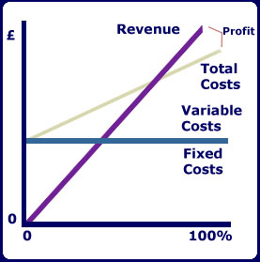**

1. ***Fixed cost:*** Expenses that do not vary with the volume of production are known as fixed expenses. Eg. Manager’s salary, rent and taxes, insurance etc. It should be noted that fixed changes are fixed only within a certain range of plant capacity. The concept of fixed overhead is most useful in formulating a price fixing policy. Fixed cost per unit is not fixed.
2. ***Variable Cost****:* Expenses that vary almost in direct proportion to the volume of production of sales are called variable expenses. Eg. Electric power and fuel, packing materials consumable stores. It should be noted that variable cost per unit is fixed.
3. ***Contribution:*** Contribution is the difference between sales and variable costs and it contributed towards fixed costs and profit. It helps in sales and pricing policies and measuring the profitability of different proposals. Contribution is a sure test to decide whether a product is worthwhile to be continued among different products.

Contribution = Sales – Variable cost

Contribution = Fixed Cost + Profit.

1. ***Margin of safety:*** Margin of safety is the excess of sales over the break even sales. It can be expressed in absolute sales amount or in percentage. It indicates the extent to which the sales can be reduced without resulting in loss. A large margin of safety indicates the soundness of the business. The formula for the margin of safety is:

Present sales – Break even sales **or** 

1. ***Break – Even- Point:*** If we divide the term into three words, then it does not require further explanation.

Break-divide

Even-equal

Point-place or position

Break Even Point refers to the point where total cost is equal to total revenue. It is a point of no profit, no loss. This is also a minimum point of no profit, no loss. This is also a minimum point of production where total costs are recovered. If sales go up beyond the Break Even Point, organization makes a profit. If they come down, a loss is incurred.

1. Break Even point (Units) = 
2. Break Even point (In Rupees) = 

**Merits:**

1. Information provided by the Break Even Chart can be understood more easily then those contained in the profit and Loss Account and the cost statement.
2. Break Even Chart discloses the relationship between cost, volume and profit. It reveals how changes in profit. So, it helps management in decision-making.
3. It is very useful for forecasting costs and profits long term planning and growth
4. The chart discloses profits at various levels of production.
5. It serves as a useful tool for cost control.
6. It can also be used to study the comparative plant efficiencies of the industry.
7. Analytical Break-even chart present the different elements, in the costs – direct material, direct labour, fixed and variable overheads.

**Demerits:**

1. Break-even chart presents only cost volume profits. It ignores other considerations such as capital amount, marketing aspects and effect of government policy etc., which are necessary in decision making.
2. It is assumed that sales, total cost and fixed cost can be represented as straight lines. In actual practice, this may not be so.
3. It assumes that profit is a function of output. This is not always true. The firm may increase the profit without increasing its output.
4. A major draw back of BEC is its inability to handle production and sale of multiple products.
5. It is difficult to handle selling costs such as advertisement and sale promotion in BEC.
6. It ignores economics of scale in production.
7. Fixed costs do not remain constant in the long run.
8. Semi-variable costs are completely ignored.
9. It assumes production is equal to sale. It is not always true because generally there may be opening stock.
10. When production increases variable cost per unit may not remain constant but may reduce on account of bulk buying etc.

# ****(A)ActualCost**** Actual cost is defined as the cost or expenditure which a firm incurs for producing or acquiring a good or service.  The actual costs or expenditures are recorded in the books of accounts of a [business](http://layman-blog.blogspot.in/2010/06/different-types-of-costs-with-examples.html) unit.  Actual costs are also called as "Outlay Costs" or "AbsoluteCosts"or"AcquisitionCosts". Examples:  Costofrawmaterials,WageBilletc.

# OpportunityCost Opportunity cost is concerned with the cost of forgone opportunities/alternatives.  In other words, it is the return from the second best use of the firms resources which the firms forgoes in order to avail of the return from the best use of the resources.  It can also be said as the comparison between the policy that was chosen and the policy that was rejected.  The concept of opportunity cost focuses on the net revenue that could be generated in the next best use of a scare input.  Opportunity cost is also called as "Alternative Cost". If a firm owns a land, there is no cost of using the land (ie., the rent) in the firms account.  But the firm has an opportunity cost of using the land, which is equal to the rent forgone by not letting the land out on rent. **(C) Sunk Cost** Sunk costs are those do not alter by varying the nature or level of business activity.  Sunk costs are generally not taken into consideration in decision - making as they do not vary with the changes in the future.  Sunk costs are a part of the outlay/actual costs.  Sunk costs are also called as "Non-Avoidable costs" or "Inescapable costs". Examples: All the past costs are considered as sunk costs. The best example is amortization of past expenses, like depreciation. (D) Incremental Cost Incremental costs are addition to costs resulting from a change in the nature of level of business activity.  As the costs can be avoided by not bringing any variation in the activity in the activity, they are also called as "Avoidable Costs" or "Escapable Costs". More ever incremental costs resulting from a contemplated change is the Future, they are also called as "Differential Costs" Example: Change in distribution channels adding or deleting a product in the product line. (E) Explicit Cost Explicit costs are those expenses/expenditures that are actually paid by the firm.  These costs are recorded in the books of accounts.  Explicit costs are important for calculating the profit and loss accounts and guide in economic decision-making.  Explicit costs are also called as "Paid out costs" Example: Interest payment on borrowed funds, rent payment, wages, utility expenses etc. (F) Implicit Cost Implicit costs are a part of opportunity cost. They are the theoretical costs ie., they are not recognised by the accounting system and are not recorded in the books of accounts but are very important in certain decisions.  They are also called as the earnings of those employed resources which belong to the owner himself.  Implicit costs are also called as "Imputed costs". Examples: Rent on idle land, depreciation on dully depreciated property still in use, interest on equity capital etc. (G) Book Cost Book costs are those business costs which don't involve any cash payments but a provision is made in the books of accounts in order to include them in the profit and loss account and take tax advantages, like provision for depreciation and for unpaid amount of the interest on the owners capital. (H) Out Of Pocket Costs Out of pocket costs are those costs are expenses which are current payments to the outsiders of the firm.  All the explicit costs fall into the category of out of pocket costs. Examples: Rent Payed, wages, salaries, interest etc (I) Accounting Costs Accounting costs are the actual or outlay costs that point out the amount of expenditure that has already been incurred on a particular process or on production as such accounting costs facilitate for managing the taxation need and profitability of the firm. Examples: All Sunk costs are accounting costs (J) Economic Costs Economic costs are related to future.  They play a vital role in business decisions as the costs considered in decision - making are usually future costs.  They have the nature similar to that of incremental, imputed explicit and opportunity costs. (K) Direct Cost Direct costs are those which have direct relationship with a unit of operation like manufacturing a product, organizing a process or an activity etc.  In other words, direct costs are those which are directly and definitely identifiable.  The nature of the direct costs are related with a particular product/process, they vary with variations in them.  Therefore all direct costs are variable in nature. It is also called as "Traceable Costs" Examples: In operating railway services, the costs of wagons, coaches and engines are direct costs. (L) Indirect Costs Indirect costs are those which cannot be easily and definitely identifiable in relation to a plant, a product, a process or a department.  Like the direct costs indirect costs, do not vary ie., they may or may not be variable in nature.  However, the nature of indirect costs depend upon the costing under consideration.  Indirect costs are both the fixed and the variable type as they may or may not vary as a result of the proposed changes in the production process etc. Indirect costs are also called as Non-traceable costs. Example: The cost of factory building, the track of a railway system etc., are fixed indirect costs and the costs of machinery, labour etc..,

# UNIT-III

# MARKETS AND NEW ECONOMIC ENVIRONMENT

# Introduction

# Pricing is an important, if not the most important function of all enterprises. Since every enterprise is engaged in the production of some goods or/and service. Incurring some expenditure, it must set a price for the same to sell it in the market.

# Price

# Price denotes the exchange value of a unit of good expressed in terms of money. Thus the current price of a maruti car around Rs. 2,00,000, the price of a hair cut is Rs. 25 the price of a economics book is Rs. 150 and so on. Nevertheless, if one gives a little, if one gives a little thought to this subject, one would realize that there is nothing like a unique price for any good. Instead, there are multiple prices.

# Price concepts

# Price of a well-defined product varies over the types of the buyers, place it is received, credit sale or cash sale, time taken between final production and sale, etc.

# The multiple prices is more serious in the case of items like cars refrigerators, coal, furniture and bricks and is of little significance for items like shaving blade, soaps, tooth pastes, creams and stationeries. Differences in various prices of any good are due to differences in transport cost, storage cost accessories, interest cost, intermediaries’ profits etc.

# Price determinants – Demand and supply (Equilibrium Price)

# The price at which demand and supply of a commodity is equal known as equilibrium price. The demand and supply schedules of a good are shown in the table below.

# Demand supply schedule

|  |  |  |
| --- | --- | --- |
| Price | Demand | Supply |
| 50 | 100 | 200 |
| 40 | 120 | 180 |
| 30 | 150 | 150 |
| 20 | 200 | 110 |
| 10 | 300 | 50 |

# Of the five possible prices in the above example, price Rs.30 would be the market-clearing price. No other price could prevail in the market. If price is Rs. 50 supply would exceed demand and consequently the producers of this good would not find enough customers for their demand, thereby they would accumulate unwanted inventories of output. Similarly if price were Rs.10, there would be excess demand, which would give rise to competition among the buyers of good, forcing price to Rs.30. At price Rs.30, demand equals supply and thus both producers and consumers are satisfied. The economist calls such a price as equilibrium price.

# 

# It was seen in unit 1 that the demand for a good depends on, a number of factors and thus, every factor, which influences either demand or supply is in fact a determinant of price. Accordingly, a change in demand or/and supply causes price change.

# BASIC FACTORS IN PRICING

# Factors considered while pricing:

# Price of raw materials: Price of any item primarily depends upon the raw material availability and the cost spent on purchasing the raw martial. If prices of raw materials are high, price of the finished product will also be high and vice versa. If availability of raw materials is less, the price will get increased else it will be minimum.

# Production costs: Next factor deterring the price of the product is the production costs. Higher the production costs, higher will be the price of finished goods. It includes cost of machinery, hiring people, transportation costs, and distribution costs etc.

# Profit expectation: Profit expectation influences the price a lot. If the organization has higher profit expectations, the price of the product becomes high and vice versa.

# Price of the complementary goods: The organization needs to have an eye on the Complementary goods price. If the complimentary goods price is high, the organization has to reduce its price otherwise both the products will lose the demand. But the firm can price the item high if the price of complimentary good is less.

# Number of substitutes: If the number of substitutes for the product is high, the organization should be very careful while pricing the item. Because of perfect competition, there is a chance of losing the customer base. If the number of substitutes is less, the organization can price the item according to their wish.

# Intervention of government: One of the most important factors in the necessary products is the government intervention. In the some product category, Government will fix some price ceiling and the organization has to price their items according to that only.

# Demand for the product: The most common factor that has to be considered while pricing is demand. Higher the demand, higher the price can be charged.

# 

# MARKET

# Market is a place where buyer and seller meet, goods and services are offered for the sale and transfer of ownership occurs. A market may be also defined as the demand made by a certain group of potential buyers for a good or service. The former one is a narrow concept and later one, a broader concept.

# Narrow concept Economists describe a market as a collection of buyers and sellers who transact over a particular product or product class (the housing market, the clothing market, the grain market etc.). For business purpose we define a market as people or organizations with wants (needs) to satisfy, money to spend, and the willingness to spend it.

# Broadly, market represents the structure and nature of buyers and sellers for a commodity/service and the process by which the price of the commodity or service is established. In this sense, we are referring to the structure of competition and the process of price determination for a commodity or service

# Different Market Structures

# Market:

# A Market is a place where sellers sell and buyers buy a commodity. According to Robert Dorfman, a market is a group of people and firm who are in contact with one another for the purpose of buying and selling some commodity. It is not necessary that every member of the market be in contact with every other one; the contacts may be indirect.

# Market structure describes the competitive environment in the market for any good or service. A market consists of all firms and individuals who are willing and able to buy or sell a particular product. This includes firms and individuals currently engaged in buying and selling a particular product, as well as potential entrants.

# fig-19

# Perfect competitionIt refers to a market structure where competition among the sellers and buyers prevails in its most perfect form. In a perfectly competitive market, a single market price prevails for the commodity, which is determined by the forces of total demand and total supply in the market.

# Monopoly:- If there is only one seller, monopoly market is said to exist. An extreme version of imperfect market is monopoly. Here a single seller completely controls the entire industry. It is only firm producing the given product in its industry. In case of monopoly, there is very little difference between the firm and industry. The firm is called monopolist or monopoly firm. Maruti-Suzuki enjoyed all the government protection for a long time when it enjoyed monopoly in respect of small cars.

# Monopolistic Competition:- When large number of sellers produces differentiated products, monopolistic competition is said to exist. A product is said to be differentiated when its important features vary. It may be differentiated based on real or perceived differences. For cameras, the important features include Zoom lenses, focal length, memory, size of camera, aperture and exposure controls, flash, safety, digital day and date display, and the overall picture quality and so on.

# Duopoly:- If there are two sellers, duopoly is said to exist. If Pepsi and coke are the two companies in soft drinks, this market is called duopoly. Basic facilities for satellite communication are presently provided by Mahan agar Telephone Nigam Limited (MNTL) and videsh sanchar Nigam Limited (VSNL). This market for satellite Communication can be referred to as duopoly.

# Oligopoly:- Another variety of imperfect competition is oligopoly. If there is competition among a few sellers, oligopoly is said to exist. The examples are the car manufacturing companies (such as Maruti suzuki, Hindustan Motors, Daewoo, Toyota and so on), newspapers (such as The Hindu, Indian Express, times of india, Economic Times, Eenadu and so on). In oligopoly, each individual seller or firm can affect the market price

# Comparison of various market forms

|  |  |  |  |  |  |
| --- | --- | --- | --- | --- | --- |
| Characteristic | | Perfect competition | Imperfect competition | | |
| Monopolistic competition | oligopoly | Monopoly |
|  | Number of firms | Many | Many | few | one |
|  | Ability to affect price | None | Limited | Some | considerable |
|  | Entry barriers | None (Free entry) | None (Free entry) | Some (limited entry) | Complete (No entry) |
|  | Product type | Homogeneous | Differentiated | Homogeneous | Brand |
|  | Marketing methods | Commodity exchanges or actions | Advertising quality and design differences | Advertising qualityRevelry administered prices | Promotional and public relations advertising |
|  | Example | Fruit stalls | Grocer | Cars | Post office |

# Characteristics of Perfect Competition

# The following features characterize a perfectly competitive market:

# A large number of buyers and sellers: The number of buyers and sellers is large and the share of each one of them in the market is so small that none has any influence on the market price.

# Homogeneous product: The product of each seller is totally undifferentiated from those of the others. Under perfect competition, the product offered for sale by all the seller must be identical in every respect. The goods offered for sale are perfect substitutes of one another. Buyers have no special preference for the product of a particular seller. No seller can raise the price above the prevailing price or lower the price below the prevailing price.

# Free entry and exit: Any buyer and seller is free to enter or leave the market of the commodity. Under perfect competition, there will be no restriction on the entry and exit of both buyers and sellers. If the existing sellers start making abnormal profits, new sellers should be able to enter the market freely. This will bring down the abnormal profits to the normal level. Similarly, when losses will occur existing sellers may leave the market. However, such free entry or free exit is possible only in the long run, but not in the short-run.

# Perfect knowledge: All buyers and sellers have perfect knowledge about the market for the commodity. Perfect competition implies perfect knowledge on the part of buyers and sellers regarding the market conditions. As a results, no buyer will be prepared to pay a price higher than the prevailing price. Sellers will not charge a price higher or lower than the prevailing price. In this market, advertisement has no scope.

# Indifference (**No attachment):**: No buyer has a preference to buy from a particular seller and no seller to sell to a particular buyer.There is no attachment between the buyers and sellers under perfect competition. Since products of all sellers are identical and their prices are the same a buyer is free to buy the commodity from any seller he likes. He has no special inclination for the product of any seller as in case of monopolistic competition or oligopoly. Theoretically, perfect competition is irrelevant. In reality, it does not exist.

# Non-existence of transport costs: Perfectly competitive market also assumes the non-existence of transport costs.

# Perfect mobility of factors of production: Factors of production must be in a position to move freely into or out of industry and from one firm to the other.The second perfection mobility of factors of production from one use to another use. This feature ensures that all sellers or firms get equal advantages so far as services of factors of production are concerned. This is essential to enable the firms and industry to achieve equilibrium.

Under such a market no single buyer or seller plays a significant role in price determination. One the other hand all of them jointly determine the price. The price is determined in the industry, which is composed of all the buyers and seller for the commodity. The demand curve facing the industry is the sum of all consumers’ demands at various prices. The industry supply curve is the sum of all sellers’ supplies at various prices.

**Pure competition and perfect competition**

The term perfect competition is used in a wider sense. Pure competition has only limited assumptions. When the assumptions, that large number of buyers and sellers, homogeneous products, free entry and exit are satisfied, there exists pure competition. Competition becomes perfect only when all the assumptions (features) are satisfied. Generally pure competition can be seen in agricultural products.

# fig-20

# The equilibrium of a perfectly competitive firm may be explained with the help of the fig. 6.2.

# In the given fig. PL and MC represent the Price line and Marginal cost curve. PL also represents Marginal revenue, Average revenue and demand. As Marginal revenue, Average revenue and demand are the same in perfect competition, all are equal to the price line. Marginal cost curve is U- shaped curve cutting MR curve at R and T. At point R marginal cost becomes equal to marginal revenue. But MC curve cuts the MR curve from above. So this is not the equilibrium position. The downward sloping marginal cost curve indicates that the firm can reduce its cost of production by increasing output.

# PRICE-OUTPUT DETERMINATION IN CASE OF PERFECT COMPETITION

# The price or value of a commodity under perfect competition is determined by the demand for and the supply of that commodity.

# Under perfect competition there is large number of sellers trading in a homogeneous product. Each firm supplies only very small portion of the market demand. No single buyer or seller is powerful enough to influence the price. The demand of all consumers and the supply of all firms together determine the price.

# The individual seller is only a price taker and not a price maker. An individual firm has no price policy of its own. Thus, the main problem of a firm in a perfectly competitive market is not to determine the price of its product but to adjust its output to the given price, So that the profit is maximum.

# Marshall however gives great importance to the time element for the determination of price. He divided the time periods on the basis of supply and ignored the forces of demand. It is two types 1. Time based 2. Profit based

# TIME BASED

# Very short period or Market period

# Short period

# Long period

# Very short period:

# It is the period in which the supply is more or less fixed because the time available to the firm to adjust the supply of the commodity to its changed demand is extremely short; say a single day or a few days. The price determined in this period is known as Market Price.

# fig-21

# In this figure quantity is represented along X-axis and price is represented along Y-axis. MS is the very short period supply curve of perishable goods. DD is demand curve. It intersects supply curve at E. The price is OP. The quantity exchanged is OM. D1 D1 represents increased demand. This curve cuts the supply curve at E1. Even at the new equilibrium, supply is OM only. But price increases to OP1. So, when demand increases, the price will increase but not the supply. If demand decreases new demand curve will be D2 D2. This curve cuts the supply curve at E2. Even at this new equilibrium, the supply is OM only. But price falls to OP2. Hence in very short period, given the supply, it is the change in demand that influences price. The price determined in a very short period is called Market Price.

# Short Period:

# In this period, the time available to firms to adjust the supply of the commodity to its changed demand is, of course, greater than that in the market period. In this period altering the variable factors like raw materials, labour, etc can change supply. During this period new firms cannot enter into the industry.

# fig-23

# In the given diagram MPS is the market period supply curve. DD is the initial demand curve. It intersects MPS curve at E. The price is OP and out put OM. Suppose demand increases, the demand curve shifts upwards and becomes D1D1. In the very short period, supply remains fixed on OM. The new demand curve D1D1 intersects MPS at E1. The price will rise to OP1. This is what happen in the very short-period.

# As the price rises from OP to OP1, firms expand output. As firms can vary some factors but not all, the law of variable proportions operates. This results in new short-run supply curve SPS. It interests D1 D1 curve at E4. The price will fall from OP1 to OP4.

# It the demand decreases, DD curve shifts downward and becomes D2D2. It interests MPS curve at E2. The price will fall to OP2. This is what happens in market period. In the short period, the supply curve is SPS. D2D2 curve interests SPS curve at E3. The short period price is higher than the market period price.

# Long period:

# In this period, a sufficiently long time is available to the firms to adjust the supply of the commodity fully to the changed demand. In this period not only variable factors of production but also fixed factors of production can be changed. In this period new firms can also enter the industry. The price determined in this period is known as long run normal price.

# http://images.flatworldknowledge.com/rittenberg/rittenberg-fig04_002.jpg

# PRICE FIXATION AND PROFIT

# Super normal profit :

# Normal profit :

# *Subnormal profit*

# Super normal profit :

# The price and output of the firm are determined, under perfect competition, based on the industry price and its own cost. The industry price has greater say in this process because the firm’s own sales are very small and significant. The process of price output determination in case of perfect competition is illustrated.

# The firm’s demand curve is horizontal at the price determined in the industry (MR=AR=price). This demand curve is also known as average revenue curve. This is because if all the units are sold at the same price, on an average, the revenue to the firm equals its price.

# When the average revenue is constant (neither falling nor rising), it will coincide with the marginal revenue curve. Thus, CC is the demand curve representing the price, average revenue curve, and also the marginal revenue curve (Price = AR = MR). Average cost (AC) and marginal cost (MC) are the firm average and marginal cost curves.

# 

# In fig. 8.3, the firm satisfies both conditions: (a) MR = MC; and (b) MC curve must cut the MR curve from below. The firm attains equilibrium at point D where MR = MC. The MC curve passes through the minimum point of AC curve.

# Equilibrium Output Determination of a Firm under Perfect Competition in the Short run:

# The firm gets higher profits as long as the price (in this case MR or AR) it receives for each unit exceeds the average cost (AC) of production.

# Average, DE is the average profit and the area CDEF is the total profit which constitutes the ‘supernormal’ or ‘abnormal’ profits.

# Based on its cost function and marker condition, the firm may make profits. Losses or just break even in the short-run

# Normal profit :

# Having been attracted by supernormal profits, more and more firms enter the industry. With the result, there will be a scramble for scare inputs among the competing firms pushing the input prices. Hence, the average cost increases. The entry of more and more firms will expand the supply pulling down the marker price. As a result, the super normal profits hitherto enjoyed by the firms get eroded. The entry of the firms into the industry continues till the supernormal profits but not supernormal profits. Normal profits are the profits that are just sufficient for the firms to stay in the business. It is to be noted that normal profits are included in the average cost curve.

# All those firms that are not able to earn at least normal will leave the industry.

# 

# Subnormal profit

# In the short-run, if the marker price is below the average cost, the firm may still supply goods provided the market price is above the average variable cost. If the market price is below the average variable cost, the firm refuses to sell the goods even in the short-run for the simple reason that, by not selling the goods, the firm suffers a loss equal to average fixed cost only. If it sells the goods, the loss will be more than the average fixed costs. Thus, the firm’s short-run supply curve will be that portion of the marginal cost curve which is above the average variable cost curve

# C:\Users\DEVA PRASAD\Desktop\loss_making_firm.png

Long-run marginal cost (LMC) curve passes through the minimum point of the long-run average cost curve (LAC) at E, while passing through the marginal revenue curve. E is the equilibrium point and the firm produces OQ units of output. It can be noted that normal profits are not visible to the naked eye since normal profits are included in the average cost. Long-run average cost includes the opportunity cost of staying in business

# C:\Users\DEVA PRASAD\Desktop\Fig. 12.4 Alt SR Outcomes.jpg

# *.*

# Monopoly

# The word monopoly is made up of two syllables, Mono and poly. Mono means single while poly implies selling. Thus monopoly is a form of market organization in which there is only one seller of the commodity. There are no close substitutes for the commodity sold by the seller. Pure monopoly is a market situation in which a single firm sells a product for which there is no good substitute.

# Features of monopoly

# The following are the features of monopoly.

# Single person or a firm: A single person or a firm controls the total supply of the commodity. There will be no competition for monopoly firm. The monopolist firm is the only firm in the whole industry.

# No close substitute: The goods sold by the monopolist shall not have closely competition substitutes.Even if price of monopoly product increase people will not go in far substitute. For example: If the price of electric bulb increase slightly, consumer will not go in for kerosene lamp.

# Large number of Buyers: Under monopoly, there may be a large number of buyers in the market who compete among themselves.

# Price Maker: Since the monopolist controls the whole supply of a commodity, he is a price-maker, and then he can alter the price.

# Supply and Price: The monopolist can fix either the supply or the price. He cannot fix both. If he charges a very high price, he can sell a small amount. If he wants to sell more, he has to charge a low price. He cannot sell as much as he wishes for any price he pleases.

# Downward Sloping Demand Curve: The demand curve (average revenue curve) of monopolist slopes downward from left to right. It means that he can sell more only by lowering price.

# Types of Monopoly

# Monopoly may be classified into various types. The different types of monopolies are explained below:

# Legal Monopoly: If monopoly arises on account of legal support or as a matter of legal privilege, it is called Legal Monopoly. Ex. Patent rights, special brands, trade means, copyright etc.

# Government Monopoly: Sometimes the government will take the responsibility of supplying a commodity and avoid private interference. Ex. Water, electricity. These monopolies, created to satisfy social wants, are formed on social considerations. These are also called Social Monopolies.

# Private Monopoly: If the total supply of a good is produced by a single private person or firm, it is called private monopoly. Hindustan Lever Ltd. Is having the monopoly power to produce Lux Soap.

# Pricing under Monopoly

# Monopoly refers to a market situation where there is only one seller. He has complete control over the supply of a commodity. He is therefore in a position to fix any price. Under monopoly there is no distinction between a firm and an industry. This is because the entire industry consists of a single firm.

# fig-27

# The market demand curve of the monopolist (the average revenue curve) is downward sloping. Its corresponding marginal revenue curve is also downward sloping. But the marginal revenue curve lies below the average revenue curve as shown in the figure. The monopolist faces the down-sloping demand curve because to sell more output, he must reduce the price of his product. The firm’s demand curve and industry’s demand curve are one and the same. The average cost and marginal cost curve are U shaped curve. Marginal cost falls and rises steeply when compared to average cost.

# Price output determination (Equilibrium Point)

# The monopolistic firm attains equilibrium when its marginal cost becomes equal to the marginal revenue. The monopolist always desires to make maximum profits. He makes maximum profits when MC=MR. He does not increasing his output if his revenue exceeds his costs. But when the costs exceed the revenue, the monopolist firm incur loses. Hence the monopolist curtails his production. He produces up to that point where additional cost is equal to the additional revenue (MR=MC). Thus point is called equilibrium point. The price output determination under monopoly may be explained with the help of a diagram.

# In the diagram 6.12 the quantity supplied or demanded is shown along X-axis. The cost or revenue is shown along Y-axis. AC and MC are the average cost and marginal cost curves respectively. AR and MR curves slope downwards from left to right. AC and MC and U shaped curves. The monopolistic firm attains equilibrium when its marginal cost is equal to marginal revenue (MC=MR). Under monopoly, the MC curve may cut the MR curve from below or from a side. In the diagram, the above condition is satisfied at point E. At point E, MC=MR. The firm is in equilibrium. The equilibrium output is OM.

# The above diagram (Average revenue) = MQ or OP

# Average cost = MR

# Profit per unit = Average Revenue-Average cost=MQ-MR=QR

# Total Profit = QRXSR=PQRS

# fig-28

# The area PQRS resents the maximum profit earned by the monopoly firm.

# But it is not always possible for a monopolist to earn super-normal profits. If the demand and cost situations are not favorable, the monopolist may realize short run losses.

# Through the monopolist is a price marker, due to weak demand and high costs; he suffers a loss equal to PABC.

# If AR > AC -> Abnormal or super normal profits.

# If AR = AC -> Normal Profit

# If AR < AC -> Loss

# In the long run the firm has time to adjust his plant size or to use existing plant so as to maximize profits.

# Monopolistic competition

# Perfect competition and pure monopoly are rate phenomena in the real world. Instead, almost every market seems to exhibit characteristics of both perfect competition and monopoly. Hence in the real world it is the state of imperfect competition lying between these two extreme limits that work. Edward. H. Chamberlain developed the theory of monopolistic competition, which presents a more realistic picture of the actual market structure and the nature of competition.

# Characteristics of Monopolistic CompetitionThe important characteristics of monopolistic competition are:

# Existence of Many firms: Industry consists of a large number of sellers, each one of whom does not feel dependent upon others. Every firm acts independently without bothering about the reactions of its rivals. The size is so large that an individual firm has only a relatively small part in the total market, so that each firm has very limited control over the price of the product. As the number is relatively large it is difficult for these firms to determine its price- output policies without considering the possible reactions of the rival forms. A monopolistically competitive firm follows an independent price policy.

# Product Differentiation: Product differentiation means that products are different in some ways, but not altogether so. The products are not identical but the same time they will not be entirely different from each other. IT really means that there are various monopolist firms competing with each other. An example of monopolistic competition and product differentiation is the toothpaste produced by various firms. The product of each firm is different from that of its rivals in one or more respects. Different toothpastes like Colgate, Close-up, Forehans, Cibaca, etc., provide an example of monopolistic competition. These products are relatively close substitute for each other but not perfect substitutes. Consumers have definite preferences for the particular verities or brands of products offered for sale by various sellers. Advertisement, packing, trademarks, brand names etc. help differentiation of products even if they are physically identical.

# Large Number of Buyers: There are large number buyers in the market. But the buyers have their own brand preferences. So the sellers are able to exercise a certain degree of monopoly over them. Each seller has to plan various incentive schemes to retain the customers who patronize his products.

# Free Entry and Exist of Firms: As in the perfect competition, in the monopolistic competition too, there is freedom of entry and exit. That is, there is no barrier as found under monopoly.

# Selling costs: Since the products are close substitute much effort is needed to retain the existing consumers and to create new demand. So each firm has to spend a lot on selling cost, which includes cost on advertising and other sale promotion activities.

# Imperfect Knowledge: Imperfect knowledge about the product leads to monopolistic competition. If the buyers are fully aware of the quality of the product they cannot be influenced much by advertisement or other sales promotion techniques. But in the business world we can see that thought the quality of certain products is the same, effective advertisement and sales promotion techniques make certain brands monopolistic. For examples, effective dealer service backed by advertisement-helped popularization of some brands through the quality of almost all the cement available in the market remains the same.

# Pricing Methods

# Pricing is not an exact science. Pricing decisions, more often, are done by trial and error. Most often we see discounts and concessions offered at the time of purchase. Sometimes, certain shames are introduced wherein if you by a packet of Tea powder, a dining still table spoon if free! Why are all these provided? While the main objective of such shames is to increase sales, one of the other objectives is also to correct the pricing strategy, if at all it has gone wrong earlier.

# Pricing is an important exercise. Under-pricing will result in losses and over-pricing will make the customers run away. To determine pricing in a scientific manner, it is necessary to understand the pricing objectives, pricing methods, pricing policies, and pricing procedures.

# PRICING OBJECTIVES

# Pricing objectives refer to the general and specific objectives, which a firm sets for itself in establishing the price of its products and/or services and these are not much different from the marketing objectives or firm's overall business objectives.

# Generally, the following are the objectives of pricing.

# (a) To maximize profits,

# (b) To increase sales

# (c) To increase the market share,

# (d) To satisfy customers, and

# (e) To meet the competition.

# PRCING POLICY

# The firm has to formulate its pricing policies, particularly when it deals in multiple products. The pricing policies are intended to bring consistency in the pricing pattern. For instance, to maintain price differentials between the deluxe models and basic models and so on. Pricing policy defines how to handle complex issues such as price discrimination and so forth.

# PRICING METHODS

# 1. COST-BASED PRICING METHODS

# (a) COST PULS PRICING;- This is also called 'full cost or mark up' pricing. Here the average cost at normal capacity of output is ascertained and then a conventional margin of profit is added to the cost to arrive at the price. In other words, find out the product unit's total cost and add a percentage of profit to arrive at the selling price.

# (b) MARGINAL COST PRICING;- In marginal cost pricing, selling price is fixed in such a way that it covers fully the variable or marginal cost and contributes towards recovery of fixed costs fully or partly, depending upon the market situations. In times of stiff competition, marginal cost offers a guide-line as to how far the selling price can be lowered.

# fig-33

# COMPETITION-ORIENTED PRICING

# Here the pricing is a very complex task. Here the price of a product is set based on what the competitor charges for similar products. In other words, a reduction in the price of products by the competitor will force us also to follow suit. In such a case, how far we can go on reducing the price? Here the marginal cost concept comes handy. As long as the price covers the marginal cost, continue to sell. If not, better stop selling. It is because, every unit sold at less than marginal cost results in loss.

# SEALED BID PRICING;- This method popular in tenders and contracts. Each contracting firm quotes its price in a sealed cover called 'tender'. All the tenders are opened on a scheduled date and the person, who quotes the lowest price, other things remaining the same, is awarded the contract. The objective of the bidding firm is to bag the contract and hence it will quote lower than others. Marginal cost concept continues to be the guiding principle here also. Any price quoted less than the marginal price results in loss. Any price quoted ambitiously, no doubt, results in profit but suffers from the danger of losing the contract.

# GOING RATE PRICING;-Here the price charged by the firm is in tune with price charged in the industry as a whole. In other words, the prevailing market price at a given point of time is the guiding factor. When one wants to buy determine the price. Normally the market leaders keep announcing the prevailing prices at a given point of time based on demand and supply positions.

# DEMAND-ORIENTED PRICING

# The higher the demand, the higher can be the price. Cost is not the consideration here. The key to pricing here is the value as perceived by the consumer. This is a relatively modern marketing concept. Today most of the organizations consider favorably such proposals where there is possibility to charge higher prices on their products and services, even though they call for higher investments and latest technology. Demand-oriented pricing can take two forms: (a) Differential pricing also called price discrimination, (b) perceived value pricing.

# PRICE DISCRIMINATION;-

# Price discrimination refers to the practice of charging different prices to customers for the same good. The firm uses its desecration to charge differently the different customers. It is also called differential pricing. customers of different profiles can be separated in various ways, such as by different consumer requirements (for example bulk and low gas supply to industrial and household consumers), by nature of product itself (for example original and replacement components of pressure cookers), by geographical areas (domestic and international markets), by income group (in a government hospital the patients are charged a fee based on their income groups) and so on.

# The objects of price discrimination are to

# \* develop a new market including for export,

# \* utilize the maximum capacity,

# \* share consumer's surplus along with consumer, not leaving it totally to him,

# \* meet competition,

# \* increase market share.

# PERCEIVED VALUE PRICING;- Perceived value pricing refers to where the price is fixed on the basis of the perception of the buyer of the value of the products.

# STRATEGY-BASED PRICING

# MARKET SKIMMING;-

# When the product is introduced for the first time in the market, the company follows this method. Under this method, the company fixes a very high price for the product. The main idea is to charge the customer maximum possible. This strategy is mostly found in case of technology products. When Sony introduces a particular TV model, it fixes a very high price. When new series of Pentium is released into market, it is priced very high. Initially, all cannot afford except a very few. As the time passes by, the price comes down and more people can afford to buy except a very few. This method can be followed only when (i) the demand for the product is inelastic,(ii) there is no threat from competitors,(iii) a high price is coupled with high technology or quality.

# MARKET PENETRATION;-

# This is exactly opposite to the market skimming method. Here the price of the product is fixed so low that the company can increase its market share. The company attains profits with increasing volumes and increase in the market share. More often, the companies believe that it is necessary to dominate the market in the long-run than making profits in the short-run. This method is more suitable where market is highly price-sensitive. In such a case, a low price stimulates more rapid growth. It will be more appropriate in cases where the costs are likely to fall with increase in output. A low price may not attract significant degree of competition also.

# TWO-PART PRICING;-

# The firms with market power can enhance profits by the strategy of two-part pricing. Under this strategy, a firm charges a fixed fee for the right to purchase its goods, plus a per unit charges for each unit purchased. Entertainment house such as country clubs. Golf courses and health clubs usually adopt this strategy. Then charge a fixed initiation fee plus a charge per month or per visit, to use the facilities. There are also organizations that charge membership fee (equivalent to the consumer surplus) and offer their products and services cost-to-cost basis.

# BLOCK PRICING;-

# Block pricing is another way a firm with market power can enhance its profits. We see block pricing in our day-to-day life very frequently. Six Lux soaps in a single packed or five Magi noodles in a single pack illustrate this pricing method. By selling certain number of units of a product as one package, the firm earns more than by selling unit wise. The block pricing is a profit maximization price on each package. It is generally the total value the consumer receives for the package, including consumer surplus.

# COMMODITY BUNDLING;-

# Commodity bundling refers to the practice of bundling two or more different products together and selling them at a single 'bundle price'. The package includes the airfare, hotel, meals, sightseeing and so on at a bundled price instead of pricing each of these services separately. Computer firms offer PCs, assembling as per the customer specifications and offer them at a bundled price. The car companies provide cars with air-conditioning, Power steering, automatic transmission, auto gear and so forth, and sell them at a special price.

# PEAK LOAD PRICING;-

# During seasonal period when demand is likely to be higher, a firm may enhance profits by peak load pricing. The firm's philosophy is to charge a higher price during peak times than is charged during off-peak times. The pricing is done in such a way that the business is not lost to the competitors. The firm following such a strategy covers the likely losses during the off-peak times form the likely profits from the peak times.

# CROSS SUBSIDISATION;-

# In cases where demand for two products produced by a firm is interrelated through demand or costs, the firm may enhance the profitability of its operations through cross subsidization. Using the profits generated by established products, a firm may expand its activates by financing new product development and diversification into new product markets.

# TRANSFER PRICING;- Transfer pricing is an internal pricing technique. It refers to a price at which inputs of one department are transferred to another, in order to maximize the overall profits of the company.