Digital Image Processing

Enhancement In Frequency Domain:

The frequency domain methods of image enhancement are based on convolution theorem. This is represented as,

g(x, y) = h (x, y)*f(x, y)

Where.

g(x, y) = Resultant image

h(x, y) = Position invariant operator f(x, y)= Input image

The Fourier transform representation of equation above is,

G (u, v) = H (u, v) F (u, v)

The function H (u, v) in equation is called transfer function. It is used to boost the edges of input image f (x, y) to emphasize the high frequency components.

The different frequency domain methods for image enhancement are as follows.

- Contrast stretching.

- Clipping and thresholding.

- Digital negative.

- Intensity level slicing and

- Bit extraction.

1. Contrast Stretching:

Due to non-uniform lighting conditions, there may be poor contrast between the background and the feature of interest. Figure 1.1 (a) shows the contrast stretching transformations.
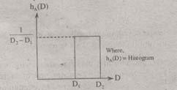

Fig.1.1 (a) Histogram of input image
Digital Image Processing
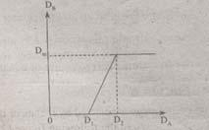

Fig.1.1 (b) Linear Law
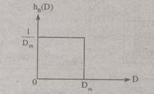

Fig.1.1 (c) Histogram of the transformed image

These stretching transformations are expressed as

In the area of stretching the slope of transformation is considered to be greater than unity. The parameters of stretching transformations i.e., a and b can be determined by examining the histogram of the image.

Clipping and Thresholding:

Clipping is considered as the special scenario of contrast stretching. It is the case in which the parameters are α = γ = 0. Clipping is more advantageous for reduction of noise in input signals of range [a, b].

Threshold of an image is selected by means of its histogram. Let us take the image shown in the following figure 1.2.
Digital Image Processing
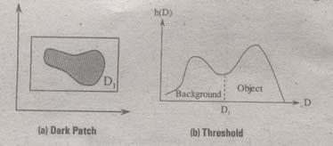

\

Fig. 1.2

The figure 1.2 (b) consists of two peaks i.e., background and object. At the abscissa of histogram minimum (D1) the threshold is selected. This selected threshold (D1) can separate background and object to convert the image into its respective binary form. The thresholding transformations are shown in figure 1.3.
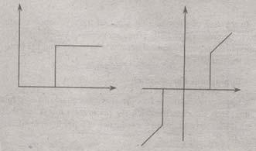

Fig.1.3

Digital Negative:

The digital negative of an image is achieved by reverse scaling of its grey levels to the transformation. They are much essential in displaying of medical images.

A digital negative transformation of an image is shown in figure 1.4.
Digital Image Processing
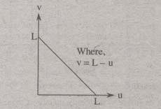

Fig.1.4

Intensity Level Slicing:

The images which consist of grey levels in between intensity at background and other objects require to reduce the intensity of the object. This process of changing intensity level is done with the help of intensity level slicing. They are expressed as
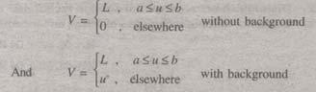

The histogram of input image and its respective intensity level slicing is shown in the figure 1.5.
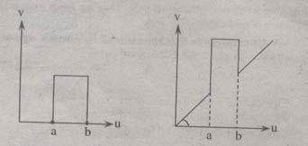

Fig.1.5

Digital Image Processing

When an image is uniformly quantized then, the n^{th} most significant bit can be extracted and displayed.

Let, u = k₁ 2^{B-1} + k₂ 2^{B-2} +……………..+ k_{B-1} 2 + k_{B}

Then, the output is expressed as
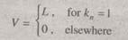

Distinguish between spatial domain and frequency domain enhancement techniques.

The spatial domain refers to the image plane itself, and approaches in this category are based on direct manipulation of pixels in an image. Frequency domain processing techniques are based on modifying the Fourier transform of an image.

The term spatial domain refers to the aggregate of pixels composing an image and spatial domain methods are procedures that operate directly on these pixels. Image processing function in the spatial domain may he expressed as.

g(x, y) = T[f(x, y)]

Where

f(x, y) is the input image

g(x, y) is the processed image and

T is the operator on f defined over some neighborhood values of

(x, y).

Frequency domain techniques are based on convolution theorem. Let g(x, y) be the image formed by the convolution of an image f(x, y) and linear position invariant operation h(x, y) i.e.,

g(x, y) = h(x, y) * f(x, y)

Applying convolution theorem

G(u, v) = H(u, v) F(u, v)
Digital Image Processing

Where G, H and F are the Fourier transforms of g, h and f respectively. In the terminology of linear system the transform H (u, v) is called the transfer function of the process. The edges in f(x, y) can he boosted by using H (u, v) to emphasize the high frequency components of F (u, v).

Ideal Low Pass Filter (ILPF) in frequency domain.

The edges and other sharp transitions (such as noise) in the gray levels of an image contribute significantly to the high-frequency content of its Fourier transform. Hence blurring (smoothing) is achieved in the frequency domain by attenuating us the transform of a given image.

G (u, v) = H (u, v) F(u, v)

where F (u, v) is the Fourier transform of an image to be smoothed. The problem is to select a filter transfer function H (u, v) that yields G (u, v) by attenuating the high-frequency components of F (u, v). The inverse transform then will yield the desired smoothed image g (x, y).

Ideal Filter:

A 2-D ideal lowpass filter (ILPF) is one whose transfer function satisfies the relation
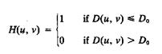

where D is a specified nonnegative quantity, and D(u, v) is the distance from point (u, v) to the origin of the frequency plane; that is,

Figure 3 (a) shows a 3-D perspective plot of H (u, v) u a function of u and v. The name ideal filter indicates that oil frequencies inside a circle of radius
Digital Image Processing
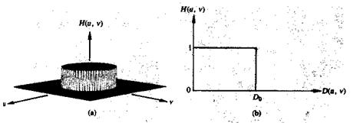

Fig.3 (a) Perspective plot of an ideal lowpass filter transfer function; (b) filter cross section.

Do are passed with no attenuation, whereas all frequencies outside this circle are completely attenuated.
The lowpass filters are radially symmetric about the origin. For this type of filter, specifying a cross section extending as a function of distance from the origin along a radial line is sufficient, as Fig. 3 (b) shows. The complete filter transfer function can then be generated by rotating the cross section 360 about the origin. Specification of radially symmetric filters centered on the N x N frequency square is based on the assumption that the origin of the Fourier transform has been centered on the square.

For an ideal lowpass filter cross section, the point of transition between H(u, v) = 1 and H(u, v) = 0 is often called the cutoff frequency. In the case of Fig.3 (b), for example, the cutoff frequency is Do. As the cross section is rotated about the origin, the point Do traces a circle giving a locus of cutoff frequencies, all of which are a distance Do from the origin. The cutoff frequency concept is quite useful in specifying filter characteristics. It also serves as a common base for comparing the behavior of different types of filters.

The sharp cutoff frequencies of an ideal lowpass filter cannot be realized with electronic components, although they can certainly be simulated in a computer.
Digital Image Processing

Butterworth filter:

The transfer function of the Butterworth lowpass (BLPF) of order n and with cutoff frequency locus at a distance Do, from the origin is defined by the relation
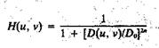

A perspective plot and cross section of the BLPF function are shown in figure 4.
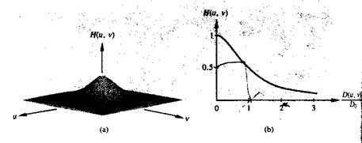

Fig.4 (a) A Butterworth lowpass filter (b) radial cross section for n = 1.

Unlike the ILPF, the BLPF transfer function does not have a sharp discontinuity that establishes a clear cutoff between passed and filtered frequencies. For filters with smooth transfer functions, defining a cutoff frequency locus at points for which H (u, v) is down to a certain fraction of its maximum value is customary. In the case of above Eq. H (u, v) = 0.5 (down 50 percent from its maximum value of 1) when D (u, v) = Do. Another value commonly used is 1/√2 of the maximum value of H (u, v). The following simple modification yields the desired value when D (u, v) = Do:
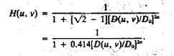
Digital Image Processing

High pass Filtering:

An image can be blurred by attenuating the high-frequency components of its Fourier transform. Because edges and other abrupt changes in gray levels are associated with high-frequency components, image sharpening can be achieved in the frequency domain by a high pass filtering process, which attenuates the low-frequency components without disturbing high-frequency information in the Fourier transform.

Ideal filter:

2-D ideal high pass filter (IHPF) is one whose transfer function satisfies the relation
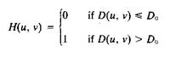

where Do is the cutoff distance measured from the origin of the frequency plane. Figure 5.1 shows a perspective plot and cross section of the IHPF function. This filter is the opposite of the ideal lowpass filter, because it completely attenuates all frequencies inside a circle of radius Do while passing, without attenuation, all frequencies outside the circle. As in the case of the ideal lowpass filler, the IHPF is not physically realizable.
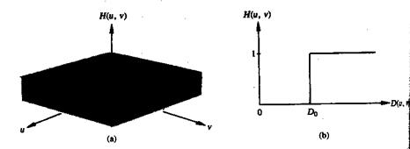

Fig.5.1 Perspective plot and radial cross section of ideal high pass filter
Digital Image Pro cessing Question & Answer s

Butterworth filter:

The tra nsfer function of the B utterworth high pass filter (BHPF ) of order n and with cutoff frequency locus at a distance Do from th e origin is d efined by the relation
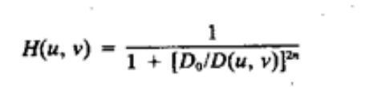

Figure 5.2 shows a perspective plot and cross section of the B HPF function. Note that when D

(u, v) = Do, H (u, v) is dow n to ½ of its maximu m value. A s in the c ase of the |  | Butterworth
lowpas s filter, com mon practice is to select the cut off frequen cy locus at points for |  | which H (u,
v) is down to 1/√2 of its maximum value.

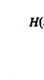

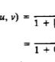

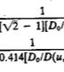

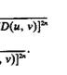
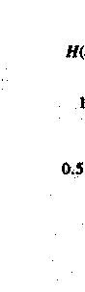
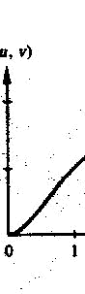
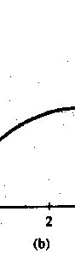
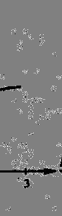

Fig.5.2 Perspectiv e plot and radial cro ss section for Butterw orth High Pass Filter with n = 1
Digital Image Processing

Gaussian Lowpass Filters:

The form of these filters in two dimensions is given by
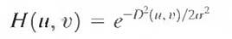

where, D(u, v) is the distance from the origin of the Fourier transform.
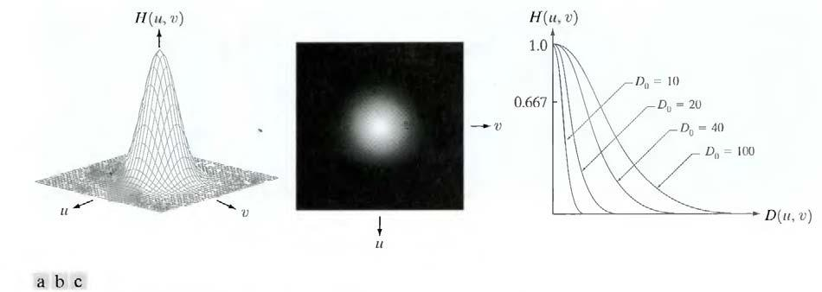

Fig.6.1 (a) Perspective plot of a GLPF transfer function, (b) Filter displayed as an image,

(c) Filter radial cross sections for various values of Do.

σ is a measure of the spread of the Gaussian curve. By letting σ = Du, we can express the filter in a more familiar form in terms of the notation:
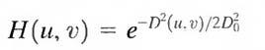

where Do is the cutoff frequency. When D (u, v) = Do, the filter is down to 0.607 of its maximum value.

Gaussian Highpass Filters:

The transfer function of the Gaussian highpass filter (GHPF) with cutoff frequency locus at a distance Do from the origin is given by
Digital Image Processing
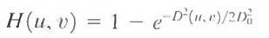

The figure 6.2 shows a perspective plot, image, and cross section of the GHPF function.
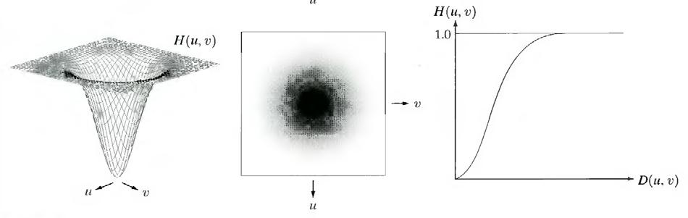

Fig.6.2. Perspective plot, image representation, and cross section of a typical Gaussian high pass filter

Even the filtering of the smaller objects and thin bars is cleaner with the Gaussian filler.

The Laplacian in the Frequency Domain:

It can be shown that
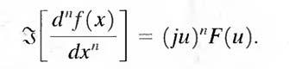

From this simple expression, it follows that
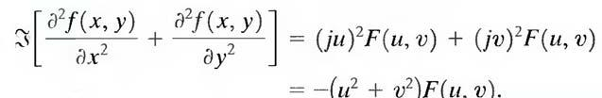

The expression inside the brackets on the left side of the above Eq. is recognized as the Laplacian of f(x, y). Thus, we have the important result

Digital Image Processing
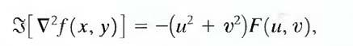

which simply says that the Laplacian can be implemented in the frequency domain by using the filter
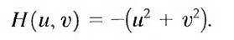

As in all filtering operations, the assumption is that the origin of F (u, v) has been centered by performing the operation f(x, y) (-1) ^{x+y} prior to taking the transform of the image. If f (and F) are of size M X N, this operation shifts the center transform so that (u, v) = (0, 0) is at point (M/2, N/2) in the frequency rectangle. As before, the center of the filter function also needs to be shifted:
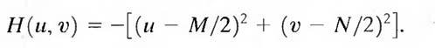

The Laplacian-filtered image in the spatial domain is obtained by computing the inverse Fourier transform of H (u, v) F (u, v):

Conversely, computing the Laplacian in the spatial domain and computing the Fourier transform of the result is equivalent to multiplying F(u, v) by H(u, v). We express this dual relationship in the familiar Fourier-transform-pair notation

The spatial domain Laplacian filter function obtained by taking the inverse Fourier transform of Eq. has some interesting properties, as Fig.7 shows. Figure 7(a) is a 3 -D perspective plot. The function is centered at (M/2, N/2), and its value at the top of the dome is zero. All other values are negative. Figure 7(b) shows H (u, v) as an image, also centered. Figure 7(c) is the Laplacian in the spatial domain, obtained by multiplying by H (u, v) by (-1)^{u+v} , taking the inverse Fourier transform, and multiplying the real part of the result by (-l)^{x+y} . Figure 7(d) is a zoomed section at about the origin of Fig.7(c).' Figure 7(e) is a horizontal gray-level profile passing through the center of the zoomed section. Finally, Fig.7 (f) shows the mask to implement the definition of the discrete Laplacian in the spatial domain.
Digital Image Processing
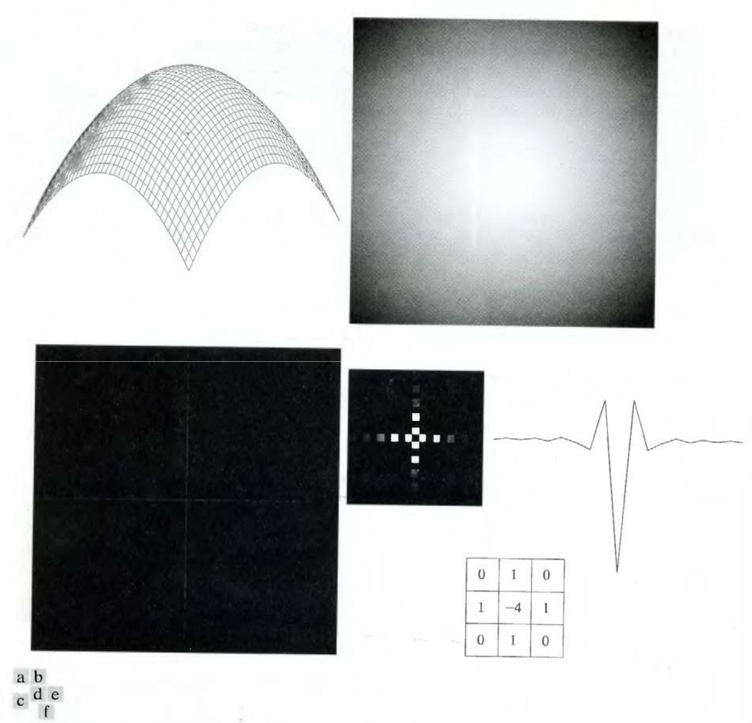

Fig.7 (a) 3 -D plot of Laplacian in the frequency domain, (b) Image representation of (a), (c) Laplacian in the spatial domain obtained from the inverse DFT of (b) (d) Zoomed section of the origin of (c). (e) Gray-level profile through the center of (d). (f) Laplacian mask
Digital Image Processing

A horizontal profile through the center of this mask has the same basic shape as the profile in Fig. 7(e) (that is, a negative value between two smaller positive values). We form an enhanced image g(x, y) by subtracting the Laplacian from the original image:
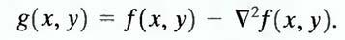

High-Boost Filtering and High-Frequency Emphasis Filtering:

All the filtered images have one thing in common: Their average background intensity has been reduced to near black. This is due to the fact that the highpass filters we applied to those images eliminate the zero-frequency component of their Fourier transforms. In fact, enhancement using the Laplacian does precisely this, by adding back the entire image to the filtered result. Sometimes it is advantageous to increase the contribution made by the original image to the overall filtered result. This approach, called high-boost filtering, is a generalization of unsharp masking. Unsharp masking consists simply of generating a sharp image by subtracting from an image a blurred version of itself. Using frequency domain terminology, this means obtaining a highpass-filtered image by subtracting from the image a lowpass-filtered version of itself. That is
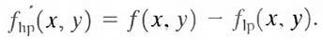

High-boost filtering generalizes this by multiplying f (x, y) by a constant A > 1:
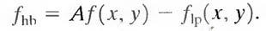

Thus, high-boost filtering gives us the flexibility to increase the contribution made by the image to the overall enhanced result. This equation may be written as

Then, using above Eq. we obtain

This result is based on a highpass rather than a lowpass image. When A = 1, high-boost filtering reduces to regular highpass filtering. As A increases past 1, the contribution made by the image itself becomes more dominant.
Digital Image Processing

We have F_{hp} (u,v) = F (u,v) – F_{lp} (u,v). But F_{lp} (u,v) = H_{lp} (u,v)F(u,v), where H_{lp} is the transfer function of a lowpass filter. Therefore, unsharp masking can be implemented directly in the frequency domain by using the composite filter
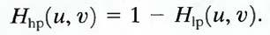

Similarly, high-boost filtering can be implemented with the composite filter

with A > 1. The process consists of multiplying this filter by the (centered) transform of the input image and then taking the inverse transform of the product. Multiplication of the real part of this result by (-l) ^{x+y} gives us the high-boost filtered image f_{hb} (x, y) in the spatial domain.

Homomorphic filtering:

The illumination-reflectance model can be used to develop a frequency domain procedure for improving the appearance of an image by simultaneous gray-level range compression and contrast enhancement. An image f(x, y) can be expressed as the product of illumination and reflectance components:
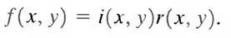

Equation above cannot be used directly to operate separately on the frequency components of illumination and reflectance because the Fourier transform of the product of two functions is not separable; in other words,
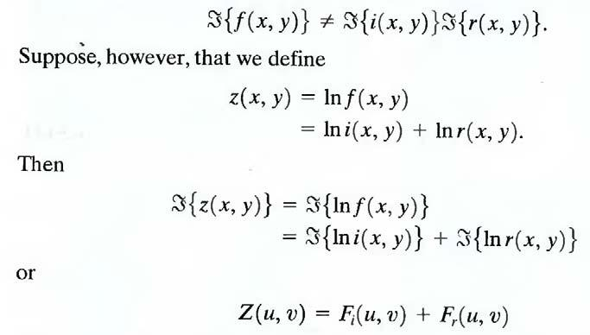
Digital Image Processing

where F_{i} (u, v) and F_{r} (u, v) are the Fourier transforms of ln i(x, y) and ln r(x, y), respectively. If we process Z (u, v) by means of a filter function H (u, v) then, from
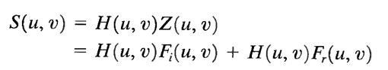

where S (u, v) is the Fourier transform of the result. In the spatial domain,
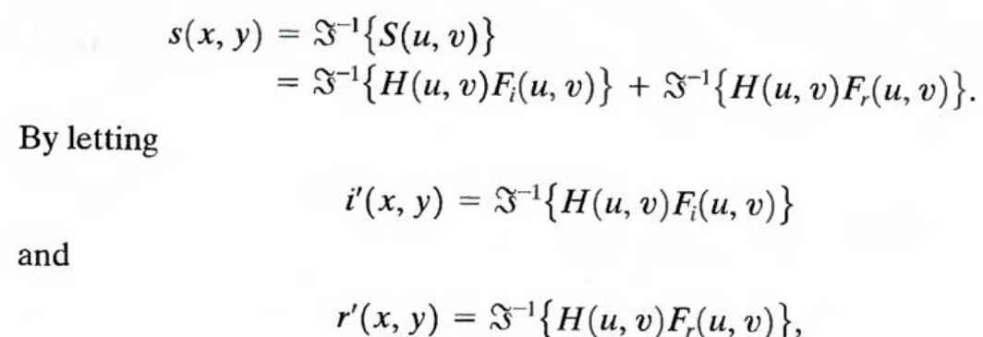

Now we have
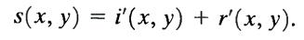

Finally, as z (x, y) was formed by taking the logarithm of the original image f (x, y), the inverse (exponential) operation yields the desired enhanced image, denoted by g(x, y); that is,
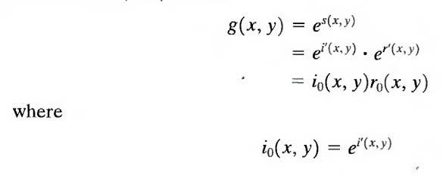
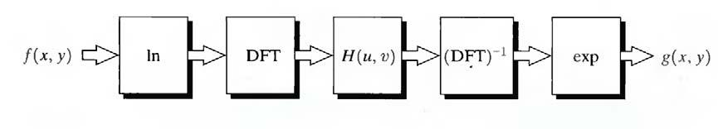

Fig.9.1 Homomorphic filtering approach for image enhancement

Digital Image Processing

and
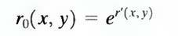

are the illumination and reflectance components of the output image. The enhancement approach using the foregoing concepts is summarized in Fig. 9.1. This method is based on a special case of a class of systems known as homomorphic systems. In this particular application, the key to the approach is the separation of the illumination and reflectance components achieved. The homomorphic filter function H (u, v) can then operate on these components separately.

The illumination component of an image generally is characterized by slow spatial variations, while the reflectance component tends to vary abruptly, particularly at the junctions of dissimilar objects. These characteristics lead to associating the low frequencies of the Fourier transform of the logarithm of an image with illumination and the high frequencies with reflectance. Although these associations are rough approximations, they can be used to advantage in image enhancement.

A good deal of control can be gained over the illumination and reflectance components with a homomorphic filter. This control requires specification of a filter function H (u, v) that affects the low- and high-frequency components of the Fourier transform in different ways. Figure 9.2 shows a cross section of such a filter. If the parameters γ_{L} and γ_{H} are chosen so that γ_{L} < 1 and γ_{H} > 1, the filter function shown in Fig. 9.2 tends to decrease the contribution made by the low frequencies (illumination) and amplify the contribution made by high frequencies (reflectance). The net result is simultaneous dynamic range compression and contrast enhancement.
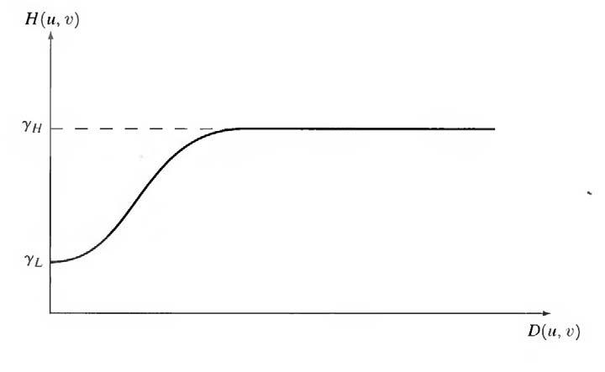

Fig.9.2 Cross section of a circularly symmetric filter function D (u. v) is the distance from the origin of the centered transform.

Digital Image Processing

