Digital Image Processing

Fourier Transform and its inverse.

Let f(x) be a continuous function of a real variable x. The Fourier transform of f(x) is defined by the equation
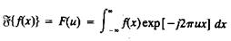

Where j = √-1

Given F(u), f(x) can be obtained by using the inverse Fourier transform
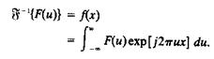

The Fourier transform exists if f(x) is continuous and integrable and F(u) is integrable. The Fourier transform of a real function, is generally complex,

F(u) = R(u) + jI(u)

Where R(u) and I(u) are the real and imiginary components of F(u). F(u) can be expressed in exponential form as

F(u) = │F(u)│e^{jØ(u)}

where

│F(u)│ = [R²(u) + I²(u)]^{1/2}

and

Ø (u, v) = tan⁻¹[ I (u, v)/R (u, v) ]

The magnitude function |F (u)| is called the Fourier Spectrum of f(x) and Φ(u) its phase angle. The variable u appearing in the Fourier transform is called the frequency variable.
Digital Image Processing
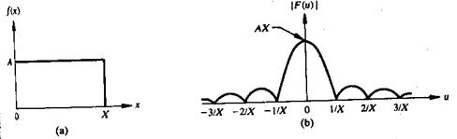

Fig 1 A simple function and its Fourier spectrum

The Fourier transform can be easily extended to a function f(x, y) of two variables. If f(x, y) is continuous and integrable and F(u,v) is integrable, following Fourier transform pair exists
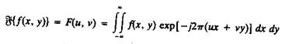

and

\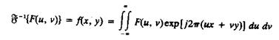

Where u, v are the frequency variables

The Fourier spectrum, phase, are

│F(u, v)│ = [R²(u, v) + I²(u, v )]^{1/2}

Ø(u, v) = tan⁻¹[ I(u, v)/R(u, v) ]

Discrete Fourier transform and its inverse.

The discrete Fourier transform pair that applies to sampled function is given by,
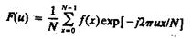

(1)

For u = 0, 1, 2 . . . . , N-1, and
Digital Image Processing
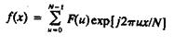

(2)

For x = 0, 1, 2 . . . ., N-1.

In the two variable case the discrete Fourier transform pair is
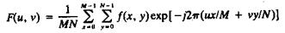

For u = 0, 1, 2 . . . , M-1, v = 0, 1, 2 . . . , N - 1, and
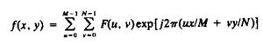

For x = 0, 1, 2 . . . , M-1, y = 0, 1, 2 . . . , N-1.

If M = N, then discrete Fourier transform pair is
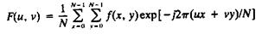

For u, v = 0, 1, 2 . . . , N – 1, and
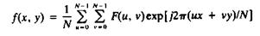

For x, y = 0, 1, 2 . . . , N – 1

Separability property of 2D-DFT.

The separability property of 2D-DFT states that, the discrete Fourier transform pair can be expressed in the separable forms. i.e. ,
Digital Image Processing
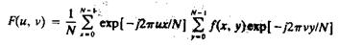

(1)

For u, v = 0, 1, 2 . . . , N – 1, and
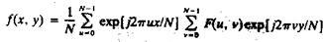

(2)

For x, y = 0, 1, 2 . . . , N – 1

The principal advantage of the separability property is that F(u,v) or f(x,y) can be obtained in two steps by successive applications of the 1-D Fourier transform or its inverse. This advantage becomes evident if equation (1) is expressed in the form
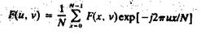

(3)

Where,
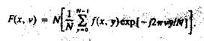

(4)

For each value of x, the expression inside the brackets in eq(4) is a 1-D transform, with frequency values v = 0, 1, . . . , N-1. Therefore the 2-D function f(x, v) is obtained by taking a transform along each row of f(x, y) and multiplying the result by N. The desired result, F(u, v), is then obtained by taking a transform along each column of F(x, v), as indicated by eq(3)

Translation property.

The translation properties of the Fourier transform pair are

(1)

and
Digital Image Processing

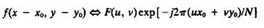(2)

Where the double arrow indicates the correspondence between a function and its Fourier Transform,

Equation (1) shows that multiplying f(x, y) by the indicated exponential term and taking the transform of the product results in a shift of the origin of the frequency plane to the point (u_{o}, v_{o}).

Consider the equation (1) with u_{o} = v_{o =} N/2 or

exp[j2Π(u_{o}x + v_{o}y)/N] = e^{jΠ(x + y)}

= (-1)^{(x + y)}

and

f(x, y)(-1)^{x +y}  F(u – N/2, v – N/2)

Thus the origin of the Fourier transform of f(x, y) can be moved to the center of its corresponding N x N frequency square simply by multiplying f(x, y) by (-1)^{x+y} . In the one variable case this shift reduces to multiplication of f(x) by the term (-1)^{x}. Note from equation (2) that a shift in f(x, y) does not affect the magnitude of its Fourier transform as,

Distributivity and scaling property.

Distributivity:

From the definition of the continuous or discrete transform pair,
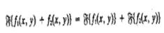

and, in general,
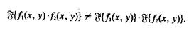
Digital Image Processing

In other words, the Fourier transform and its inverse are distributive over addition but not over multiplication.

Scaling:

For two scalars a and b,

af (x, y)  aF(u, v)
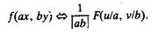

Hotelling transform:

The basic principle of hotelling transform is the statistical properties of vector representation. Consider a population of random vectors of the form,
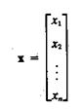

And the mean vector of the population is defined as the expected value of x i.e.,

m_{x =} E{x}

The suffix m represents that the mean is associated with the population of x vectors. The expected value of a vector or matrix is obtained by taking the expected value of each elememt. The covariance matrix C_{x} in terms of x and m_{x} is given as

C_{x} = E{(x-m_{x}) (x-m_{x})^{T}}

T denotes the transpose operation. Since, x is n dimensional, {(x-m_{x}) (x-m_{x})^{T}} will be of n x n dimension. The covariance matrix is real and symmetric. If elements x_{i} and x_{j} are uncorrelated, their covariance is zero and, therefore, c_{ij} = c_{ji} = 0.

For M vector samples from a random population, the mean vector and covariance matrix can be approximated from the samples by
Digital Image Processing
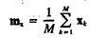

and
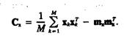

Slant transform.

The Slant transform matrix of order N x N is the recursive expression S_{n} is given by
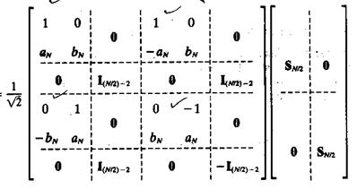

Where I_{m} is the identity matrix of order M x M, and
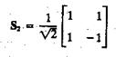

The coefficients are
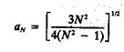

and

Digital Image Processing
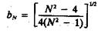

The slant transform for N = 4 will be
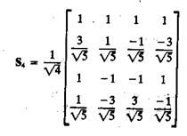

Properties of Slant transform

(i) The slant transform is real and orthogonal.

S = S*

S⁻¹ = S^{T}

- The slant transform is fast, it can be implemented in (N log₂N) operations on an N x 1 vector.

- The energy deal for images in this transform is rated in very good to excellent range.

- The mean vectors for slant transform matrix S are not sequentially ordered for n ≥ 3.

Discrete cosine transform.

The 1-D discrete cosine transform is defined as
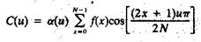

For u = 0, 1, 2, . . , N-1. Similarly the inverse DCT is defined as

Digital Image Processing
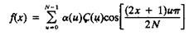

For u = 0, 1, 2, . . , N-1

Where α is
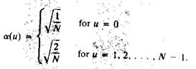

The corresponding 2-D DCT pair is
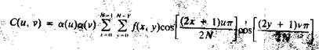

For u, v = 0, 1, 2, . . , N-1, and
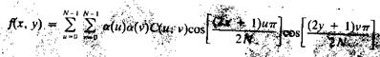

For x, y= 0, 1, 2, . . , N-1

Haar transform.

The Haar transform is based on the Haar functions, h_{k}(z), which are defined over the continuous, closed interval z ε [0, 1], and for k = 0, 1, 2 . . . , N-1, where N = 2^{n}. The first step in generating the Haar transform is to note that the integer k can be decomposed uniquely as

k = 2^{p} + q - 1

where 0 ≤ p ≤ n-1, q = 0 or 1 for p = 0, and 1 ≤ q ≤ 2^{p} for p ≠ 0. For example, if N = 4, k, q, p have following values
Digital Image Processing
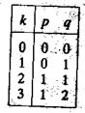

The Haar functions are defined as
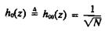

for z ε [0, 1] ……. (1)

and
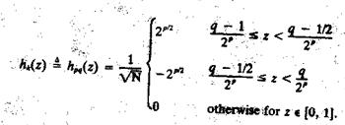

These results allow derivation of Haar transformation matrices of order N x N by formation of the ith row of a Haar matrix from elements oh h_{i}(z) for z = 0/N, 1/N, . . . , (N-1)/N. For instance, when N = 2, the first row of the 2 x 2 Haar matrix is computed by using h_{o}(z) with z = 0/2, 1/2. From equation (1) , h_{o}(z) is equal to 1/, independent of z, so the first row of the matrix has two

identical 1/ elements. Similarly row is computed. The 2 x 2 Haar matrix is
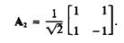

Similarly matrix for N = 4 is
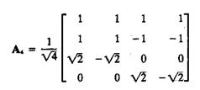

.

Digital Image Processing

Properties of Haar transform:

- The Haar transform is real and orthogonal.

- The Haar transform is very fast. It can implement O(n) operations on an N x 1 vector.

- The mean vectors of the Haar matrix are sequentially ordered.

- It has a poor energy deal for images.

Hadamard transform.

1-D forward kernel for hadamard transform is
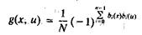

Expression for the 1-D forward Hadamard transform is
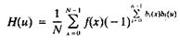

Where N = 2^{n} and u has values in the range 0, 1, . . . , N-1. 1-D inverse kernel for hadamard transform is
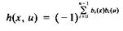

Expression for the 1-D inverse Hadamard transform is
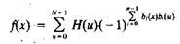

The 2-D kernels are given by the relations

Digital Image Processing
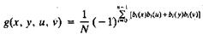

and
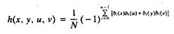

2-D Hadamard transform pair is given by following equations
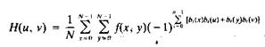
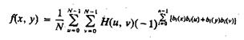

Values of the 1-D hadamard transform kernel for N = 8 is
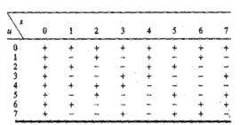

The Hadamard matrix of lowest order N = 2 is
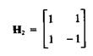

If H_{N} represents the matrix of order N, the recursive relationship is given by

Digital Image Processing
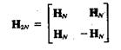

Where H_{2N} is the Hadamard matrix of order 2N and N = 2^{n}

Walsh transform.

The discrete Walsh transform of a function f (x), denoted W(u), is given by
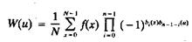

Walsh transform kernel is symmetric matrix having orthogonal rows and columns. These properties, which hold in general, lead to an inverse kernel given by
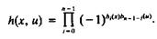

Thus the inverse Walsh transform is given by
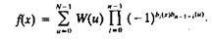

The 2-D forward and inverse Walsh kernels are given by
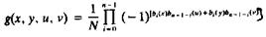

and
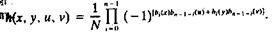

Thus the forward and inverse Walsh transforms for 2-D are given by
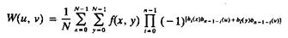

and

Digital Image Processing
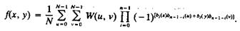

The Walsh Transform kernels are seperable and symmetric, because
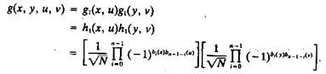

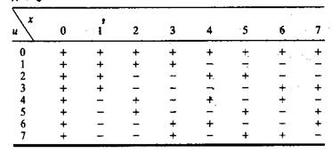
Values of the 1-D walsh transform kernel for N = 8 is

