**A**

**COURSE FILE**

**ON**

**“JAVA PROGRAMMING”**

**Submitted by**

**M.S.S.LAKSHMI LAVANYA**

**Assistant Professor**

**II B-Tech II Semester**

**In the department of**

**CSE- Data Science**



**CMR ENGINEERING COLLEGE**

(Approved by AICTE-NewDelhi, Affiliated to J.N.T.U, Hyderabad)

Kandlakoya(v),Medchal Road,Hyderabad-501 401,Telangana State, India .Website: www.cmrec.ac.in

**(2021-22)**

**CONTENTS OF COURSE FILE:**

1. Department vision & mission
2. List of PEOs, POs, PSOs
3. List of Cos (action verbs as per blooms)
4. Syllabus copy and suggested or reference books
5. Session plan/ lesson plan
6. Session execution log
7. Lecture notes
8. Assignment Questions (samples)
9. Mid exam question papers (samples)
10. Scheme of evaluation
11. Mapping of Cos with Pos and PSOs
12. Attainment of Cos, Pos and PSOs (Excel sheet)
13. University question papers or question bank.
14. Power point presentations (PPTs)
15. Websites or URLs e- Resources

**Submitted By**

M S S LAKSHMI LAVANYA

1. **Department vision & mission**

**VISION**

To create the next generation and globally competent data scientists/data engineers in the field of Data Science domain by providing quality engineering education along with cutting edge technologies

**MISSION**

* To provide value based engineering education through continues learning and research by imparting solid foundation in applied mathematics, algorithms and programming paradigms to build software models and simulations.
* To develop concepts building, logical and problem solving skills of graduates to address current global challenges of industry and society.
* To offer excellence in teaching and learning process, industry collaboration activities and research to mould graduates into industry ready professionals
* **List of PEOs, POs, PSOs**

**PROGRAM EDUCATIONAL OBJECTIVES (PEOS)**

* To prepare graduates with a varied range of expertise in different aspects of data science such as data collection, processing, modeling and visualization of large data sets
* To acquire good knowledge of both theory and application of applied statistics, mathematics and computer science based existing data science models to analyze huge data sets originating from different application areas
* To create models using the knowledge acquired from the program to solve future challenges and real-world problems requiring large scale data analysis.
* To make better trained professionals to cater the growing demand for data scientists, data analysts, data architects and data engineers in industry.

**PROGRAM OUTCOMES (POS)**

***Engineering Graduates will be able to satisfy these NBA graduate attributes:***

1. **Engineering knowledge:** An ability to apply knowledge of computing, mathematics, science and engineering fundamentals appropriate to the discipline
2. **Problem analysis:** An ability to analyze a problem, and identify and formulate the computing requirements appropriate to its solution
3. **Design/development of solutions:** An ability to design, implement, and evaluate a computer-based system, process, component, or program to meet desired needs with appropriate consideration for public health and safety, cultural, societal and environmental considerations
4. **Conduct investigations of complex problems:** An ability to design and conduct experiments, as well as to analyze and interpret data
5. **Modern tool usage:** An ability to use current techniques, skills, and modern tools necessary for computing practice
6. **The engineer and society:** An ability to analyze the local and global impact of computing on individuals, organizations, and society
7. **Environment and sustainability:** Knowledge of contemporary issues
8. **Ethics:** An understanding of professional, ethical, legal, security and social issues and responsibilities
9. **Individual and team work:** An ability to function effectively individually and on teams, including diverse and multidisciplinary, to accomplish a common goal
10. **Communication:** An ability to communicate effectively with a range of audiences
11. **Project management and finance:** An understanding of engineering and management principles and apply these to one’s own work, as a member and leader in a team, to manage projects
12. **Life-long learning:** Recognition of the need for and an ability to engage in continuing professional development

**PROGRAM SPECIFIC OUTCOMES (PSO’S)**

* **Apply knowledge of Data Science in real-time software project development using open-source programming environment or commercial environment to deliver quality software product for the organizations success**
* **Analyze, design and develop computer-based systems in the areas related to machine learning, algorithms, big data and data analytics, and cloud computing of varying complexity.**
* **Acquaint with the contemporary trends in industrial/research areas and thereby innovate novel solutions to existing problems**

**3. COURSE OUTCOMES**

CO1.To List out various Oops Concepts.

CO2. To understand the use of abstract classes and OOP techniques.

CO3. To solve problems using java collection framework and I/o classes.

CO4. To examine multithreaded applications with synchronization.

CO5. To develop applets for web applications.

CO6. To design GUI based applications

**4. SYLLABUS COPY**

**UNIT – I**

**Object-Oriented Thinking-** A way of viewing world – Agents and Communities, messages and methods, Responsibilities, Classes and Instances, Class Hierarchies- Inheritance, Method binding, Overriding and Exceptions, Summary of Object-Oriented concepts. Java buzzwords, An Overview of Java, Data types, Variables and Arrays, operators, expressions, control statements, Introducing classes, Methods and Classes, String handling.

**Inheritance–** Inheritance concept, Inheritance basics, Member access, Constructors, Creating Multilevel hierarchy, super uses, using final with inheritance, Polymorphism-ad hoc polymorphism, pure polymorphism, method overriding, abstract classes, Object class, forms of inheritance- specialization, specification, construction, extension, limitation, combination, benefits of inheritance, costs of inheritance.

**UNIT - II**

**Packages-** Defining a Package, CLASSPATH, Access protection, importing packages. Interfaces- defining an interface, implementing interfaces, Nested interfaces, applying interfaces, variables in interfaces and extending interfaces.

**Stream based I/O (java.io) –** The Stream classes-Byte streams and Character streams, Reading console Input and Writing Console Output, File class, Reading and writing Files, Random access file operations, The Console class, Serialization, Enumerations, auto boxing, generics.

**UNIT - III**

**Exception handling -** Fundamentals of exception handling, Exception types, Termination or resumptive models, Uncaught exceptions, using try and catch, multiple catch clauses, nested try statements, throw, throws and finally, built- in exceptions, creating own exception sub classes.

**Multithreading-** Differences between thread-based multitasking and process-based multitasking, Java thread model, creating threads, thread priorities, synchronizing threads, inter thread communication.

**UNIT - IV**

**The Collections Framework (java.util)-** Collections overview, Collection Interfaces, The Collection classes- Array List, Linked List, Hash Set, Tree Set, Priority Queue, Array Deque. Accessing a Collection via an Iterator, Using an Iterator, The For-Each alternative, Map Interfaces and Classes, Comparators, Collection algorithms, Arrays, The Legacy Classes and Interfaces- Dictionary, Hashtable ,Properties, Stack, Vector More Utility classes, String Tokenizer, Bit Set, Date, Calendar, Random, Formatter, Scanner

**UNIT - V**

**GUI Programming with Swing**  – Introduction, limitations of AWT, MVC architecture, components, containers. Understanding Layout Managers, Flow Layout, Border Layout, Grid Layout, Card Layout, Grid Bag Layout.

**Event Handling**- The Delegation event model- Events, Event sources, Event Listeners, Event classes, Handling mouse and keyboard events, Adapter classes, Inner classes, Anonymous Inner classes.

**A Simple Swing Application,Applets –** Applets and HTML, Security Issues, Applets and Applications, passing parameters to applets. Creating a Swing Applet, Painting in Swing, A Paint example, Exploring Swing Controls- JLabel and Image Icon, JText Field, The Swing Buttons- JButton, JToggle Button, JCheck Box, JRadio Button, JTabbed Pane, JScroll Pane, JList, JCombo Box, Swing Menus, Dialogs.

**TEXT BOOKS:**

1. Java The complete reference, 9th edition, Herbert Schildt, McGraw Hill Education (India) Pvt. Ltd.

2. Understanding Object-Oriented Programming with Java, updated edition, T. Budd, Pearson Education**.**

**REFERENCE BOOKS:**

1. An Introduction to programming and OO design using Java, J. Nino and F.A. Hosch, John Wiley & sons

2. Introduction to Java programming, Y. Daniel Liang, Pearson Education. 3. Object Oriented Programming through Java, P. Radha Krishna, University Press.

4. Programming in Java, S. Malhotra, S. Chudhary, 2nd edition, Oxford Univ. Press.

5. Java Programming and Object-oriented Application Development, R. A. Johnson, Cengage Learning.

**5. SESSION PLAN/LESSON PLAN**

|  |  |  |  |  |  |
| --- | --- | --- | --- | --- | --- |
| **S.NO** | **Topic (JNTUH syllabus)** | **Sub-Topic** | **NO. OF LECTURES REQUIRED** | **Suggested Books** | **Teaching Methods** |
| 1 | **Unit - 1** |  |  |  |  |
| 2 | **Object-Oriented Thinking** | Agents and Communities, messages and methods, and Responsibilities | 1 | T1, T2 | BB / PPT |
| 5 |  | Classes and Instances, Class Hierarchies |  | T1, T2 | BB / PPT |
| 7 |  | Inheritance, Method binding | 1 | T1, T2 | BB / PPT |
| 9 |  | Overriding and Exceptions |  | T1, T2 | BB / PPT |
| 10 |  | Summary of Object-Oriented concepts | 1 | T1, T2 | BB / PPT |
| 11 |  | Java buzzwords | 1 | T1, T2 | BB / PPT |
| 12 |  | An Overview of Java |  | T1, T2 | BB / PPT |
| 13 |  | Data types, Variables and Arrays | 1 | T1, T2 | BB / PPT |
| 15 |  | operators, expressions | 1 | T1, T2 | BB / PPT |
| 17 |  | control statements | 1 | T1, T2 | BB / PPT |
| 18 |  | Introducing classes, Methods and Classes | 1 | T1, T2 | BB / PPT |
| 20 |  | String handling | 1 | T1, T2 | BB / PPT |
| 21 | **Inheritance** | Inheritance concept, Inheritance basics | 1 | T1, T2 | BB / PPT |
| 23 |  | Member access, Constructors | 1 | T1, T2 | BB / PPT |
| 25 |  | Creating Multilevel hierarchy | 1 | T1, T2 | BB / PPT |
| 26 |  | super uses, using final with inheritance | 1 | T1, T2 | BB / PPT |
| 28 |  | Polymorphism-ad hoc polymorphism | 1 | T1, T2 | BB / PPT |
| 29 |  | pure polymorphism | 1 | T1, T2 | BB / PPT |
| 30 |  | method overriding, abstract classes, Object class | 1 | T1, T2 | BB / PPT |
| 33 |  | forms of inheritance- specialization, specification, construction, extension, limitation, combination | 1 | T1, T2 | BB / PPT |
| 34 |  | benefits of inheritance and costs of inheritance | T1, T2 | BB / PPT |
| 36 |  | **Total classes required for UNIT - 1** | 17 |  |  |
| 37 | **UNIT - 2** |  |  |  |  |
| 38 | **Packages** | Defining a Package | 1 | T1, T2 | BB / PPT |
| 39 |  | CLASSPATH | T1, T2 | BB / PPT |
| 40 |  | Access protection | T1, T2 | BB / PPT |
| 41 |  | importing packages | 1 | T1, T2 | BB / PPT |
| 42 | **Interfaces** | defining an interface | T1, T2 | BB / PPT |
| 43 |  | implementing interfaces | 1 | T1, T2 | BB / PPT |
| 44 |  | Nested interfaces | T1, T2 | BB / PPT |
| 45 |  | applying interfaces | 1 | T1, T2 | BB / PPT |
| 46 |  | variables in interfaces | T1, T2 | BB / PPT |
| 47 |  | extending interfaces | T1, T2 | BB / PPT |
| 48 | **Stream based I/O** | classes-Byte streams and Character streams | 1 | T1, T2 | BB / PPT |
| 49 |  | Reading console Input and Writing Console Output | T1, T2 | BB / PPT |
| 50 |  | File class | 1 | T1, T2 | BB / PPT |
| 51 |  | Reading and writing Files | T1, T2 | BB / PPT |
| 52 |  | Random access file operations | 1 | T1, T2 | BB / PPT |
| 53 |  | The Console class | T1, T2 | BB / PPT |
| 54 |  | Serialization | 1 | T1, T2 | BB / PPT |
| 55 |  | Enumerations | 1 | T1, T2 | BB / PPT |
| 56 |  | auto boxing | T1, T2 | BB / PPT |
| 57 |  | generics | T1, T2 | BB / PPT |
| 58 |  | **Total classes required for UNIT - 2** | 9 |  |  |
| 59 | **UNIT - 3** |  |  |  |  |
| 60 | **Exception handling** | Fundamentals of exception handling | 1 | T1, T2 | BB / PPT |
| 61 |  | Exception types | T1, T2 | BB / PPT |
| 62 |  | Termination or resumptive models | 1 | T1, T2 | BB / PPT |
| 63 |  | Uncaught exceptions | T1, T2 | BB / PPT |
| 64 |  | using try and catch | 1 | T1, T2 | BB / PPT |
| 65 |  | multiple catch clauses | T1, T2 | BB / PPT |
| 66 |  | nested try statements | 1 | T1, T2 | BB / PPT |
| 67 |  | throw, throws and finally | T1, T2 | BB / PPT |
| 68 |  | built- in exceptions | 1 | T1, T2 | BB / PPT |
| 69 |  | creating own exception sub classes | 1 | T1, T2 | BB / PPT |
| 70 | **Multithreading** | Differences between thread-based multitasking and process-based multitasking | 1 | T1, T2 | BB / PPT |
| 71 |  | Java thread model | T1, T2 | BB / PPT |
| 72 |  | creating threads | 1 | T1, T2 | BB / PPT |
| 73 |  | thread priorities | 1 | T1, T2 | BB / PPT |
| 74 |  | synchronizing threads | T1, T2 | BB / PPT |
| 75 |  | inter thread communication | 1 | T1, T2 | BB / PPT |
| 76 |  | **Total classes required for UNIT - 3** | 10 |  |  |
| 77 | **UNIT - 4** |  |  |  |  |
| 78 | **The Collections Framework** | Collections overview | 1 | T1, T2 | BB / PPT |
| 79 |  | Collection Interfaces | T1, T2 | BB / PPT |
| 80 |  | The Collection classes- Array List, Linked List, Hash Set, Tree Set, Priority Queue, Array Deque | 2 | T1, T2 | BB / PPT |
| 81 |  | Accessing a Collection via an Iterator | 1 | T1, T2 | BB / PPT |
| 82 |  | Using an Iterator | T1, T2 | BB / PPT |
| 83 |  | The For-Each alternative | T1, T2 | BB / PPT |
| 84 |  | Map Interfaces and Classes | 1 | T1, T2 | BB / PPT |
| 85 |  | Comparators | T1, T2 | BB / PPT |
| 86 |  | Collection algorithms | T1, T2 | BB / PPT |
| 87 |  | Arrays | T1, T2 | BB / PPT |
| 88 |  | The Legacy Classes and Interfaces- Dictionary, Hashtable ,Properties, Stack, Vector More Utility classes, String Tokenizer, Bit Set, Date, Calendar, Random, Formatter, Scanner | 3 | T1, T2 | BB / PPT |
| 89 |  | **Total classes required for UNIT - 4** | 8 |  |  |
| 90 | **UNIT - 5** |  |  |  |  |
| 91 | **GUI Programming with Swing** | Introduction and limitations of AWT | 1 | T1, T2 | BB / PPT |
| 92 |  | MVC architecture | T1, T2 | BB / PPT |
| 93 |  | components | 1 | T1, T2 | BB / PPT |
| 94 |  | containers | T1, T2 | BB / PPT |
| 95 |  | Understanding Layout Managers, Flow Layout, Border Layout, Grid Layout, Card Layout, Grid Bag Layout | 1 | T1, T2 | BB / PPT |
| 96 | **Event Handling** | The Delegation event model | 1 | T1, T2 | BB / PPT |
| 97 |  | Events, Event sources, Event Listeners, and Event classes | T1, T2 | BB / PPT |
| 98 |  | Handling mouse and keyboard events | 1 | T1, T2 | BB / PPT |
| 99 |  | Adapter classes | 1 | T1, T2 | BB / PPT |
| 100 |  | Inner classes | T1, T2 | BB / PPT |
| 101 |  | Anonymous Inner classes | T1, T2 | BB / PPT |
| 102 | **A Simple Swing Application, Applets** | Applets and HTML | 1 | T1, T2 | BB / PPT |
| 103 |  | Security Issues | T1, T2 | BB / PPT |
| 104 |  | Applets and Applications | T1, T2 | BB / PPT |
| 105 |  | passing parameters to applets | 1 | T1, T2 | BB / PPT |
| 106 |  | Creating a Swing Applet | T1, T2 | BB / PPT |
| 107 |  | Painting in Swing | T1, T2 | BB / PPT |
| 108 |  | A Paint example | 1 | T1, T2 | BB / PPT |
| 109 |  | Exploring Swing Controls- JLabel and Image Icon, JText Field | T1, T2 | BB / PPT |
| 110 | **The Swing Buttons** | JButton | 2 | T1, T2 | BB / PPT |
| 111 |  | JToggle Button | T1, T2 | BB / PPT |
| 112 |  | JCheck Box | T1, T2 | BB / PPT |
| 113 |  | JRadio Button | T1, T2 | BB / PPT |
| 114 |  | JTabbed Pane | T1, T2 | BB / PPT |
| 115 |  | JScroll Pane | T1, T2 | BB / PPT |
| 116 |  | JList | T1, T2 | BB / PPT |
| 117 |  | JCombo Box | T1, T2 | BB / PPT |
| 118 |  | Swing Menus | T1, T2 | BB / PPT |
| 119 |  | Dialogs | T1, T2 | BB / PPT |
| 120 |  | **Total classes required for UNIT - 5** | 11 |  |  |
| 121 |  | **Total classes required** | **55** |  |  |

**METHODS OF TEACHING:**

|  |  |  |
| --- | --- | --- |
| **M1 : Lecture Method** | **M4 : Presentation /PPT** | **M7 : Assignment** |
| **M2 : DemoMethod** | **M5 : Lab/Practical** | **M8 : Industry Visit** |
| **M3 : Guest Lecture** | **M6 : Tutorial** | **M9 : Project Based** |

NOTE:

1. AnySubjectinaSemesterissupposetobecompletedin55to65periods.
2. Each Period is of 50minutes.
3. Each unit duration &completion should be mentioned in the Remarks Coloumn.
4. ListofSuggestedbookscanbemarkedwithCodeslikeT1,T2,R1,R2etc.

# INDIVIDUAL TIME TABLE (M S S LAKSHMI LAVANYA)

|  |  |  |  |  |  |  |  |  |
| --- | --- | --- | --- | --- | --- | --- | --- | --- |
|  | **I** | **II** | **III** | **IV** | **lunch** | **V** | **VI** | **VII** |
| **MON** | JAVA-B | JAVA-B |  |  |  | |  |
| **TUE** | JAVA-B | JAVA-B |  |  |  |  |  |
| **WED** |  |  | JAVA-B | JAVA-B |  |  |  |
| **THU** |  |  |  |  |  |  |  |
| **FRI** |  |  | JAVA-B | JAVA-B |  |  |  |
| **SAT** | JAVA-B | JAVA-B |  |  | JAVA-B |  |  |

**6. Session Execution Log:**

|  |  |  |  |  |
| --- | --- | --- | --- | --- |
| **S no** | **Units** | **Scheduled started date** | **Completed date** | **Remarks** |
| **1** | **I** |  |  |  |
| **2** | **II** |  |  |  |
| **3** | **III** |  |  |  |
| **4** | **IV** |  |  |  |
| **5** | **V** |  |  |  |

**7. Lecture Notes – (hand written)**

**8.ASSIGNMENT QUESTIONS ALONG SAMPLE ASSIGNMENT SCRIPTS**

**CMR ENGINEERING COLLEGE**

**(**Accredited by NBA, Approved by AICTE, Affiliated to JNTU, Hyderabad**)**

KANDLAKOYA (V), MEDCHAL ROAD, HYDERABAD-501401.

Ph: 08418 200037, 92470 22662, Fax: 08418 200240, www.cmrec.org.

**II.B.TECH II SEM - I MID ASSIGNMENT QUESTIONS**

**Subject: JAVA PROGRAMMING BRANCH: CSE -DS**

**Answer the following questions**

1. A)Explain Object oriented programming?(CO1)

B)Discuss about Java Buzzwords?(CO1)

1. Write about the following in detailed (CO1)

I)Data types 2)Arrays 3) operators 4)Control statements 5)String handling

1. A)What is an inheritance? Explain about various types with example programs?(CO1)

B)Differentiate between abstract classes and interfaces?(CO2)

1. A)Write a program for constructor overloading? (CO2)

B)Write programs for different types of polymorphism?(CO2)

1. A)Define a package, with example explain about importing packaes?(CO2)

B)Write a program for implementing the interfaces and nested interfaces? (CO2)

**CMR ENGINEERING COLLEGE**

**(**Accredited by NBA, Approved by AICTE, Affiliated to JNTU, Hyderabad**)**

KANDLAKOYA (V), MEDCHAL ROAD, HYDERABAD-501401.

Ph: 08418 200037, 92470 22662, Fax: 08418 200240, www.cmrec.org.

**II.B.TECH II SEM - IIMID ASSIGNMENT QUESTIONS**

**Subject: JAVA PROGRAMMING BRANCH: CSE -DS**

**Answer the following questions**

**1.**A)Explain Exception handling ,itstypes and hierarchy of java Exception class. (CO3)

B) Explain the following with one example. (CO3)

1) try 2)catch 3)throw 4)throws 5)finally

2. A) Differentiate between Thread based Multithreading & Process base Multithreading. (CO4)

B)Explain java thread model,thread priorities and inter thread communication with example. (CO4)

3.A)List out Collection framework classes and inter faces with two example programs.(CO3).

B)write about legacy classes and interfaces. How to accessing a collection using iterator with an example. (CO3)

4.A) Discuss about MVC Architectureand Explain Layout Managers. Write a Java program for any two layout managers. (CO6)

B)Explain about adapter classes ,Explain Mouse and Keyboard Events.(CO6)

5A) What is an Applet? How to Create & Execute an Applet, Write a java program for passing parameters to applets.

B) creating swing applet, Exploring swing controls with example.(CO5,CO6).

**9.MID EXAM QUESTION PAPER ALONG SAMPLE ANSWER SCRIPT**

**CMR ENGINEERING COLLEGE**

**(**Accredited by NBA, Approved by AICTE, Affiliated to JNTU, Hyderabad**)**

KANDLAKOYA (V), MEDCHAL ROAD, HYDERABAD-501401.

**II.B.TECH II-SEM-II MID-I EXAMINATIONS, APRIL-2022**

Subject: Java Programming Branch: CSD/CSM/CSC Time: 1.30hr

**Year/Semester :** II/II

# PART-I

## Answer the following questions. 5*2=10 Marks

1. List the primitive data types. Use suitable examples.
2. Explain the uses of final keyword. Use suitable examples.
3. Explain the uses of super keyword. Use suitable examples.
4. What is type wrapper? What is the role of auto boxing?

5. Discuss the different levels of access protection available in Java.

# PART-II

## Answer the following questions. 3*5=15 Marks

1. A) Explain the Java Buzz words Technique in detail.
   1. Write a Java program to calculate the Factorial of an integer number? Both iterative and recursive solutions.

(OR)

1. A) Explain the concept of constructors. Use suitable examples.
   1. Write a java program to demonstrate the concept of passing arrays to methods.
2. A) Explain the concept of abstract classes and abstract methods.

B)Write a Java program to demonstrate the use of multilevel inheritance

(OR)

9. A) Explain the concept of classes and objects with suitable examples.

B)Write a program in Java to demonstrate the concept of polymorphism..

10.A) Explain the concept of parameter passing mechanism in Java. Use suitable examples

* 1. Write a Java program demonstrate the concept of multidimensional arrays.

(OR)

11.A) Explain the concept of static variables and static methods of a class. Use suitable examples.

* 1. Explain the difference between method overloading and method overriding. Use suitable examples.

**CMR ENGINEERING COLLEGE**

**Kandlakoya (v), Medchal Road, Hyderabad -501401**

**II.B.TECH II-SEM-II MID-II EXAMINATIONS, JUNE-2022**

Subject: Java Programming Branch: CSD/CSM/CSC Time: 1.30hr

**Year/Semester :** II/II

**PART-I**

**Answer the following questions. 5*2=10 Marks**

1. List out Collection Framework Classes & interfaces. (CO3)

2. Write about Legacy Classes & Interfaces. (CO3).

3. Discuss about MVC Architecture. (CO6)

4. Explain About Adapter Classes. (CO6)

5. What is an Applet? How to Create & Execute an Applet. (CO5)

**PART-II**

**Answer the following questions. 3*5=15 Marks**

6. A) Differentiate between Thread based Multithreading & Process base Multithreading. (CO4)

B) Write a Java program that correctly implements the producer – consumer problem using the concept of inter thread communication. (CO4)

(OR)

7. Explain the following with one example. (CO3)

1) try 2)catch 3)throw 4)throws 5)finally.

8. A) Explain about accessing a collection using iterator with an example. (CO3)

B) Write a java program for priority queues. (CO3)

(OR)

9. Explain about AWT Controls with an example program. (CO6)

10. A) What is an Event? Explain Mouse & keyboard events with example programs. (CO6)

B) Explain Layout Managers. Write a Java program for Grid Layout. (CO6)

(OR)

11. A) Explain about swing controls. Write a java program for passing parameters to applets. (CO5)

B) Write a Java program that creates a user interface to perform integer divisions. The user enters two numbers in the text fields, Num1 and Num2. The division of Num1 and Num 2 is displayed in the Result field when the Divide button is clicked. If Num1 or Num2 were not an integer, the program would throw a Number Format Exception. If Num2 were Zero, the program would throw an Arithmetic Exception. Display the exception in a message dialog box. (CO5, CO6)

**10. Mid-1Scheme of evaluation**

COURSE: **B.Tech** YEAR**: II** SEM: II A-Y: **2020-21**

NAME OF SUBJECT**:** JAVA PROGRAMMING MID: **I**

|  |  |  |
| --- | --- | --- |
| **No. of Question** | **Marks** | **Total** |
| 25 | 1 | 25 |

**DEPARTMENT OF CSE-DS**

COURSE: **B.Tech** YEAR**: II** SEM: II A-Y: **2021-22**

NAME OF SUBJECT**:** JAVA PROGRAMMING MID: **II**

|  |  |  |  |  |
| --- | --- | --- | --- | --- |
| **Scheme of Evaluation(MID I)** | | | | |
|  |  | Part-A | |  | |  |
| **S.No** | | **Theory** | | **Marks** | | **Total** |
| 1 | List the primitive data types | | | 1 | | 2 |
| Use suitable examples | | | 1 | |
| 2 | Explain the uses of final keyword. | | | 1 | | 2 |
| Use suitable examples | | | 1 | |
| 3 |  | | Explain the uses of super keyword | 1 | | 2 |
|  | | Use suitable examples | 1 | |
| 4 |  | | What is type wrapper | 1 | | 2 |
|  | | What is the role of auto boxing | 1 | |
| **5** |  | | Discuss the different levels of access protection available in Java.  . | 2 | | **2** |
|  |  | |  |
| **Total** |  | |  |  | | **10** |

**Part-B**

|  |  |  |  |  |
| --- | --- | --- | --- | --- |
| S.No | Theory | | Marks | Total |
| **6** | **a** | Explain the Java Buzz words Technique in detail | **2.5** | **5** |
| **b** | Write a Java program to calculate the Factorial of an integer number? Both iterative and recursive solutions | **2.5** |
| **7** | **a** | Explain the concept of constructors. Use suitable examples. | **2.5** | **5** |
| **b** | . B) Write a java program to demonstrate the concept of passing arrays to methods. | **2.5** |
| **8** | **a** | Explain the concept of abstract classes and abstract methods. | **2.5** | **5** |
| **b** | Write a Java program to demonstrate the use of multilevel inheritance | **2.5** |
| **9** | **a** | Explain the concept of classes and objects with suitable examples. | **2.5** | **5** |
| **b** | Write a program in Java to demonstrate the concept of polymorphism | **2.5** |
| **10** | **a** | Explain the concept of parameter passing mechanism in Java. Use suitable examples | **2.5** | **5** |
| **b** | Write a Java program demonstrate the concept of multidimensional arrays. | **2.5** |
| **11** | **a** | Explain the concept of static variables and static methods of a class. Use suitable examples. | **2.5** | **5** |
| **b** | Explain the difference between method overloading and method overriding. Use suitable examples. | **2.5** |
| **Total** |  |  |  | **15** |

|  |  |  |  |  |  |  |  |  |  |  |  |  |  |  |  |  |  |  |  |  |  |  |  |  |  |  |  |  |  |  |  |  |
| --- | --- | --- | --- | --- | --- | --- | --- | --- | --- | --- | --- | --- | --- | --- | --- | --- | --- | --- | --- | --- | --- | --- | --- | --- | --- | --- | --- | --- | --- | --- | --- | --- |
| **11.Mapping of Course Objectives, Course Outcomes with PEOs and Pos** | | | | | | | | | | | | | | | | | | | | | | | | | | | | | | |  | |
|  | |  | |  | | **Program Outcome(PO):** | | | | | | | | | | | | | | | | | | | | | | | | | | | |  |
| **PEOS** | |  | | | 1 | | 2 | | 3 | | 4 | | 5 | | 6 | | 7 | | | 8 | | 9 | 10 | | 11 | | |  | | 12 | |
| **I** | | | **X** | | **X** | | **X** | | **X** | |  | |  | |  | | |  | |  |  | |  | | |  | |  | |
| **II** | | | **X** | | **X** | | **X** | | **X** | | **X** | |  | |  | | |  | |  |  | | **X** | | |  | |  | |
| **III** | | |  | | **X** | | **X** | | **X** | | **X** | |  | |  | | |  | |  |  | |  | | |  | |  | |
|  | | |  | |  | |  | |  | |  | | **X** | |  | | | **X** | |  |  | |  | | |  | |  | |
|  | | |  | |  | |  | |  | |  | |  | | **X** | | |  | | **X** |  | |  | | |  | |  | |
|  | | |  | |  | |  | |  | |  | |  | |  | | |  | |  | **X** | |  | | |  | |  | |
|  | |  | | |  | |  | |  | |  | |  | |  | |  | | |  | |  |  | |  | | |  | |  | |
|  | **Course Outcomes** | | **Relationship of Course outcomes to Program Outcomes (PO AVG)** | | | | | | | | | | | | | | | | | | | | | | | | | | | |  | |
| CO/PO | | **PO1** | | **PO2** | | | **PO3** | | **PO4** | | **PO5** | | **PO6** | | **PO7** | | **PO8** | | **PO9** | **PO10** | | **PO11** | | | **PO12** | | **PSO**  **1** | **PS**  **O2** | | **PS03** | |
| **CO1** | | 2 | | 2 | | | 3 | | 3 | | - | | - | | - | | - | | - | - | | - | | | - | | - | - | |  | |
| **CO2** | | 3 | | 3 | | | 2 | | 3 | | - | | - | | - | | - | | - | - | | 3 | | | - | | 2 | - | |  | |
| **CO3** | | 3 | | 2 | | | 3 | | 2 | | - | | - | | 2 | | - | | - | - | | - | | | 2 | | 2 | 2 | | 2 | |
| **CO4** | | 3 | | 2 | | | 3 | | 3 | | - | | - | | - | | - | | - | - | | - | | | - | | 2 | - | |  | |
| **CO5** | | 3 | | 2 | | | 2 | | 2 | | - | | - | | 3 | | - | | 3 | - | | - | | | 2 | | 1 | 1 | | 1 | |

1. **ATTAINMENT OF CO’s, PO’s AND PSO’s (EXCELSHEET):**

|  |  |  |  |  |  |  |  |  |  |  |  |  |  |  |  |  |  |  |
| --- | --- | --- | --- | --- | --- | --- | --- | --- | --- | --- | --- | --- | --- | --- | --- | --- | --- | --- |
|  | **COURSE** | **PO1** | **PO2** | **PO3** | **PO4** | **PO5** | **PO6** | **PO7** | **PO8** | **PO9** | **PO10** | **PO11** | **PO12** | **PSO1** | **PSO2** |  |  |  |
|  | **CO-PO&PSO MATRIX** | 2 | - | 3 | 3 | - | - | - | - | - | - | - | - | - | - |  |  |  |
|  | **C205.2** | - | 3 | - | 3 | - | - | - | - | - | - | 3 | - | 2 | - |  |  |  |
|  | **C205.3** | - | - | 3 | - | - | - | 2 | - | - | - | - | 2 | 2 | 2 |  |  |  |
|  | **C205.4** | 3 | - | 3 | 3 | - | - | - | - | - | - | - | - | 2 | - |  |  |  |
|  | **C205.5** | 3 | - | - | - | - | - | 3 | - | 3 | - | - | 2 | 1 | 1 |  |  |  |
|  | **AVERAGE** | **3** | **3** | **3** | **3** | **-** |  | **3** | **-** | **3** | **-** | **-** | **2** | **2** | **1** |  |  |  |
|  |  |  |  |  |  |  |  |  |  |  |  |  |  |  |  |  |  |  |
|  |  |  |  |  |  |  |  |  |  |  |  |  |  |  |  |  |  |  |
|  |  |  |  |  |  |  |  |  |  |  |  |  |  |  |  |  |  |  |
|  |  |  |  |  |  |  |  |  |  |  |  |  |  |  |  |  |  |  |
|  | **ASSESSMENT OF PO'S & PSO'S THROUGH THE COURSE** | | | | | | | | | |  |  |  |  |  |  |  |  |
|  | **PO** | **CO** | **Value** | **Final PO Value** | | | | | | |  |  |  |  |  |  |  |  |
|  | **PO1** | CO1 | 2.84 |  | | | | | | |  |  |  |  |  |  |  |  |
|  | CO4 | 3.00 |  |  |  |  |  |  |  |  |
|  | CO5 | 3.00 |  |  |  |  |  |  |  |  |
|  | **PO2** | CO2 | 2.79 |  | | | | | | |  |  |  |  |  |  |  |  |
|  | **PO3** | CO1 | 2.84 |  | | | | | | |  |  |  |  |  |  |  |  |
|  | CO3 | 2.8 |  |  |  |  |  |  |  |  |
|  | CO4 | 3.00 |  |  |  |  |  |  |  |  |
|  | C04 | 2.80 |  |  |  |  |  |  |  |  |
|  | **PO4** | C01 | 2.84 |  | | | | | | |  |  |  |  |  |  |  |  |
|  | C02 | 2.79 |  |  |  |  |  |  |  |  |
|  | CO4 | 3.00 |  |  |  |  |  |  |  |  |
|  | **PO7** | CO3 | 2.8 |  | | | | | | |  |  |  |  |  |  |  |  |
|  | CO5 | 3.00 |  |  |  |  |  |  |  |  |
|  | **PO9** | C05 | 3.00 |  | | | | | | |  |  |  |  |  |  |  |  |
|  | **P011** | C02 | 2.79 |  | | | | | | |  |  |  |  |  |  |  |  |
|  | **PO12** | CO3 | 2.8 |  |  |  |  |  |  |  |  |
|  | CO5 | 3.00 |  |  |  |  |  |  |  |  |
|  | **PSO1** | C02 | 2.79 |  |  |  |  |  |  |  |  |
|  | CO3 | 2.8 |  | | | | | | |  |  |  |  |  |  |  |  |
|  | CO4 | 3.00 |  |  |  |  |  |  |  |  |
|  | CO5 | 3.00 |  |  |  |  |  |  |  |  |
|  | **PSO2** | CO3 | 2.8 |  | | | | | | |  |  |  |  |  |  |  |  |
|  | CO5 | 3.00 |  |  |  |  |  |  |  |  |
|  |  |  |  |  |  |  |  |  |  |  |  |  |  |  |  |  |  |  |
|  |  |  |  |  |  |  |  |  |  |  |  |  |  |  |  |  |  |  |
|  |  |  |  |  |  |  |  |  |  |  |  |  |  |  |  |  |  |  |
|  |  |  |  |  |  |  |  |  |  |  |  |  |  |  |  |  |  |  |
|  |  |  |  |  |  |  |  |  |  |  |  |  |  |  |  |  |  |  |
|  |  |  |  |  |  |  |  |  |  |  |  |  |  |  |  |  |  |  |
|  |  |  |  |  |  |  |  |  |  |  |  |  |  |  |  |  |  |  |
|  |  |  |  |  |  |  |  |  |  |  |  |  |  |  |  |  |  |  |
|  |  |  |  |  |  |  |  |  |  |  |  |  |  |  |  |  |  |  |
|  |  |  |  |  |  |  |  |  |  |  |  |  |  |  |  |  |  |  |
|  |  |  |  |  |  |  |  |  |  |  |  |  |  |  |  |  |  |  |
|  |  |  |  |  |  |  |  |  |  |  |  |  |  |  |  |  |  |  |
|  |  |  |  |  |  |  |  |  |  |  |  |  |  |  |  |  |  |  |
|  |  |  |  |  |  |  |  |  |  |  |  |  |  |  |  |  |  |  |
|  |  |  |  |  |  |  |  |  |  |  |  |  |  |  |  |  |  |  |
|  |  |  |  |  |  |  |  |  |  |  |  |  |  |  |  |  |  |  |
|  |  |  |  |  |  |  |  |  |  |  |  |  |  |  |  |  |  |  |
|  |  |  |  |  |  |  |  |  |  |  |  |  |  |  |  |  |  |  |
|  |  |  |  |  |  |  |  |  |  |  |  |  |  |  |  |  |  |  |
|  |  |  |  |  |  |  |  |  |  |  |  |  |  |  |  |  |  |  |
|  |  |  |  |  |  |  |  |  |  |  |  |  |  |  |  |  |  |  |
|  |  |  |  |  |  |  |  |  |  |  |  |  |  |  |  |  |  |  |
|  |  |  |  |  |  |  |  |  |  |  |  |  |  |  |  |  |  |  |
|  |  |  |  |  |  |  |  |  |  |  |  |  |  |  |  |  |  |  |
|  |  |  |  |  |  |  |  |  |  |  |  |  |  |  |  |  |  |  |
|  |  |  |  |  |  |  |  |  |  |  |  |  |  |  |  |  |  |  |
|  |  |  |  |  |  |  |  |  |  |  |  |  |  |  |  |  |  |  |
|  |  |  |  |  |  |  |  |  |  |  |  |  |  |  |  |  |  |  |
|  |  |  |  |  |  |  |  |  |  |  |  |  |  |  |  |  |  |  |
|  |  |  |  |  |  |  |  |  |  |  |  |  |  |  |  |  |  |  |
|  |  |  |  |  |  |  |  |  |  |  |  |  |  |  |  |  |  |  |
|  |  |  |  |  |  |  |  |  |  |  |  |  |  |  |  |  |  |  |

|  |  |  |
| --- | --- | --- |
| R20-II.B.TECH-II.SEM I-MID MARKS SHEET A.Y.2021-22 |  |  |
| Course:II.B.Tech II SEM |  |  |
| Branch:CSD |  |  |
| S.No | Roll No. | JP |
|  |  | 30 |
| 1 | 208R1A6761 | 28 |
| 2 | 208R1A6762 | 22 |
| 3 | 208R1A6763 | 29 |
| 4 | 208R1A6764 | 18 |
| 5 | 208R1A6765 | 22 |
| 6 | 208R1A6766 | 21 |
| 7 | 208R1A6767 | 21 |
| 8 | 208R1A6768 | 29 |
| 9 | 208R1A6769 | 17 |
| 10 | 208R1A6770 | 23 |
| 11 | 208R1A6771 | 19 |
| 12 | 208R1A6772 | 18 |
| 13 | 208R1A6773 | 23 |
| 14 | 208R1A6774 | 17 |
| 15 | 208R1A6775 | 15 |
| 16 | 208R1A6776 | 16 |
| 17 | 208R1A6777 | 17 |
| 18 | 208R1A6778 | 25 |
| 19 | 208R1A6779 | 28 |
| 20 | 208R1A6780 | 24 |
| 21 | 208R1A6781 | 29 |
| 22 | 208R1A6782 | 15 |
| 23 | 208R1A6783 | 15 |
| 24 | 208R1A6784 | 26 |
| 25 | 208R1A6785 | 18 |
| 26 | 208R1A6786 | 28 |
| 27 | 208R1A6787 | 15 |
| 28 | 208R1A6788 | 16 |
| 29 | 208R1A6789 | 24 |
| 30 | 208R1A6790 | 26 |
| 31 | 208R1A6791 | 15 |
| 32 | 208R1A6792 | 26 |
| 33 | 208R1A6793 | 15 |
| 34 | 208R1A6794 | 23 |
| 35 | 208R1A6795 | 18 |
| 36 | 208R1A6796 | 5 |
| 37 | 208R1A6797 | 15 |
| 38 | 208R1A6798 | 15 |
| 39 | 208R1A6799 | 26 |
| 40 | 208R1A67A0 | 23 |
| 41 | 208R1A67A1 | 15 |
| 42 | 208R1A67A2 | 17 |
| 43 | 208R1A67A3 | 16 |
| 44 | 208R1A67A4 | 15 |
| 45 | 208R1A67A5 | 15 |
| 46 | 208R1A67A6 | 21 |
| 47 | 208R1A67A7 | 21 |
| 48 | 208R1A67A8 | 15 |
| 49 | 208R1A67A9 | 28 |
| 50 | 208R1A67B0 | 23 |
| 51 | 208R1A67B1 | 29 |
| 52 | 208R1A67B2 | 26 |
| 53 | 208R1A67B3 | 29 |
| 54 | 208R1A67B4 | 27 |
| 55 | 208R1A67B5 | 20 |
| 56 | 208R1A67B6 | 28 |
| 57 | 208R1A67B7 | 15 |
| 58 | 208R1A67B8 | 17 |
| 59 | 208R1A67B9 | 16 |
| 60 | 208R1A67C0 | 29 |
| 61 | 218R5A6707 | 15 |
| 62 | 218R5A6708 | 17 |
| 63 | 218R5A6709 | 23 |
| 64 | 218R5A6710 | 20 |

**13.University Question Papers or Question Bank.**

# Code No: 154BE

**R18**

**JAWAHARLAL NEHRU TECHNOLOGICAL UNIVERSITY HYDERABAD**

# B.TechIIYearIISemesterExaminations,November/December - 2020

# JAVA PROGRAMMING

**(Common to CSE, IT)**

# Time: 2 Hours Max. Marks: 75

**Answer any Five Questions All Questions Carry Equal Marks**

# - - -

1. Illustrate constructor overloading concept with an example. [15]
2. Define a package. How to import packages? Explain with illustrations. [15]
3. How to create multiple threads in a program? Explain with an example. [15]
4. Write a program to read content of a file, split the sentences into words and count number of occurrences of ‘is’ in the given text. [15]
5. Create a user interface to collect data from customer for opening an account in a bank. Use all possible swing components and layout manager for your interface design. [15]
6. Demonstrate various forms of inheritance with suitable program segments. [15]
7. Write a program to copy two files into a target file. [15]
8. Explain how to create your own exception in Java program with an example? [15]

# Code No: 114CX

**R13**

**JAWAHARLAL NEHRU TECHNOLOGICAL UNIVERSITY HYDERABAD**

# B.Tech II Year II Semester Examinations, December - 2018 JAVA PROGRAMMING

**(Common to CSE, IT)**

# Time: 3 Hours Max. Marks: 75

**Note:** This question paper contains two parts A and B.

Part A is compulsory which carries 25 marks. Answer all questions in Part A. Part B consists of 5 Units. Answer any one full question from each unit. Each question carries 10 marks and may have a, b, c as sub questions.

# PART- A

**(25 Marks)**

* 1. What is the significance of Java’s byte code? [2]
     1. List the applications of object oriented programming. [3]
     2. Differentiate class, abstract class and interface. [2]
     3. How to create and use a package in Java program? [3]
     4. How does Java support inter thread communication? [2]
     5. List any four unchecked exception. [3]
     6. What is the use of Iterator class? [2]
     7. Compare byte streams with character streams. [3]
     8. Give the subclasses of JButton class. [2]
     9. Differentiate between grid layout and border layout managers. [3]

# PART- B

**(50 Marks)**

2.a) What are the drawbacks of procedural languages? Explain the need of object oriented programming with suitable program.

b) Discuss the lexical issues of Java. [5+5]

# OR

3.a) What are the primitive data types in Java? Write about type conversions.

b) What is a constructor? What is its requirement in programming? Explain with program. [5+5]

4.a) With suitable code segments illustrate various uses of ‘final’ keyword.

b) Discuss about anonymous inner classes. [5+5]

# OR

5. What are the benefits of inheritance? Explain the various forms of inheritance with suitable code segments. [10]

6.a) With a program illustrate user defined exception handling

b) How to handle multiple catch blocks for a nested try block? Explain with an example. [5+5]

# OR

7.a) Describe how to create a thread with an example.

b) Write a program to explain thread priorities

8. What support is provided by File class for file management? Illustrate with suitable scenarios. [10]

# OR

9.a) Describe different types of JDBC drivers.

b) Explain the random access file operations with a suitable program. [5+5]

10.a) What is the role of event listeners in event handling? List the Java event listeners

b) Write an applet to display the mouse cursor position in that applet window.[5+5]

# OR

11.a) Discuss various AWT containers with examples.

b) Explain about the adapter class with an example. [5+5]

# --ooOoo-

# Code No: 114CX

**R13**

**JAWAHARLAL NEHRU TECHNOLOGICAL UNIVERSITY HYDERABAD**

# B.Tech II Year II Semester Examinations, December - 2017 JAVA PROGRAMMING

**(Common to CSE, IT)**

# Time: 3 Hours Max. Marks: 75

**Note:** This question paper contains two parts A and B.

Part A is compulsory which carries 25 marks. Answer all questions in Part A. Part B consists of 5 Units. Answer any one full question from each unit. Each question carries 10 marks and may have a, b, c as sub questions.

# PART- A

**(25 Marks)**

* 1. Define data abstraction. [2]
     1. What is the size of char data type? Why does it differ from C language? [3]
     2. What is the use of anonymous inner class? [2]
     3. What is a package? How to define it and access it? [3]
     4. Differentiate between error and exception. [2]
     5. How to assign priorities to threads? [3]
     6. List the functions of Stack class. [2]
     7. What is the need of JDBC type 3, type 4 drivers? [3]
     8. What are the sources for item event? [2]
     9. Give the hierarchy for swing components. [3]

# PART-B

2.a) What feature of Java makes it platform independent and portable?

# (50 Marks)

b) Is Java a robust language? Justify your answer. [5+5]

# OR

3.a) Differentiate between a class and object.

b) Demonstrate constructor overloading concept. [5+5]

4. What is inheritance? Explain different forms of inheritance with suitable program segments and real world example classes. [10]

# OR

5.a) Differentiate between interface and abstract class.

b) What is meant by dynamic method dispatch? [5+5]

6.a) Write a program to illustrate the use of multiple catch blocks for a try block.

b) What are the uses of ‘throw’ and ‘throws’ clauses for exception handling? [5+5]

# OR

7.a) What is the difference between a thread and a process?

b) How to achieve synchronization among threads? Write suitable code. [5+5]

8.a) What is a vector? How does it differ from array, list?

b) Write a program to count number of words in a given sentence. [5+5]

# OR

9.a) Write a program to copy the contents of file1 to file 2. Read the names of files as command line arguments.

b) Write about driver manager class for database connectivity. [5+5]

10.a) Why swing components are preferred over AWT components?

b) What is an adapter class? What is their role in event handling? [5+5]

# OR

11.a) Explain the life cycle of an applet.

b) What are the various layout managers used in Java? [5+5]

# ---ooOoo---

**14.PPTs AND PRESENTATION**

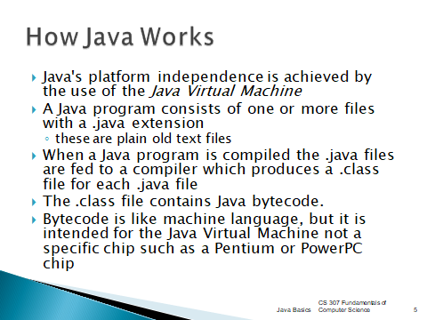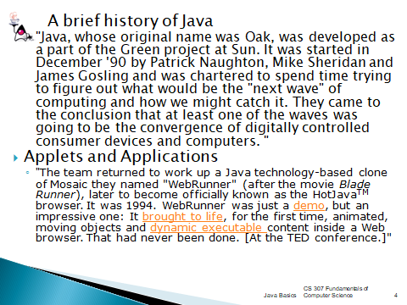 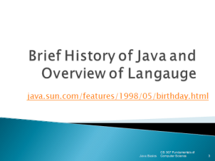

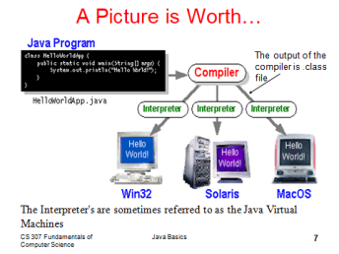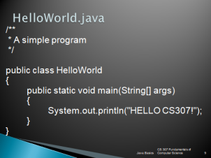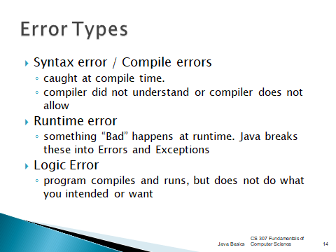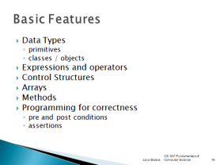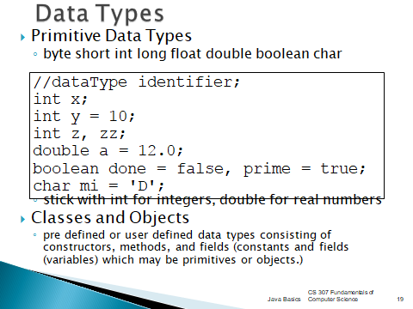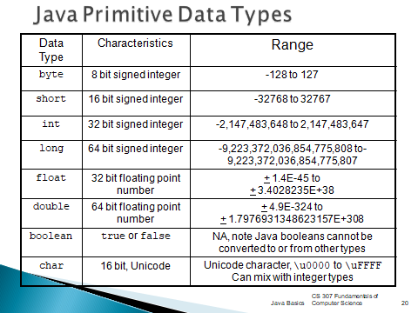

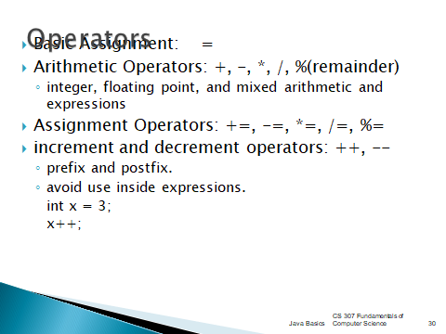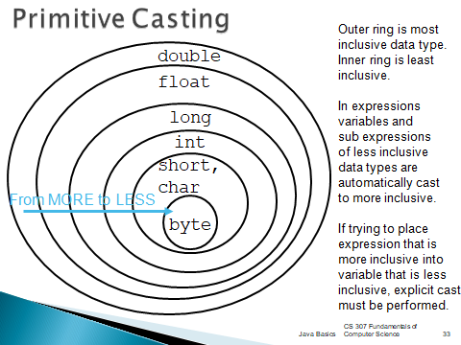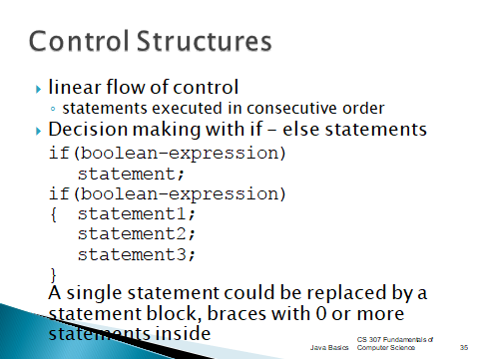

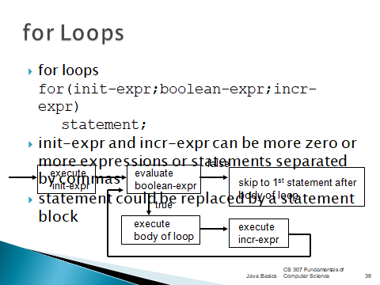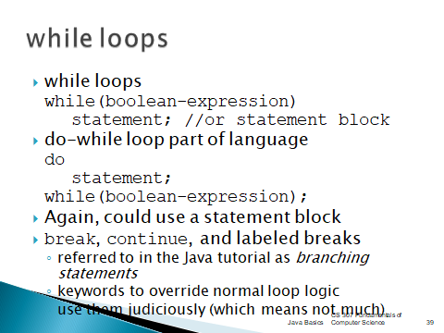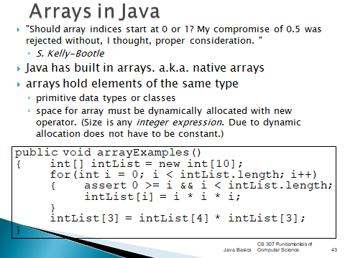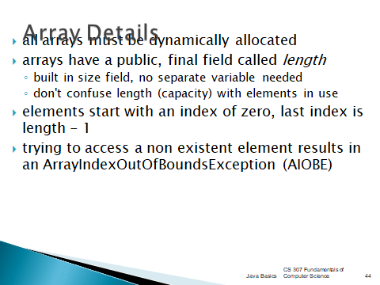

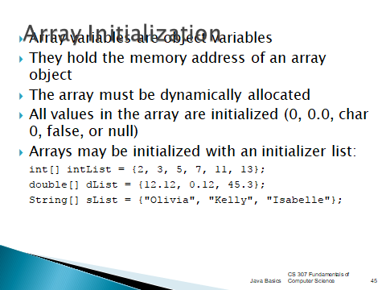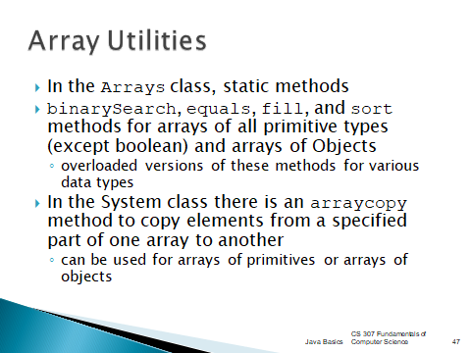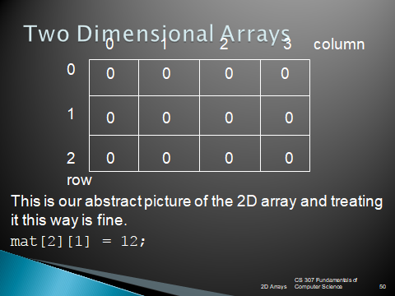

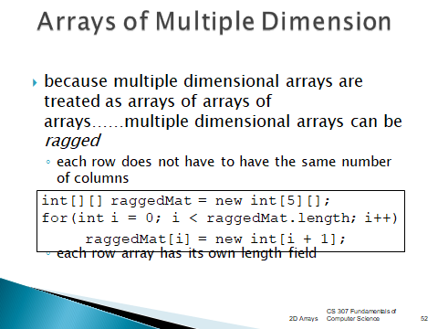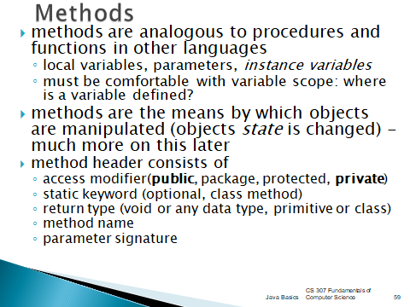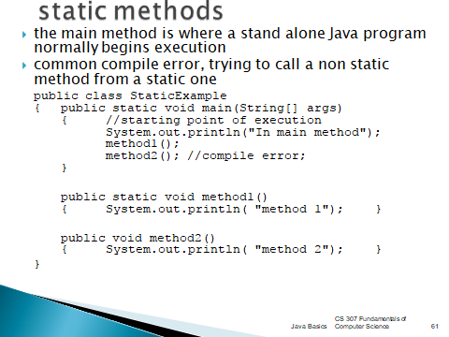

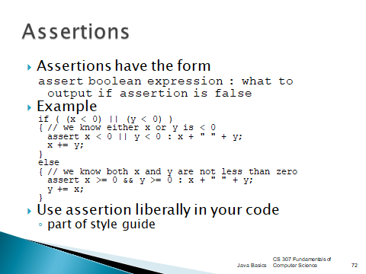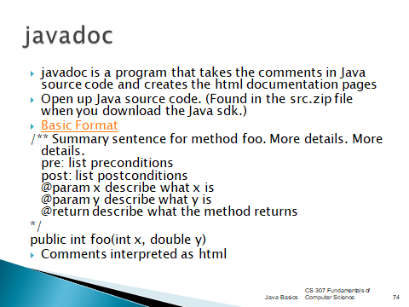

**15.**Websites or URLs e- Resources

1. <https://nptel.ac.in/courses/106/105/106105191/>
2. <https://www.udemy.com/topic/java/free/>
3. <https://www.greatlearning.in/academy/learn-for-free/courses/java-programming>
4. <https://www.coursera.org/specializations/core-java>
5. <https://www.w3schools.com/java/>