A
Course File Report
On
“Discrete Mathematics”
Submitted by
Mr. J.Rajendar
Asst. Professor
Department of
CSE-Data Science

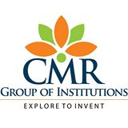

CMR ENGINEERING COLLEGE
(Affiliated to JNTU, HYDERABAD)
Kandlakoya(v),Medchal -501 401
(2021-2022)

COURSE FILE

Subject: Discrete Mathematics
Year: IIrd B. Tech. II -SEM Branch: CSE-DS

S.NO | CONTENTS
1 | Department Vision & Mission
2 | List of PEOs , POs & PSOs
3 | List of COs(Action verbs as per Bloom's Taxonomy)
4 | Syllabus Copy and Suggested/Reference Books
5 | Session Plan/Lesson Plan
6 | Session Execution Log
7 | Lecture Notes (Hand Written)
8 | Assignment Questions along with sample Assignments Scripts
9 | Mid exam Question Papers along with sample Answers Scripts
10 | Scheme of Evaluation
11 | Mapping of COs with POs and PSO’s
12 | Attainment of CO’s, PO’s and PSO’s (Excel Sheet)
13 | University Question Papers/ Question Bank
14 | Power Point Presentations (PPTs)
15 | Websites/URLs/ e- Resources

Submitted By
Mr. V. Kiran Kumar
Asst Professor
Data Science Department

1. Department vision & mission:

Vision

To create the next generation and globally competent data scientists/data engineers in the field of Data Science domain by providing quality engineering education along with cutting edge technologies

Mission
M1. To provide value based engineering education through continues learning and research by imparting solid foundation in applied mathematics, algorithms and programming paradigms to build software models and simulations.
M2. To develop concepts building, logical and problem solving skills of graduates to address current global challenges of industry and society.
M3. To offer excellence in teaching and learning process, industry collaboration activities and research to mould graduates into industry ready professionals
2. Program Educational outcome (PEO):
PEO 1: To provide strong fundamentals in engineering principles to analyze, design and develop optimal solution using modern tools.
PEO 2: To create an Atmosphere for building the ability to lead or work in inter-disciplinary domains collaboratively and complete research & product oriented applications.
PEO 3: Exhibit professionalism, multidisciplinary teamwork and adapt to current trends by engaging in lifelong learning and practice their profession with legal and ethical responsibilities.

2.1 Program Outcome (PO):

- PO1. An ability to apply knowledge of computing, mathematics, science and engineering fundamentals appropriate to the discipline.
- PO2. An ability to analyze a problem, and identify and formulate the computing requirements appropriate to its solution.
- PO3. An ability to design, implement, and evaluate a computer-based system, process, component, or program to meet desired needs with appropriate consideration for public health and safety, cultural, societal and environmental considerations.
- PO4. An ability to design and conduct experiments, as well as to analyze and interpret data.
- PO5. An ability to use current techniques, skills, and modern tools necessary for computing practice.
- PO6. An ability to analyze the local and global impact of computing on individuals, organizations, and society.
- PO7. Knowledge of contemporary issues.
- PO8. An understanding of professional, ethical, legal, security and social issues and responsibilities.
- PO9. An ability to function effectively individually and on teams, including diverse and multidisciplinary, to accomplish a common goal.
- PO10. An ability to communicate effectively with a range of audiences.
- PO11. An understanding of engineering and management principles and apply these to one’s own work, as a member and leader in a team, to manage projects.
- PO12. Recognition of the need for and an ability to engage in continuing professional development.
Program Specific Outcomes (PSO’s)
- Professional Skills and Foundations of Software development: Ability to analyze, design and develop applications by adopting the dynamic nature of Software developments.
- Applications of Computing and Research Ability: Ability to use knowledge in cutting edge technologies in identifying research gaps and to render solutions with innovative ideas.
3. Course Outcomes
S. No | Course Out Come
CS401PC.1 | Ability to understand and construct precise mathematical proofs
CS401PC.2 | Ability to use logic and set theory to formulate precise statements
CS401PC.3 | Ability to analyze and solve counting problems on finite and discrete structures
CS401PC.4 | Ability to describe and manipulate sequences
CS401PC.5 | Ability to apply graph theory in solving computing problems

4. Syllabus Copy and Suggested/Reference Books

UNIT - I
The Foundations: Logic and Proofs: Propositional Logic, Applications of Propositional Logic, Propositional Equivalence, Predicates and Quantifiers, Nested Quantifiers, Rules of Inference, Introduction to Proofs, Proof Methods and Strategy.

UNIT - II
Basic Structures, Sets, Functions, Sequences, Sums, Matrices and Relations Sets, Functions, Sequences & Summations, Cardinality of Sets and Matrices Relations, Relations and Their Properties, n-ary Relations and Their Applications, Representing Relations, Closures of Relations, Equivalence Relations, Partial Orderings.

UNIT - III
Algorithms, Induction and Recursion: Algorithms, The Growth of Functions, Complexity of Algorithms
Induction and Recursion: Mathematical Induction, Strong Induction and Well-Ordering, Recursive Definitions and Structural Induction, Recursive Algorithms, Program Correctness

UNIT - IV
Discrete Probability and Advanced Counting Techniques: An Introduction to Discrete Probability, Probability Theory, Bayes’ Theorem, Expected Value and Variance
Advanced Counting Techniques: Recurrence Relations, Solving Linear Recurrence Relations, Divide-and-Conquer Algorithms and Recurrence Relations, Generating Functions, Inclusion- Exclusion, Applications of Inclusion-Exclusion

UNIT - V
Graphs: Graphs and Graph Models, Graph Terminology and Special Types of Graphs, Representing Graphs and Graph Isomorphism, Connectivity, Euler and Hamilton Paths, Shortest-Path Problems, Planar Graphs, Graph Coloring.
Trees: Introduction to Trees, Applications of Trees, Tree Traversal, Spanning Trees, Minimum Spanning Trees

Suggested Books

TEXT BOOKS
T1. 1. Discrete Mathematics and its Applications with Combinatorics and Graph Theory- Kenneth H Rosen, 7th Edition, TMH.
REFERENCE BOOKS
R1 Discrete Mathematical Structures with Applications to Computer Science-J.P. Tremblay and R. Manohar, TMH,
R2 Discrete Mathematics for Computer Scientists & Mathematicians: Joe L. Mott, Abraham Kandel, Teodore P. Baker, 2nd ed, Pearson Education.
R3 Discrete Mathematics- Richard Johnsonbaugh, 7Th Edn., Pearson Education.
R4 Discrete Mathematics with Graph Theory- Edgar G. Goodaire, Michael M. Parmenter.
R5 Discrete and Combinatorial Mathematics - an applied introduction: Ralph.P. Grimald, 5th edition, Pearson Education.

- Session plan /Lesion plan
UNIT | Topic (JNTU syllabus) | Sub-Topic | NO. OF LECTURES REQUIRED | Suggested Books | Remarks
I | The Foundations: Logics and proofs | Propositional Logic, | L1,L2 | T1,R1,R2
I | The Foundations: Logics and proofs | Applications of Propositional Logic, | L3,L4 | T1,R1,R2
I | The Foundations: Logics and proofs | Propositional Equivalence | L5,L6 | T1,R1,R2
I | The Foundations: Logics and proofs | Predicates and Quantifiers | L7,L8 | T1,R1,R2
I | The Foundations: Logics and proofs | Nested Quantifiers | L9 | T1,R1,R2
I | The Foundations: Logics and proofs | Rules of Inference | L10,L11,L12 | T1,R1,R2
I | The Foundations: Logics and proofs | Introduction to Proofs | L13 | T1,R1,R2
I | The Foundations: Logics and proofs | Proof Methods and Strategy | L14,L15 | T1,R1,R2
II | Set theory and relations | Basic Structures, Sets, | L1,L2 | T1,R1,R2
II | Set theory and relations | Functions, | L3,L4 | T1,R1,R2
II | Set theory and relations | Sequences, Sums | L5 | T1,R1,R2
II | Set theory and relations | Matrices and Relations Sets | L6 | T1,R1,R2
II | Set theory and relations | Cardinality of Sets and Matrices Relations | L7 | T1,R1,R2
II | Set theory and relations | Relations and Their Properties | L8 | T1,R1,R2
II | Set theory and relations | n-ary Relations and Their Applications | L9 | T1,R1,R2
II | Set theory and relations | Representing Relations | L10 | T1,R1,R2
II | Set theory and relations | Closures of Relations | L11,L12 | T1,R1,R2
II | Set theory and relations | Equivalence Relations | L13 | T1,R1,R2
II | Set theory and relations | Partial Orderings. | L14,L15 | T1,R1,R2
III | Algorithms, Induction and Recursion | Algorithms | L1
III | Algorithms, Induction and Recursion | The Growth of Functions | L2,L3
III | Algorithms, Induction and Recursion | Complexity of Algorithms | L4
III | Algorithms, Induction and Recursion | Mathematical Induction | L5 | T1,R1,R2
III | Algorithms, Induction and Recursion | Strong Induction and Well-Ordering | L6,L7 | T1,R1,R2
III | Algorithms, Induction and Recursion | Recursive Definitions and Structural Induction | L8 | T1,R1,R2
III | Algorithms, Induction and Recursion | Recursive Algorithms | L9,L10 | T1,R1,R2
III | Algorithms, Induction and Recursion | Program Correctness | L11 | T1,R1,R2
IV | Discrete Probability and Advanced Counting Techniques | An Introduction to Discrete Probability | L1 | T1,R1,R2
IV | Discrete Probability and Advanced Counting Techniques | Probability Theory, Bayes’ Theorem | L2,L3 | T1,R1,R2
IV | Discrete Probability and Advanced Counting Techniques | Expected Value and Variance | L4 | T1,R1,R2
IV | Discrete Probability and Advanced Counting Techniques | Recurrence Relations | L5 | T1,R1,R2
IV | Discrete Probability and Advanced Counting Techniques | Solving Linear Recurrence Relations | L6,L7 | T1,R1,R2
IV | Discrete Probability and Advanced Counting Techniques | Divide-and-Conquer Algorithms and Recurrence Relations | L8,L9 | T1,R1,R2
IV | Discrete Probability and Advanced Counting Techniques | Generating Functions | L10 | T1,R1,R2
IV | Discrete Probability and Advanced Counting Techniques | Inclusion-Exclusion, Applications of Inclusion-Exclusion | L11 | T1,R1,R2
V | Graphs And Trees | Graphs and Graph Models | L1 | T1,R1,R2
V | Graphs And Trees | Graph Terminology and Special Types of Graphs | L2 | T1,R1,R2
V | Graphs And Trees | Representing Graphs and Graph Isomorphism | L3 | T1,R1,R2
V | Graphs And Trees | Connectivity, Euler and Hamilton Paths | L4 | T1,R1,R2
V | Graphs And Trees | Shortest-Path Problems | L5 | T1,R1,R2
V | Graphs And Trees | Planar Graphs, Graph Coloring | L6 | T1,R1,R2
V | Graphs And Trees | Introduction to Trees, Applications of Trees | L7 | T1,R1,R2
V | Graphs And Trees | Tree Traversal, Spanning Trees, Minimum Spanning Trees | L8 | T1,R1,R2
METHODS OF TEACHING
M1 : Lecture Method | M6 : Tutorial
M2 : Demo Method | M7 : Assignment
M3 : Guest Lecture | M8 : Industry Visit
M4 : Presentation /PPT | M9 : Project Based
M5 : Lab/Practical | M10 : Charts / OHP

6. SESSION EXECUTION LOG
Unit. NO | SCHEDULED DATE | COMPLETED DATE | REMARKS
I | 15/3/2022 | 16/3/2022
II | 3/04/2022 | 2/04/2022
III | 10/05/2022 | 11/05/2022
IV | 23/05/2022 | 24/05/2022
V | 3/06/2022 | 04/06/2022

7. Hand written notes to be attached

8. Assignment Questions along with sample Assignments Scripts

ASSIGNMENT-I

1. a).Show the following premises are inconsistent
Premise 1: If today is 1st April then today is fools day
Premise 2: If today is 1st April then 2+2≠8
Premise 3: If today is fools day then 2+2=8
Premise 4: Today is 1st April.(CO1)
2. Prove (~P^ (~Q^R)) V(Q^R)V(P^R) <=> R (CO1)
3. Define Poset. Draw the Hasse diagram for the positive divisors of 36 (CO-2)
4. (a). Discuss in Detail about Properties of Relations with Examples? (CO-2)
(b). Let f:R->R be given by f(x)=x³-2.Find inverse function. (CO-2)
5.Define Law of Duality,converse,inverse and contrapositive with examples?(CO1)

ASSIGNMENT-II
1)Find the Generating function for the Recurrence Relation
a_{n}-a_{n-1} +6a_{n-2 =} 0 for n ≥ 2 .(CO3)
2)Find the solution for a₀₋ 3a_{n-1} -4a_{n-2 = 0 for n}≥ 2 and a₀ ₌₁a₁₌₁.(CO3)
3)Write primes algorithm with example?(CO5)
4)State and prove Hand Shaking Theorem?(CO5)
5)Explain Mathematical induction with simple example? (CO1)

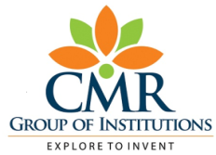
- MID EXAM QUESTION PAPERS ALONG WITH SAMPLE ANSWERS SCRIPTS
CMR ENGINEERING COLLEGE
KANDLAKOYA (V), MEDCHAL (M), R.R.DIST.
DEPARTMENT OF INFORMATION TECHNOLOGY
I MID Question Paper for the A.Y 2021-22, II-SEM
CLASS: B.Tech II – CSE-DS
SUB: Discrete Mathematics
Date: 15-4-2022
Time: 10:00-11:00 A.M
Answer any two of the following & each carries 5 marks. 2×5=10
1. (a) find PDNF of PV(~P^~Q^~R)(CO-1)
(b). Let f:R->R and g:R->R and f(x)=3x+4,g(x)=2x+5,for all x E R ,find fog,gof,fof,gog,fofof. (CO-2)
2) Define the following. (CO-2)
(i) Relation (ii) Function (iii) CP Rule
(3). (a) Show the following Premises are inconsistent
P→Q,R →S,PVR,7(QVS) (CO-1)
(b)Prove (~P^ (~Q^R)) V(Q^R)V(P^R) <=> R (CO-1)
4) (a). Discuss in Detail about Properties of Relations with Examples? (CO-2)
(b). Let f:R->R be given by f(x)=x³-2.Find inverse function. (CO-2)

10. SCHEME OF EVALUATION
MID-I
1. (a) find PDNF of PV(~P^~Q^~R)(CO-1)
(b). Let f:R->R and g:R->R and f(x)=3x+4,g(x)=2x+5,for all xER,find fog,gof,fof,gog,fofof. (CO-2)
Find PDNF of PV(~P^~Q^~R) 2.5 Marks
Find fog,gof,fof,gog,fofof. 2.5 Marks
Total marks 5 marks
2) Define the following. (CO-2)
(i) Relation (ii) Function (iii) CP Rule
Define Relation 2 Marks
Define Function 2 Marks
Define CP Rule 1 Marks
Total marks 5 marks
(3). (a) Show the following Premises are inconsistent
P→Q,R →S,PVR,7(QVS) (CO-1)
(b)Prove (~P^ (~Q^R)) V(Q^R)V(P^R) <=> R (CO-1)
Show the Premises are inconsistent
P→Q,R →S,PVR,7(QVS) 2.5 Marks
Prove (~P^ (~Q^R)) V(Q^R)V(P^R) <=> R 2.5 Marks
Total marks 5 marks

4) (a). Discuss in Detail about Properties of Relations with Examples? (CO-2)
(b). Let f:R->R be given by f(x)=x³-2.Find inverse function. (CO-2)
Discuss in Detail about Properties of Relations with Examples? 2.5Marks
Find inverse function 2.5Marks
Total marks 5 marks

11 . MAPPING OF COS WITH POS AND PSOS
Course Name: Discrete Mathematics YEAR: 2021-22
Btech –II Year-II Sem

Course Outcomes | Relationship of Course outcomes to Program Outcomes (PO AVG)
CO/PO | PO1 | PO2 | PO3 | PO4 | PO5 | PO6 | PO7 | PO8 | PO9 | PO10 | PO11 | PO12 | PSO1 | PSO2
CO1 | 2 | 3
CO2 | 2 | 2
CO3 | 1 | 2 |  | 3 |  |  |  |  |  |  |  |  | 1
CO4 | 2 | 2 |  | 3 | 1
CO5 | 2 | 2 |  | 2 |  |  |  |  |  |  |  |  | 2
1-low 2-moderate 3-highly related.

12. Attainment of COs , POs And PSOs (Excel Sheet) – Attached

13. University question papers/Question Bank
- UNIT-I
- Define statement and atomic statement?
- Explain logical equivalence with an example?
- Describe the tautology?
- Apply the converse, inverse and contra positive of the following
propositions: P -> (Q -> R)
- Interpret that Pv[P^(PvQ)] and P is a logically equivalent without
using truth table ?
- Explain P↑Q in terms of “↓” ?
- Define predicate and predicate logic?
- Demonstrate the truth table for conjunction and conditional
statements?
- Construct the truth table for p->(q->r)?
- Construct the statements R: Mark is rich. H:Mark is happy write the following statements in symbolic form a) mark is poor but happy b)mark is poor but happy
- Construct the following statement in symbolic form: “the crop will be destroyed if there is a flood”.
- Show that R→S can be derived from the premises P→(Q→S), ~R v P and Q
- Define the converse, inverse and contra positive of the following propositions:
i. P -> (Q -> R)
ii. (P ^ (P -> Q) ) -> Q.
- Construct the pdnf of (p^q)V(~pVr)V(qVr) using truth table.

UNIT-II

- Describe a relation?
- Illustrate the operations on relations?
- Define bounded lattice and distributive lattice?
- Explain is a partial order relation?
- Construct the Hasse diagram represented with positive divisors of 36?
- Solve the functions f:A→B,g:B→C, h:C→D,then prove that ho(gof)=(hog)of ?
- Describe a bijective function. Explain with reasons whether the following functions are bijective or not. Find also the inverse of each of the functions.
- f(x) = 4x+2, A = set of real numbers
- f(x) = 3+1/x, A= set of non- zero real numbers
- f(x) = (2x+3) mod7 , A=N7

UNIT-III
- Describe, in how many ways we can distribute 12 identical pencils to 4 children such that every children get at least one pencil?
- Solve the co-efficient of x, y, z² in the expansion of (2x-y-z)⁴ using multinomial theorem ?
- Explain pigeon-hole principle?
- Prove that if there are 8 cars and 26 passengers at least one car has 4 or more passengers?
- A library contains 30 books whose total number of pages is 2560.
- Show that one of the books must have at least 86 pages?
- Describe, the co-efficient of a²b³c³d⁵ in the expansion of (a+2b- 3c+2d+5)¹⁶?
- Describe how many words of three distinct letters can be formed from the letters of the word MAST?
- Describe, that in how many different outcomes are possible by tossing 10 similar coins?Solve the co-efficient of x¹² of x³(1-2x)¹⁰ ?
- Solve the co-efficient fo x⁵ of (1-2x)⁻⁷ ?
- Solve the generating functions for the following sequences 1²,2²,3²
- Solve the generating functions for the following sequences 0², 1²,2²,3² ,……………
- Solve the recurrence relation an=an-1+n³ ,n>=1 where a0=5 by using substitution method ?
- Solve the recurrence relation an=an-1+3n² +3n+1 ,n>=1 where a0=5 by using substitution method ?
- Solve the generating functions for the following sequences 0², 1³,2³,3³ ,-------------
- Solve the recurrence relation an+1=8an ,n>=0 where a0=4

UNIT-IV
- Solve recurrence relation an=an-1+n³ ,n≥1 where a0=5 by using substitution method ?
- Solve recurrence relation an=an-1+n ,n≥1 where a0=2 by using substitution method ?
- Identify the generating functions for the following sequences
i)1,2,3,4 ii)1,-3,-4 iii)0,1,2,3 iv)0 ,1,-2,3,-4
- Identify the generating function for the following sequence
i)1²,2²,3² ,----------- ii)0², 1²,2²,3² ,-----------
- Identify the generating function for the following sequence
i)1³,2³,3³ ,-------------ii)0², 1³,2³,3³ ,-------------
- Identify the co-efficient of x⁵ of (1-2x)⁻⁷ ?
- Identify the co-efficient of x²⁷ of i)(x⁴+x⁵+x⁶………….)⁵ ii))(x⁴+2x⁵+3x⁶ )⁵
- Solve the recurrence relation an=an-1+n³ ,n>=1 where a0=5 by using substitution method
- Solve the recurrence relation an=an-1+3n² +3n+1 ,n>=1 where a0=5 by using substitution method ?
- Solve the recurrence relation an+1=8an ,n>=0 where a0=4
- Solve the recurrence relation an-7an-1+10an-2=0 n>=2 ,a0=10 a1=41
- Solve the recurrence relation an-9an-1+26an-2+24an-3=0 n>=3,a0=0 a1=1 a2=10
- Solve the recurrence relation an=3an-1+2n a1=3
- Solve the recurrence relation an-3an-1=n , n>=1 a0=1 by using generating function ?
- Solve the recurrence relation an+1-an=3^{n} , n>=0 a0=1 by using generating function ?

UNIT-V

- Illustrate the adjacency matrix of directed graph?

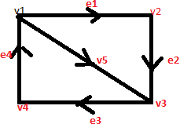
- Describe the spanning trees of graph?

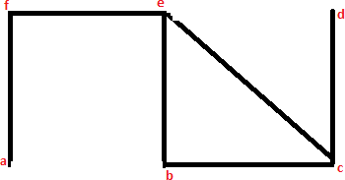
- Describe simple graph AND degree of each vertex?

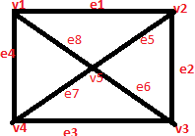
- Define
- Null graph? Isolated vertex?

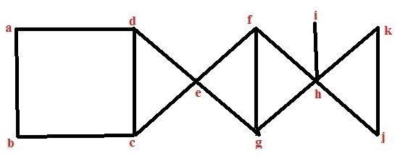
- Construct the spanning tree of graph G by using
i) BFS ii)DFS

- Construct the spanning tree of graph G by using BFS
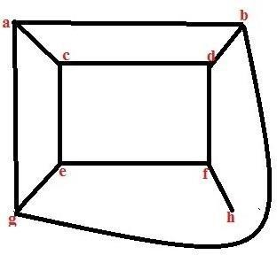

- Construct the minimal cost spanning tree for the cities shown in above graph using Kruskal’s algorithm?

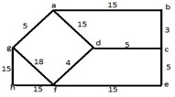

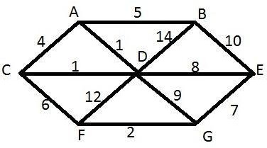

- Construct the minimal cost spanning tree for the cities shown in above graph using Prim’s algorithm?
5

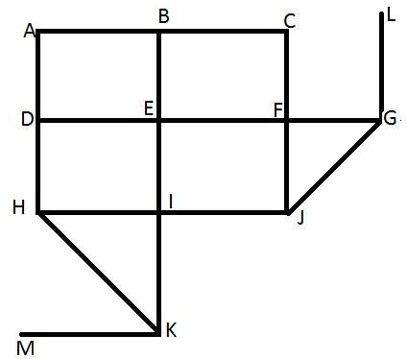
- Construct the spanning tree of the graph G by using DFS with vertex in the ordering “abcfjihdegl”?
6
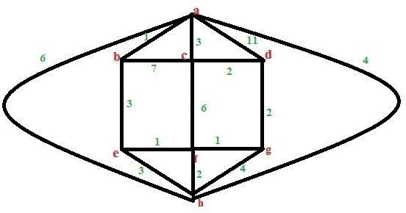
- Construct the minimal cost spanning tree for the cities shown in above graph using krushkals algorithm?
- Construct the minimal spanning tree of weighted graph G by using Prim’s algorithm?

14.Powerpoint presentations –Attached
15.Websites/URLs e-resources
TEXT BOOKS
T1. Discrete Mathematics and its Applications with Combinatorics and Graph Theory- Kenneth H Rosen, 7th Edition, TMH.
REFERENCE BOOKS
R1. Discrete Mathematical Structures with Applications to Computer Science-J.P. Tremblay and R. Manohar, TMH,
R2. Discrete Mathematics for Computer Scientists & Mathematicians: Joe L. Mott, Abraham Kandel, Teodore P. Baker, 2nd ed, Pearson Education.
R3. Discrete Mathematics- Richard Johnsonbaugh, 7Th Edn., Pearson Education.
R4. Discrete Mathematics with Graph Theory- Edgar G. Goodaire, Michael M. Parmenter.
R5. Discrete and Combinatorial Mathematics - an applied introduction: Ralph.P. Grimald, 5th edition, Pearson Education.

Websites
Do not confine yourself to the list of websites mentioned here alone. Be cognizant and keep yourself abreast of the others too. The given list is not exhaustive.
www.powershow.com/.../Lecture_2_Foundations_Mat...
2. www.csie.ndhu.edu.tw/~rschang/dmchap2.ppt‎
3. www.ee.ntu.edu.tw/~yen/courses/dm-s08/S08-Module-01-Logic.ppt‎
4. www.ifm.ac.tz/staff/bajuna/courses/.../Predicate%20Logic.ppt‎
5. srg.cs.uiuc.edu/~anwar/ai/lecture7.ppt‎
6. www.mgt.ncu.edu.tw/~ylchen/dismath/chap05.ppt‎
7. homepages.ius.edu/rwisman/C251/html/chapter8.htm‎
8. sherwood.ebrschools.org/eduWEB2/.../permutations_combinations.ppt‎
9. www.gvu.gatech.edu/~jarek/courses/1050/slides/X13Permutations.ppt‎
10. www.cs.umbc.edu/~ypeng/S03203/lecture-notes/Ch06.ppt‎
11. www.cs.drexel.edu/~kschmidt/.../recurrenceRelations-substitution.ppt‎
12. www.csie.ndhu.edu.tw/~rschang/dmchap11.ppt‎
13 www.cis.temple.edu/~latecki/Courses/CIS166-Spring08/.../ch9.3-9.4.ppt‎
Journals
National
1. Discrete and Combinational Mathematics – An applied Introduction – 5th Edition– Ralph.P.Grimaldi.Pearson Education
2. Discrete Mathematical and its Applications, Kenneth H.Rosen, 5th Editions, TMH.
3. Discrete Mathematical structures Theory and application-Malik & Sen, Cengage.
4. Discrete Mathematics with Applications, Thomas Koshy, Elservier.
5. Logic and Discrete Mathematics, Grass Man & Trembley, Person Education
International
- Acta Informatica, Acta Scientiarum Mathematicarum (Szeged), Advances in Applied Mathematics, Algebra Colloquium, Algebra i Logika, Algebra Universalis.
- Semigroup Forum, SIAM Journal on Discrete Mathematics, Siberian Electronic Mathematical Reports, Simon Stevin, Studia Logica;

